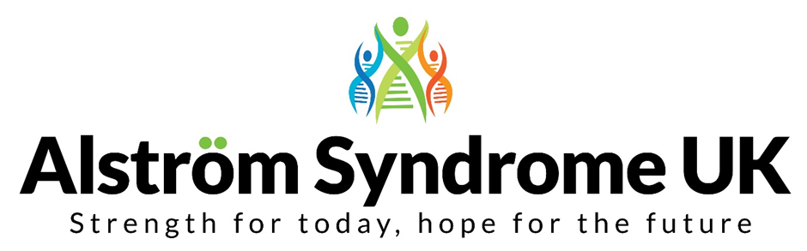

Health, Happiness and Well-being!

Professional and Family Conference 6th and 7th October 2017
The 2017 conference for researchers, clinicians, academics, practitioners, individuals affected by Alström Syndrome and their families.

Call for Papers
Research, development and clinical management of Alström Syndrome

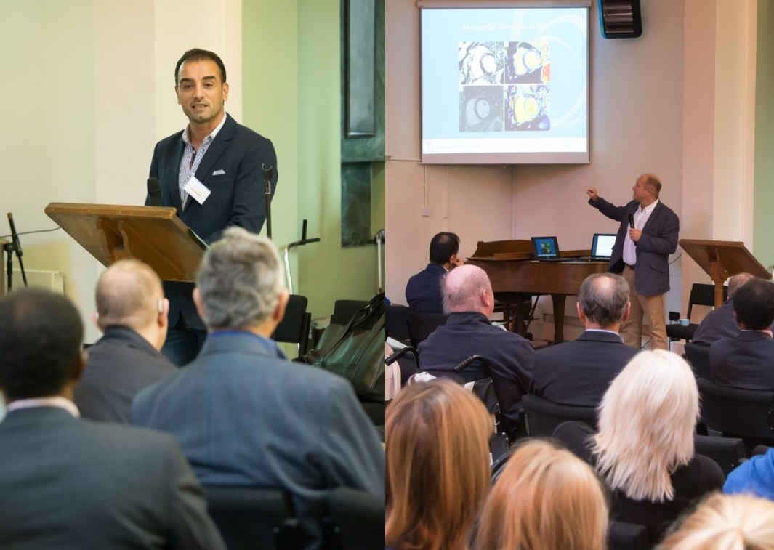

Introduction
This 18th conference hosted by Alström Syndrome UK (ASUK) aims to bring together the research and practice in learning about and managing this ultra-rare condition. The conference offers the Alström community the chance to get together, share stories and hear about the latest research in the UK and more widely. It will offer the opportunity for clinicians, educationalists, academics, individuals affected, and their families the chance to network and find out what is happening in areas of research and treatment.

Key note speakers will include leading clinicians and academics and presentations from people who have personal experience of this complex condition.

New for 2017
This year, ASUK is pleased to be introducing a research symposium. Offering the opportunity for knowledge sharing, learning and networking together.

Friday 6th October 2017 - Scientific Symposium
The symposium is aimed at researchers, clinicians, academics and other professionals. Its aim is to bring together perspectives on current research activities and any new thinking around Alström Syndrome.

We welcome papers for presentation on any aspect of Alström Syndrome including the heart, hearing, vision, organ function, diabetes, endocrinology and metabolism, organ transplants and genetics. There will be a panel discussion at the end of the symposium.

Saturday 7th October 2017 - Professional and Family Conference
There will be parallel sessions throughout the day linked to the conference theme. Each session will last around an hour and give families and individuals the chance to ask questions and exchange ideas. If you would like to submit a paper and/or a workshop idea, please consider the following topics.
Suggested themes for the parallel sessions for 2017 are:
- Research and practice in supporting children and young people
- Research and practice in supporting adults
- Clinical Trials: involving patients and their carers
- Research development in ophthalmologic and audiology treatments
- Guidelines in AS for organ transplantation
- Genomics: The impact on health and treatments
- Taking care of your heart
- Healthy eating and exercise

We welcome practice examples and case studies; these can be presented within the themes above as a discussion paper.
The language of the event is English.

Submission
Speakers are invited to register to attend the whole of the event. Before submitting a paper, please ensure that if it is accepted for presentation you will be able to present on either day.
We will, in some instances, make allowances for papers to be delivered on a specific day, however papers will be allocated to parallel sessions according to themes.

Please ensure that your abstract and or suggestion to run a workshop is relevant to the core theme of the event—the conference focus is Health, Happiness and Well-being; What can help individuals and families to manage and improve their quality of life.

We will accept submissions in any accessible format such as DVD’s, photos or drawings. Please ensure your submission is accessible to all, including people affected by dual-sensory loss. ASUK can advise on this if necessary.

Timeline
Please be aware of the following dates:

24 January 2017 Call for papers opens
31 March 2017 Close of applications
22 April 2017 Successful papers will be accepted by this date and confirmed.

Guidance
- Use the application form below
- Ensure the abstract is relevant to the conference themes and title
- Papers are presented for 25 minutes as part of a session lasting 60 minutes
- Clearly state the title of the paper
- Clearly name all presenters
- Ensure you reference all relevant papers and research
- Ensure that the paper will be ready one month prior to the event. You will be expected to make available all materials including the handouts and accompanying PowerPoint presentations (if appropriate to the session). These must be sent to ASUK a month before the event
- Submission of an abstract indicates that you agree to your presentation being included in the conference programme and report
- All papers and associated documents will be made available to participants and published on the ASUK website

We may film presentations and will always ask for permission to use films clips for the ASUK website and our social media platforms.

The venue for the conference is Aston University Conference Centre in Birmingham, UK.

Submission for ASUK 2017 Conference
6th and 7th October 2017
Contact Details
Name of primary author

Email address

Mobile telephone number
Work telephone number
Contact Address

Title of Paper or Workshop Session

Name of Author(s) | Job Title and Employing Organisation
Name of Presenter(s) | Job Title and Employing Organisation

Indicate the three main learning outcomes or key messages for delegates

1.

2.

3.

Please provide an abstract (outline) of the paper to be presented, using no more than one side of A4:

Please sign below to indicate that all named presenters agree to abide by the conditions of acceptance. This will include registering to attend both days and being responsible for any expenses associated with attendance, including travel and accommodation.
Please sign:

Date:

If you would like any more details or help in completing this form, please contact Catherine Lewis at ASUK on 07970 071675

Please send the completed submission to Catherine Lewis at ASUK via email Catherine.lewis@alstrom.org.uk or by post to our registered office at 31 Shearwater Drive, Torquay, Devon TQ2 7TL

2017 Conference Sponsorship and Exhibiting Opportunities

ASUK is hoping to gain sponsorship towards the event and will consider individual requests for help towards paying for accommodation and or travel.

ASUK will also have exhibiting opportunities for organisations to showcase their work to the Alström community and professionals alike.

If you or your organisation is interested in sponsoring any part of the event or would like to discuss the exhibiting opportunities, please get in touch with Catherine Lewis on 07970 071675 or email Catherine.lewis@alstrom.org.uk

Strength for today, hope for the future
Registered Charity no: 1071196 Company no: 3557191

