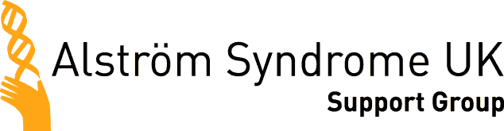

Close Encounters Children’s Outing!

While parents attended the Alström Syndrome UK Conference, we took 29 children off to Paignton Zoo for an exciting outing to meet lots of animals.
The children and volunteers were eager to get going as we left the hotel to make our way across Torbay to the award winning zoo in Paignton. The children and parents had a great morning at the zoo looking around the animals and having a private bird show, especially scheduled for them. The birds came very close to the children and were flying over their heads, they really enjoyed the experience.
After lunch we headed back to the Toorak Hotel for a ‘Really Wild’ show.
Neil Vaughan was the presenter and as we entered the function room the sounds of the rainforest could be heard. He had brought many different creepy crawlies and really wild animals for the children to learn about and hold!
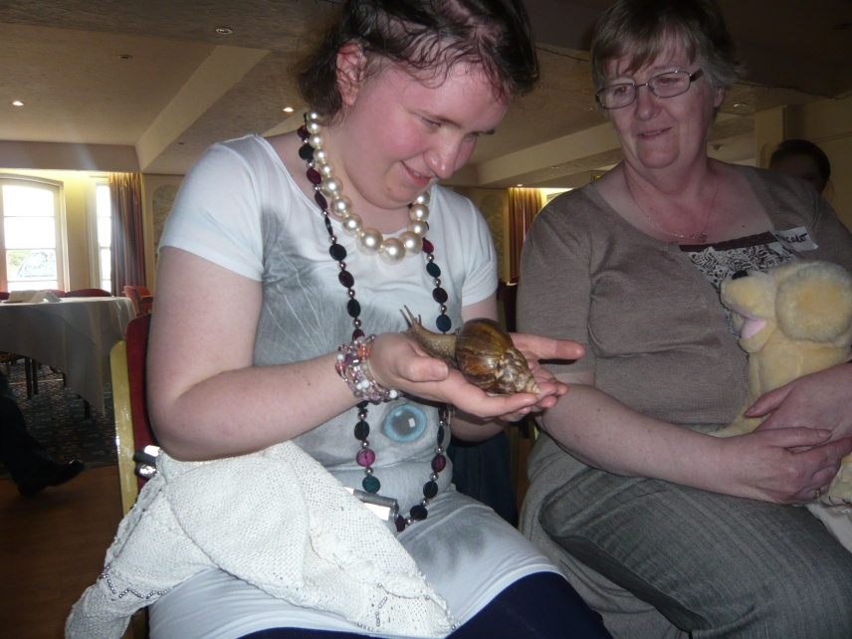

The children were able to hold a giant snail which slimmed all over their arms, a tarantula and a giant lizard. This was a great experience for both children and parents. I didn’t get off lightly myself as I ended up being dragged to the front of the room to have the giant lizard placed on my head to give me a new hair do!
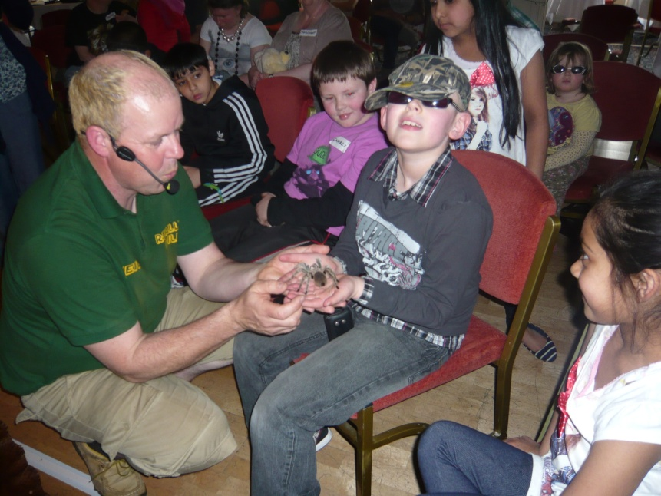
The children really enjoyed the experience and were returned to their parents exhausted after their exciting day.
Thank you to all the volunteers who took part in the children’s outing without their help the outing wouldn’t have been able to take place.

