

**2013**

**Menzies Strathallan Hotel**

**225 Hagley Road, Edgbaston, Birmingham, B16 9RY**

**Sunday 28th April 2013**

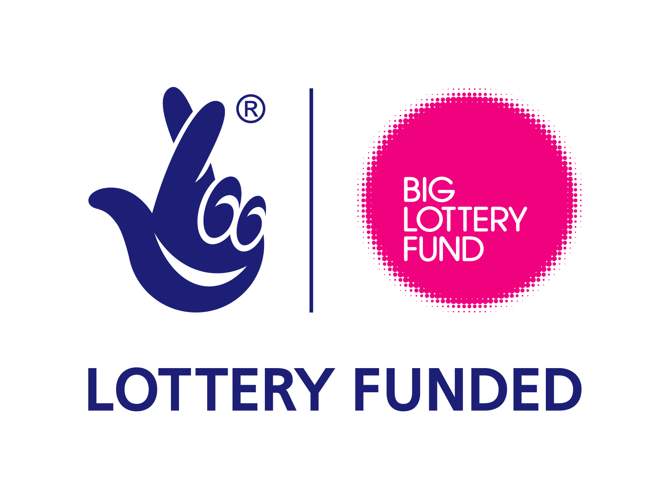



Charity no: 1071196

Company no: 3357191

Alström Syndrome UK

Family and Professional Conference

Programme

Sunday 28th April 2013

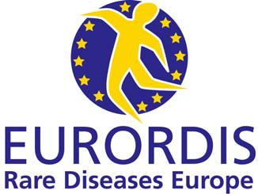Patient Organisation 2013



**Welcome**

We are delighted to welcome you to the Alström Syndrome UK Family and Professional conference 2013.

This year’s conference combines presentations from experts in their fields alongside group discussions in our afternoon workshops.

We have focused the theme around current and future research and ensuring families have the support, information and help that they need.

**Alström Syndrome UK (ASUK) Quick Facts**

* ASUK was established in 1998 when John and Kay’s two children were diagnosed with Alström Syndrome but no help was available at this time
* ASUK were instrumental in developing specialised multi-disciplinary clinics for patients affected
* Asian Mentoring Scheme project offers support and awareness in the Asian Community
* ASUK Collects prestigious European Award – EURORDIS Patient Organisation 2013
* ASUK awarded £344,232 Big Lottery Research Grant ‘Bringing Hope to Alström Patients’
* ASUK is a key partner in the EURO WABB research project – An EU rare diseases registry for Alström Syndrome, Bardet-Biedl, Wolfram Syndrome and other rare diabetes syndromes.
* ASUK has produced the only medical handbook into the condition
* ASUK manage the only Alström Syndrome patient database in the UK
* ASUK are a founder member of the Ciliopathy Alliance
* Last year Family Fundraising Events raised over £30,000

**Rare Quick Facts**

* 1 in 17 people will be affected by a rare disease at some point in their life.
* This amounts to approximately 3.5 million people in the UK.
* There are over 6,000 recognised rare diseases.
* Collectively rare diseases are not rare.
* Approximately 50% of rare diseases have no disease specific support services or research programmes.

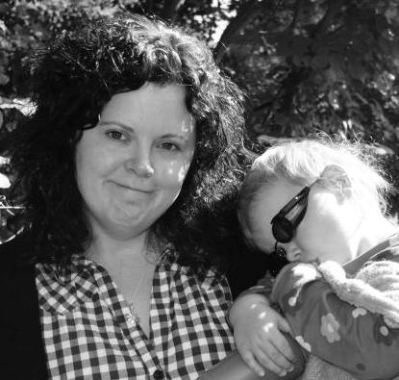

Michelle Hough

ASUK Chair

**Meet the ASUK Team**

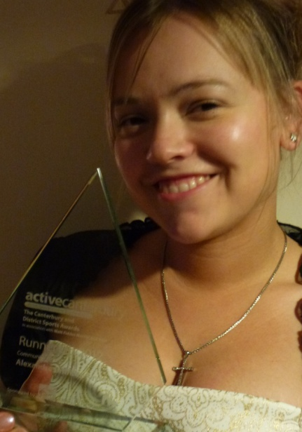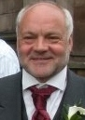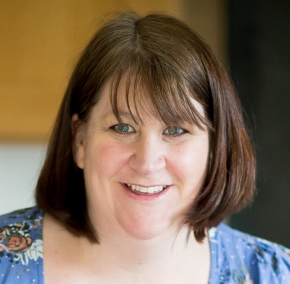C:\Users\Catherine\AppData\Local\Microsoft\Windows\Temporary Internet Files\Content.Word\Cycle Ride Group 2012.jpg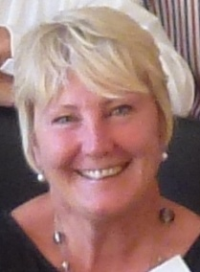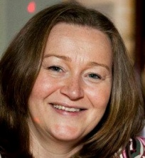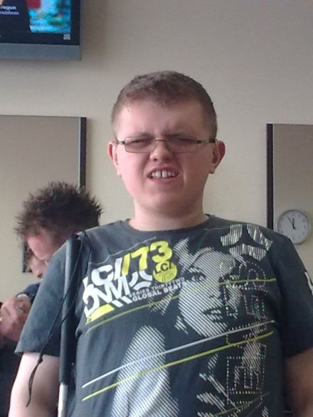

Phil Leeson

Financial Director

(Non-Executive)

Julie Beck

Trustee

Parent Representative

Area: Awareness

Mark Millais

Trustee

Parent Representative

Area: Independent Living

Trevor Parkin

ASUK vice Chair

Kay Parkinson

ASUK Founder

Director (Non-Executive)

Dawn Mayes

Trustee

Professional Representative

Area: Awareness

Curtis Vasey

Trustee

Patient Representative

Area: Activities

Alexi Griffiths-Rayson

Trustee

Patient Representative

Area: Adult activities

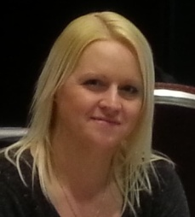

Kerry Leeson-Beevers

Acting Chief Executive Officer

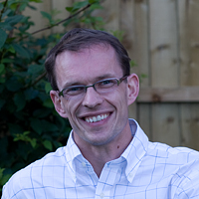

Dr. Robert Semple

Medical and Scientific Advisor

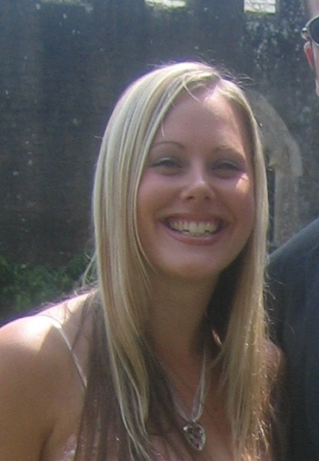

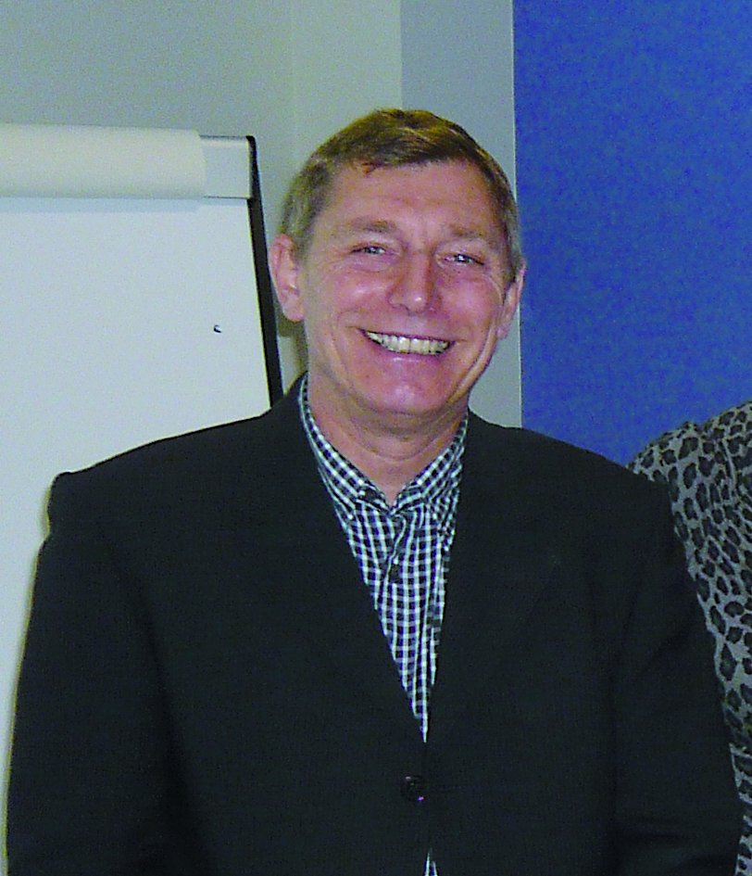

John Parkinson

Family Liaison Officer

Catherine Lewis

Administrator and Events Coordinator

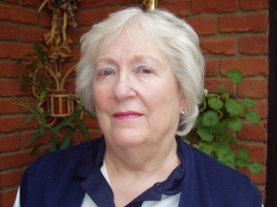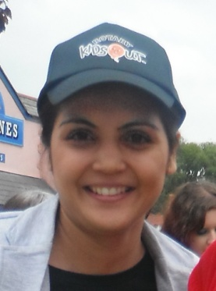

Iram Shah

Asian Mentoring

Project Assistant

Julia Scott

Fundraiser

Dr. Rob Semple

Scientific and Medical Advisor

Iram Shah

Asian Mentoring

Project Assistant

Julia Scott

Fundraising Manager

John Parkinson

Family Liaison Officer

Catherine Lewis

Administrator and Event Coordinator

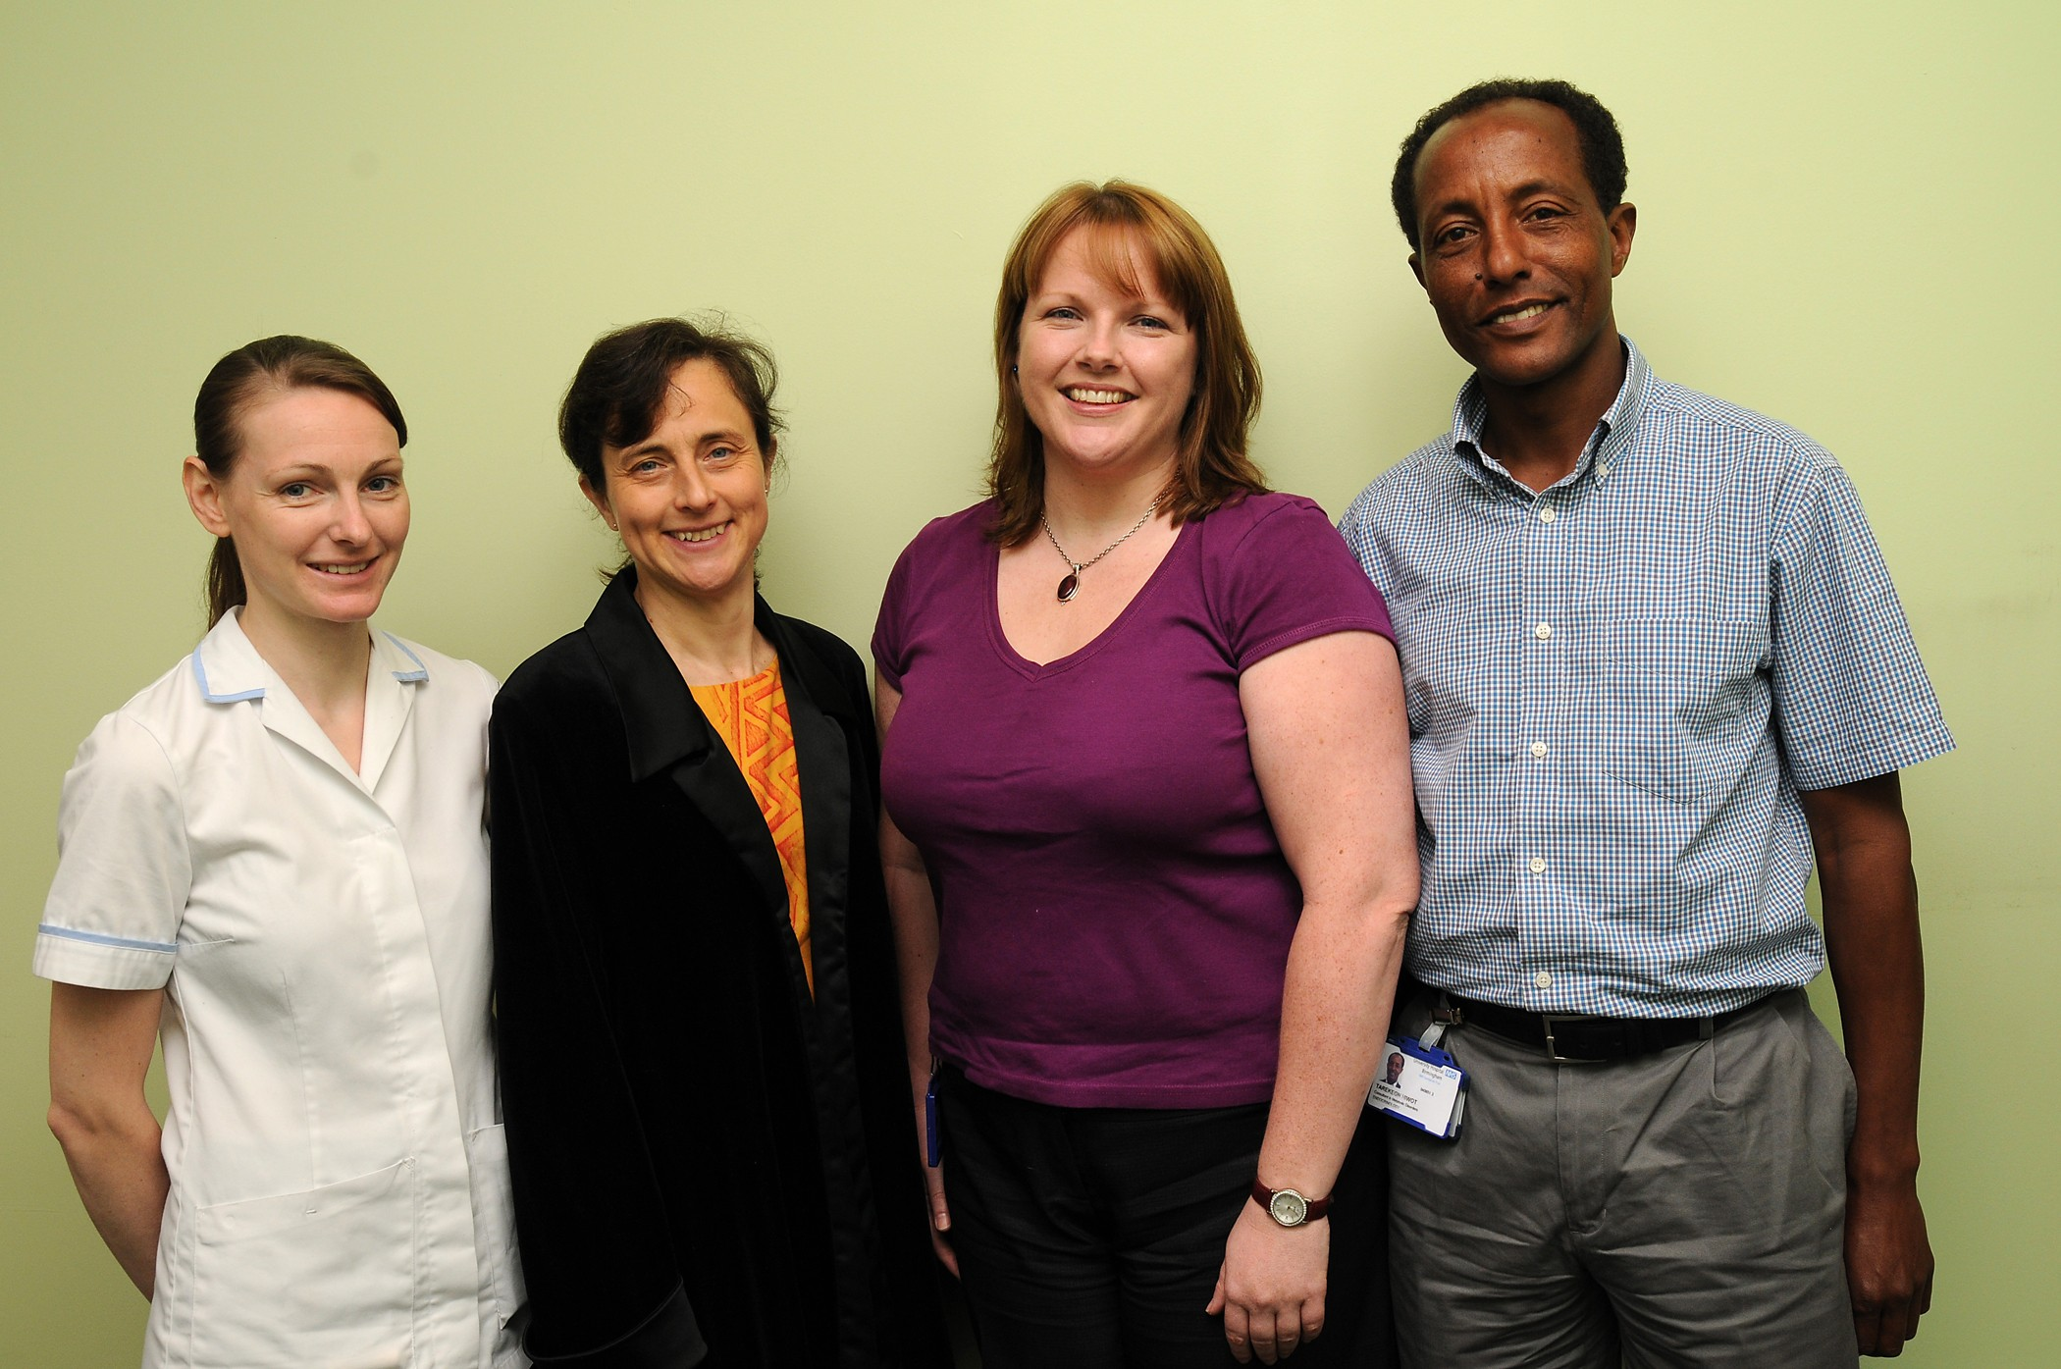**Meet the Speakers**

Dr. Tarek Hiwot

Inherited Metabolic Disorder Consultant

Clinical Lead – ASUK Adult multi-disciplinary Clinics

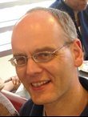

Professor Tim Barrett

Professor of Paediatric Endocrinology at Birmingham Children’s Hospital

Clinical Lead – ASUK Children’s Multi-disciplinary Clinics

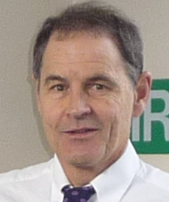

Dr. Richard Paisey

Consultant Endocrinologist

Torbay Hospital

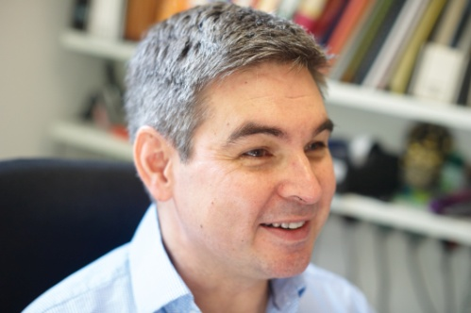

Professor Phil Beales

University College London

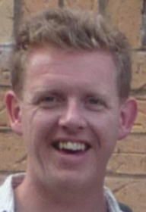

Dr. Dan Jagger

Deafness Researcher

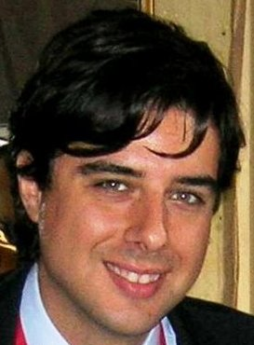

Dr. Edward Callus

Clinical Psycologist

Paediatric and Adult Congenital Heart Disease Centre, Italy

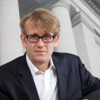

Richard Copson

Head of Disability Rights and Public Law at Pannone Solicitors, Manchester

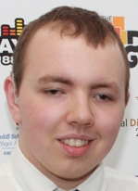

Liam Mackin

Award Winning Patient Representative

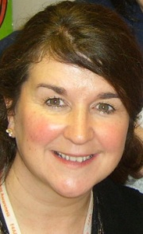

Marie McGee

Transition Coordinator

Birmingham Children’s Hospital

**Conference Schedule**

The main conference is located on the ground floor in the Wallace Suite

|  |  |
| --- | --- |
| **09:00 – 09:30**  **09:30 – 10:00** | Children meet Catherine Lewis and John Parkinson at reception for their fun-filled day at Drayton Manor Theme Park  Registration and Refreshments |
| **Morning Session, chaired by Alex Griffiths-Rayson, ASUK Trustee and Patient representative** | |
| **10:00 – 10:10** | Welcome – Kerry Leeson-Beevers |
| **10:10 – 11:00** | Findings from the Big Lottery Medical and Scientific Research Project  Chaired by Dr Dan Jagger, Scientific Management Advisor  Presentations to be given by Dr Robert Semple, Consultant Endocrinologist, University of Cambridge, Professor Tim Barrett, Professor of Paediatric Endocrinology, University of Birmingham and Dr Richard Paisey, Consultant Endocrinologist, Torbay Hospital |
| **11:00 – 11:15** | New Adipose Study  Dr Tarek Hiwot, Consultant in Inherited Metabolic Disorders |
| **11:15 – 11:30**  **11:30 -11.45** | Questions  Refreshments |
| **11:45 – 12:10** | Future for Ciliopathies  Professor Phil Beales,University College London |
| **12:10 – 12:30** | Research into Alström Syndrome in France  Dr Vincent Marion, Hôpitaux Universiatires de Strasbourg, (UDS. and INSERM), Strasbourg, France,) |
| **12:30 – 12:45** | Living with Alström Syndrome  Liam Mackin, AS patient representative and winner of the National Diversity Award for ‘Positive Role Model for Disability’ |
| **12:45 – 13:00** | Sailing on the Tall Ships  Philip Watts, The Jubilee Sailing Trust |
| **13:00 - 13:15** | Questions and Answer Session |
| **13:15 – 14:15** | Lunch and Networking – Restaurant and the Pentland Suite |

|  |  |  |  |
| --- | --- | --- | --- |
| **Afternoon Workshops, chaired by Alex Griffiths-Rayson**  **The afternoon sessions will consist of a choice of workshops**  **You can attend up to three workshops**  **Workshops are located on the ground floor of the Hotel**  **With the except of the transition workshop which is located on the 4th Floor** | | | |
|  | **14:15 – 14:45** | **14:45 – 15:15** | **15:15 – 15:45** |
| 1. Transition   Marie McGee, Transition Coordinator, Birmingham Children’s Hospital  Location: The Boardroom (4th Floor) |  |  |  |
| 1. 1 year on, Development of the Adult Service   Dr Tarek Hiwot, Consultant in Inherited Metabolic Disorders  Location: Pentland Lounge |  |  |  |
| 1. Euro WABB and the Paediatric Clinics Professor Tim Barrett, Professor of Paediatric Endocrinology   Location: Wallace Suite |  |  |  |
| 1. Disability Rights   Richard Copson, Pannone’s Solicitors, Manchester  Location: Cramond Lounge |  |  |  |
| 1. Accessible Technology   Gujit Kahlon, Technology Team Lead  Action for the Blind  Location: Cramond Suite |  |  |  |
| **15:45 – 16:00** Refreshments will be served in the Wallace Suite | | | |

|  |  |
| --- | --- |
| **Afternoon Meetings** | |
| **16:00 – 17:00** | AGM  Chaired by Michelle Hough ASUK Chair  Families and Trustees only  Wallace Suite |
| **16:00 – 18:30** | Medical and Scientific Meeting  Coordinating Research, Clinics and Future Treatments  Cramond Suite |
| **17:00** | **Family Conference closes** |
| **18:30** | **Medical /Scientific meeting closes** |
| **Medical and Scientific Meeting**  **Cramond Suite** | |
| **Chaired by Dr Robert Semple**  **Alström Syndrome UK Medical and Scientific Chair** | |
| **16:00 – 16:30** | Ciliopathies  Professor Phil Beales  Professor of Medical Genetics |
| **16:30 – 17:00** | New Insights and Treatments for Alström Syndrome  Dr Vincent Marion  Hôpitaux Universitaires de Strasbourg  Scientific ALMS research UDS and INSERM, Strasbourg |
| **17:00 - 17:30** | Enhancing Physician-Patient communication in end of life care.  Dr Edward Callus  Clinical Psychologist and International Public Relations, Italian, GUCH Association. |
| **17:30 – 18:00** | Questions |
| **18:00 – 18:30** | General Discussions Question  Will the findings from the Big Lottery Research Project and the Alström Syndrome Audit 2013 change the way we manage and monitor the care of patients who are affected by Alström Syndrome? |
| **18:30** | **Medical /Scientific meeting closes** |
| **18:30 – 19:00** | **Big Lottery Grant Emergency Meeting**  Signing of Documentation  Research Partners only |

**Exhibitors**

Jubilee Sailing Trust

HearFirst Training

Guide Dogs for the Blind

Royal National College for the Blind – Hereford

|  |  |  |
| --- | --- | --- |
| **Delegates** | **Position** | **Area** |
| Margaret Baraks | Teaching Assistant | Birmingham |
| Professor Tim Barrett | Professor of Paediatric Endocrinology | Birmingham Children's Hospital |
| Professor Phil Beales | Professor of Medical Genetics | London |
| Julie Beck | Parent and ASUK Trustee | North Yorkshire |
| Joan Beck | Relative | North Yorkshire |
| Fatema Bismillah | Parent | Birmingham |
| Soab Bismillah | Parent | Birmingham |
| Sue Bushell | Community Engagement Officer | Guide Dogs for the Blind |
| Tim Broome | Royal National College for the Blind | Hereford |
| Dr. Edward Callus | Clinical Psychologist | Italy |
| Nichola Cartwright | Physiotherapist | University Hospitals Birmingham |
| Dr. Cathy Carey | Cardiologist | Torbay Hospital |
| Richard Copson | Head of Disability Rights and Public Law | Panones Solicitors, Manchester |
| Dr. Rob Cramb | Consultant Chemical Pathologist | University Hospitals Birmingham |
| Jackie Elshaw | Rehabilitation Officer | Guide Dogs for the Blind |
| Johanne Foster | Patient Representative | Blackpool |
| Paul Foster | Relative | Blackpool |
| Sue Gleeson | Specialist Diabetes Nurse | Birmingham Children's Hospital |
| Lynne Grice-Saddington | Relative | North Yorkshire |
| Alex Griffiths Rayson | Patient Representative and ASUK Trustee | Kent |
| Wasim Hamid | Parent | Southampton |
| Khazar Hayat | Parent | West Yorkshire |
| Dilshad Hayat | Parent | West Yorkshire |
| Shokat Hayat | Parent | West Yorkshire |
| Dr. Tarek Hiwot | Consultant in Inherited Metabolic Disorders | University Hospitals Birmingham |
| Danielle Horne | Parent | London |
| Esme Horne | Relative | London |
| Leo Horne | Patient Representative | London |
| Michelle Hough | Parent and ASUK Chair | Cornwall |
| Chris Hunter | Relative | Liverpool |
| Farzanna Iqbal | Parent | Birmingham |
| Kauser Jabeen | Parent | Birmingham |
| Dr. Dan Jagger | Deafness Researcher | University College London |
| Gurjit Kahlon | Technology Team Lead | Action for the Blind |
| Arshad Khan | Relative | Birmingham |
| Becky Leeson | Relative | North Yorkshire |
| Kerry Leeson-Beevers | Parent and Acting ASUK Chief Executive | North Yorkshire |
| Phil Leeson | Relative and ASUK Finance Director | North Yorkshire |
| Liz Little | Parent | North Yorkshire |
| Dean Little | Parent | North Yorkshire |
| Liam Mackin | Patient Representative | North Yorkshire |
| Dr. Shyam Madathil | Respiratory Consultant | University Hospitals Birmingham |
| Heather Mann | New College Worcester | Birmingham |
| Romana Naz | Parent | Birmingham |
| Dr. Vincent Marion | Researcher | Strasbourg, France |
| Dawn Mayes | ASUK Trustee | Cheltenham |
| Julie Maxwell | Enabler | Kent |
| Liz McAlister | IMD Coordinator | University Hospitals Birmingham |
| Marie McGee | Transition Coordinator | Birmingham Children's Hospital |
| Mark Millais | Parent and ASUK Trustee | London |
| Catherine Mohan | Euro WABB Research Nurse | Birmingham Children's Hospital |
| Dr. Richard Paisey | Consultant Endocrinologist | Torbay Hospital |
| Andrew Parker | Patient Representative | Winchester |
| John Parker | Parent | Winchester |
| Trevor Parkin | Patient Representative and ASUK Vice Chair | Birmingham |
| Ruth Parkin | Relative | Birmingham |
| Kay Parkinson | Parent and ASUK Founder and Director | Devon |
| Kate Peers | IMD Nurse Specialist | University Hospitals Birmingham |
| Phil Pell | ASUK Media Advisor | Devon |
| Lesley Porter | Rare Diabetes Syndromes Coordinator | Birmingham Children's Hospital |
| Paul Radcliffe | Enabler | Blackpool |
| Julie Ryder | Director | HearFirst Training |
| Julia Scott | ASUK Fundraiser | Rugby |
| Roy Scott | ASUK Supporter | Rugby |
| Rob Semple | Consultant Endocrinologist | Cambridge University |
| Iram Shah | Parent and ASUK Project Assistant | Birmingham |
| Sedat Simseker | Parent | Australia |
| Zafroon Tariq | Parent | Bradford |
| Stephen Thacker | Patient Representative | Nottinghamshire |
| Brian Vasey | Parent | North Yorkshire |
| Curtis Vasey | Patient Representative | North Yorkshire |
| Sue Vasey | Parent | North Yorkshire |
| Jean Waiting | Parent | Cumbria |
| Philip Watts | Representative | The Jubilee Sailing Trust |
| Dr. Denise Williams | Consultant Clinical Geneticist | Birmingham Women’s NHS Hospital Foundation Trust |

Thank you to everyone who has attended the ASUK conference and we wish you a safe journey home.

You can follow us on:

[www.facebook.com/AlstromsyndromeUK](http://www.facebook.com/AlstromsyndromeUK)

Twitter: AS_UK

[www.rareconnect.org/en/community/alstrom-syndrome](http://www.rareconnect.org/en/community/alstrom-syndrome)

If you require any further information please go to [www.alstrom.org.uk](http://www.alstrom.org.uk)

Alternatively please contact the relevant person below:

Acting Chief Executive Officer

Kerry Leeson-Beevers

01709 210151

[Kerry.leeson@alstrom.org.uk](mailto:Kerry.leeson@alstrom.org.uk)

ASUK Research Projects

Kay Parkinson

Founder and Director

01803 524238

[Kay.parkinson@alstrom.org.uk](mailto:Kay.parkinson@alstrom.org.uk)

ASUK Family Support

John Parkinson

01803 409952

[John.parkinson@alstrom.org.uk](mailto:John.parkinson@alstrom.org.uk)

ASUK Events and Fundraising

Catherine Lewis

01803 613117

[Catherine.lewis@alstrom.org.uk](mailto:Catherine.lewis@alstrom.org.uk)

Asian Mentoring Project Assistant

If you would like to speak to someone in Urdu or Punjabi

Please contact Iram Shah

079882 37664

[Iram.shah@alstrom.org.uk](mailto:Iram.shah@alstrom.org.uk)

**NOTES**