Front Page
Alström Syndrome UK (ASUK) is an award winning charity who provide information, support and advice for individuals affected, their families, carers and professionals working with them. Alström Syndrome is a very rare genetic condition which can lead to progressive blindness and deafness and can also lead to heart and kidney failure, type 2 diabetes, liver dysfunction and associated problems. The symptoms arise at different stages making diagnosis difficult. We endeavour to raise awareness, conduct pioneering research and enable better treatments and monitoring through the AS multi-disciplinary NHS clinics. Further information about our work can be found at www.alstrom.org.uk
Appointment of a new Chief Executive Officer for ASUK
ASUK would like to announce the appointment of our new Chief Executive Officer, Ann Chivers. We are delighted to have someone of Ann’s know how, skills and experience to continue to develop our great charity and strengthen the support and achievements we have made over the past 18 years.
Ann’s previous CEO position was with the British Institute of Learning Disabilities (BILD) where she made a significant contribution to their development, strengthening their mission to improve the quality of life experienced by people with a learning disability and autism. Ann will be responsible for the leadership and growth of ASUK at this important time in its evolution.
Ann gives her thoughts:
“First of all a big HELLO! I am delighted to have this opportunity to develop the brilliant work of Alström Syndrome UK. The coming months, and years may be some of the most challenging faced by small charities. However with our dedicated and committed team I will ensure families have the best support possible. I am also keen to continue stimulating and disseminating research, improving our knowledge, reach and influence. I am looking forward to building on the achievements of ASUK and meeting you all soon”
Ann joined us at the beginning of July and we are sure she will be a great asset to our team.
She has already visited one of our multi-disciplinary clinics at the QEH in Birmingham, where she had the opportunity to meet with families and professionals to hear their views on our past and present work.
Please feel free to contact Ann, her email address is ann.chivers@alstrom.org.uk
Welcome to our new Family Support Worker
Jane Biglin will be offering support to our families located in the South of England.
‘Hello, I have been asked to provide a little background about myself but the main thing is I am very excited about the future with ASUK so I won't dwell too long on my past!
As someone who loves travel I started out in the tourism industry - but always with a particular interest in access for people with a range of disabilities. Initially I helped to run a very small charity which offered holiday information to disabled travellers. This led to an interest in provision from some large tour operators so that I had the very hard task of visiting and inspecting hotels to see how suitable they were for disabled clients - it was hard!
Many years of tour operation, and rather too much work on holiday complaints, came to an end when I started my family. Travel around the world quickly became a thing of the past - I needed a change of direction. I found huge enjoyment in supporting sensory impaired students, often with additional needs, at colleges and universities to the extent that I decided to study to become a Teacher of the Deaf for Post 16 students. This involved tutorial support to individual students and liaison with the colleges to ensure good support, access and inclusion.
Next came Sense, the national charity for deaf blind people. For the past 4 years I have thoroughly enjoyed supporting people with, or affected by Usher Syndrome. Usher is a genetic condition which affects sight, hearing and balance. I have visited and supported many families and individuals as well as working with professionals and training on Usher awareness. I have loved the work and the very special people I have met but I then saw this opportunity with ASUK.
So I have come full circle back to a charity almost as small as the one I started with. I am very excited to be given the opportunity to work with ASUK. I have particularly admired the work of the charity and now I am very happy to become part of a team but also, it seems to me, part of a family. I am really looking forward to meeting everyone.’ Jane
New Logo - tell us what you think!
ASUK has been through many changes over the past few years developing into a vibrant and innovative charity, putting our families at the heart of everything that we do. We now feel it is time to have a look which reflects our current work and progress. We have been consulting with families to develop a new fresh and vibrant feel for the charity to help us stand out. We have developed three logos and colours which we hope you will like (see below).
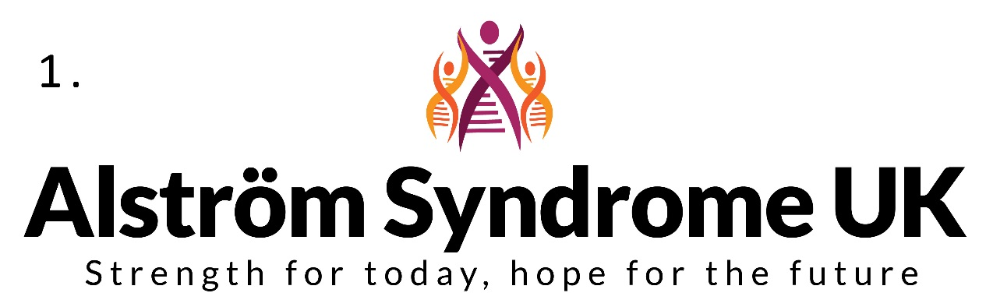
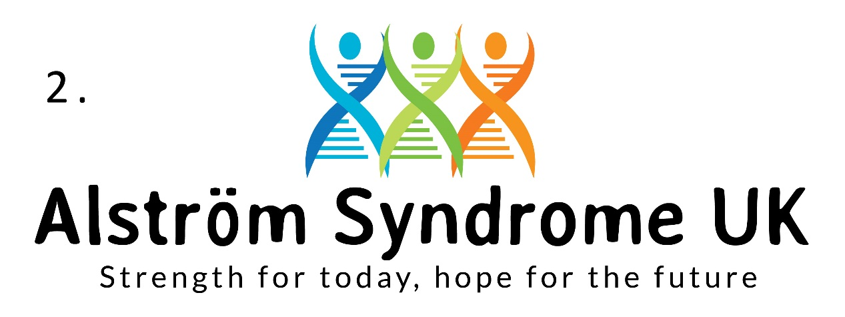
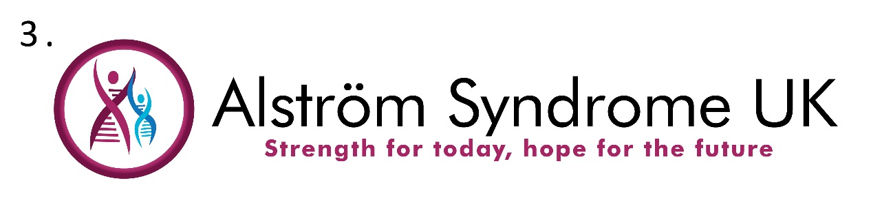
Please find a comments form within this newsletter for you to comment on your preferred choice of colour, font and style to be developed into a final logo. You can either fill in the form, email or post back to us or tell us directly by phone or email. Contact Catherine Lewis on Catherine.lewis@alstrom.org.uk or telephone 01803 613117 all comments gratefully received by the 10th October 2016 – thank you!
Let’s Get Moving - Fitness Project
Over the past few months, we have been contacting families to see if they would like to be involved in a new research project and Lifestyle Audit. The audit will collect data to look at the difference a healthy lifestyle can have on your overall health and wellbeing. As part of the project families will receive a Fitbit exercise tracker which they will wear on their wrist. The Fitbit gathers information about their exercise habits, heart rate, sleep patterns and even food intake so we can gather information about the benefits of a healthy lifestyle.
Families have also been provided with exercise equipment or gym membership to enable them to actively participate in exercise on a regular basis.
There is still time to be part of this project as the information pack is currently being reviewed by our medical teams at the Queen Elizabeth Hospital and the Birmingham Children’s Hospital, so please contact Catherine Lewis for more information.
Have Fun Exercising this Summer
Exercise has many benefits - it can ease muscle aches and pains, reduce stiffness, and increase flexibility, balance, strength and mobility. It can also help you get fitter, have more energy, lose weight, lift your mood and most importantly, it can be fun. We all deserve to spend time doing something we enjoy!
It doesn’t have to be something you do by yourself, it can be fun with friends and family and a great way to meet new people too.
Alström syndrome makes it especially difficult to maintain a healthy weight so regular exercise is really important.
The name of the game is to try and get your heart beating faster and your lungs working a bit harder for at least 10 minutes at a time. It is recommended for you to build up to doing this for a total of 150 minutes a week. Try breaking this down to 20 or 30 minute sessions every day.
Some ideas to increase your activity this summer;
- Just get walking!
Walking is a great active hobby and a great way to de-stress. You can do it alone or with friends and family, and as slow or fast as you like. For example, instead of choosing to sit on your sofa after a meal, go out and have a walk in your local park. Count your steps – set a target for the number of steps you take each day. There are apps you can add to your phone which work as pedometers or activity trackers such as ‘fitbits’ we are using for the ‘ASUK Lifestyle Audit’ which can monitor your activity.

- Take the stairs
Choosing to take the stairs instead of the lift can help maximise fitness and burn extra calories. You can set a daily target for the ‘number of floors climbed’.

- Take the challenge of ‘Coach to 5K’
Try downloading ‘Couch to 5K’ from NHS choices, a nine-week series of podcasts, designed to help get you off the coach running 5km in just nine weeks! http://www.nhs.uk/livewell/c25k/Pages/couch-to-5k.aspx

- Going to the gym
It may not be everyone’s cup of tea but gym equipment allows you to do both aerobic and strength exercises within your exercise programme. Specially trained, qualified instructors can help give you the right support. Some gyms can also offer weekly group exercise sessions. You can find your nearest adaptive gym on the EFDS (English federation of Disability Sport) website (http://www.efds.co.uk/inclusive_fitness/ifi_gyms)

- Splash out!
Swimming is a great way to be more active, because the water can support your body as well as giving extra resistance to work against. It is especially good for keeping your muscles in your arms, shoulders, chest and back strong, as well as developing stamina. Whether it is a splash about with the family or swimming lengths it is a fun way to get active.

- Bowling
Release your competitive side! Activity doesn’t have to feel like a workout - a regular trip to the bowling alley with friends or family is a great way of getting up and about to build more exercise into your life.

- Get on your bike!
According to many enthusiastic participants tandem cycling can be highly social, immense fun, good exercise – and very fast!
If anyone would like support or guidance with getting started with something new or support accessing local health and fitness initiatives, please contact Nicky Condon, Senior Physiotherapist at QEH her email address is Nicola.condon@uhb.nhs.uk
Happy exercising!

T- KASH Knowledge and Skills in Healthcare
Our National Transition Coordinator, Marie McGee has been working with young people to discuss how they can better manage their health and care throughout all stages of growing up.
Young people who attend the AS multi-disciplinary clinics at Birmingham Children’s Hospital had highlighted gaps in their knowledge and skills to manage their healthcare. Over a 10 month consultation period through home visits, clinic discussions and telephone conversations young people were able to develop a range of posters and symbols which:
- Draw attention to the knowledge and skills young people should be developing to manage their healthcare, while having the best life possible
- Prepare young people/families for identifying and coping with change at key points in their lives
- Support young people to plan for their future
The resources were launched in February at the University of Birmingham, during the British Paediatric Surveillance Unit (BPSU) Rare Disease Day Conference 2016. At the event, these inspirational young people were able to present at a panel discussion about the importance of these resources.
The resources can be used by any clinical speciality and are free to any health, education or charity group who would like to use them to inform their staff/families about what young people want to say. There are Braille copies to accompany the resources so they can have lots of uses. So far the resources have been sent to health professionals in USA, Australia, Canada and Europe. Along with a multitude of organisations in the UK, including rehabilitation specialist, cleft palate team, rheumatologists, researchers and renal teams.

ASUK Transition Coordinator Marie McGee has led on this project and she gives her thoughts ‘The impact this project has had is amazing. Our young people have created some brilliant transition resources; All the young people worked so hard and together they can see the difference that can be achieved!’ Organisations who attended the event also give their views:
‘Wonderful project and initiative. Youth voice always matters.’ CYP Team at RCPCH
‘Resources are fantastic a really excellent holistic approach.’ Dr. Larissa Kerecuk, Rare Disease Lead, Birmingham Children’s Hospital
Getting to Know You
In March 2016, families enjoyed a ‘Getting to Know You’ weekend at Whitemore Lakes, Staffordshire funded by Children in Need. The purpose of the weekend was for families to get to know each other, try out new activities and above all have fun! Abseiling, Zip Wiring, Archery, Problem Solving, Art and High Ropes were just some of the activities that families enjoyed. Although the weather was a little cold, everyone threw themselves into the activities which also included a campfire with popcorn, toasted marshmallows, singing silly songs and big dollops of fun! Parents and carers also enjoyed ‘Dads Yoga’ and Jewellery making. The games proved to be very popular, with the adults enjoying them so much that they had to extend the session for an extra hour!
The weekend also included feedback from ASUK Trustees: (Kez and Julie about what ASUK has been doing) a consultation about further events and a talk from Anne Cheesbrough, SENSE Representative.
Here are some of the comments from families who attended, ‘I enjoyed the zip wire and archery and how everyone was included in the activities.’ 14 year old, female. ‘The activities were fun for both the young people and adults. I enjoyed the social aspect of being with everybody as a group.’ Dad.
The Children in Need funding has helped create activities and opportunities which families and children can enjoy together. ASUK will continue to consult, organise and offer some unique activities for all to enjoy.
What’s next?
The Transition project is now in its second year. We are planning specialised driving lessons, bowling, visit to University Hospital Birmingham to prepare young people for their eventual transfer to adult care and a water sports weekend. If you would like to know more please get in touch with Marie, her email address is marie.mcgee@alstrom.org.uk
Breaking down Barriers - Project
In 2008, ASUK began working within Asian communities to raise awareness of the condition and to support families to develop a greater understanding of the complex nature of Alström Syndrome. Through this work we realised there was a need for further support and we applied for funding to enable ASUK to develop this work further. In 2011, The Sylvia Adams Charitable Trust contributed funding towards Alström Syndrome UK’s (ASUK) Asian Mentoring Scheme (AMS). This was a three-year project aimed at developing further understanding of the needs of South Asian families; raising awareness, increasing referrals and providing access to our specialist centres in Birmingham.
Statistics have shown that there is an increased risk of a child being born with a genetic condition within families where consanguineous marriages are common*. This was explored further within the AMS and despite the fact that we were aware of how rare this condition is, it was considered that there may be individuals and families within the UK who had not been diagnosed. It was also felt that some families appeared reluctant to contact support groups and engage with professionals as they were often very well supported within their own families and communities. In addition to this, families often turn to seek support from religious leaders, leading to spiritual support from their practicing religion. However, this prevented children and adults having access to specialist health care, advice and support.
This project enabled us to identify new families and provide access to medical care at the specialised multi-disciplinary clinic in Birmingham. We worked with the whole family to ensure everyone was aware of the risks of having further children with the condition so that they were able to make informed choices and to support families to learn more about Alström Syndrome (AS) to enable them to effectively manage the condition.
We worked within South Asian communities to develop a greater understanding of diversity, culture and beliefs, the barriers and challenges experienced and to raise awareness of Alström Syndrome. Changes were made to the services we provide and we now offer a diverse and inclusive service to all families involved. Information is provided in an accessible format, ensuring that families receive the information they need about their condition and the reproductive options available to them. As consanguineous marriages can be more common amongst some South Asian families, this information can benefit entire families.
The project was a great success and ASUK initially received an increase in referrals from South Asian families due to our awareness raising campaign. Families became more aware of genetics and made informed choices about the options available to them and other extended family members.
You will see from the graph below that the number of South Asian families diagnosed with AS increased significantly throughout the duration of the AMS and the Sylvia Adam’s Charitable Trust has now committed to invest additional funds to widen the benefits of this project to other organisations. Kerry Leeson-Beevers who was involved in the design of the AMS and managed the project, will now lead a new and exciting project called Breaking down Barriers.
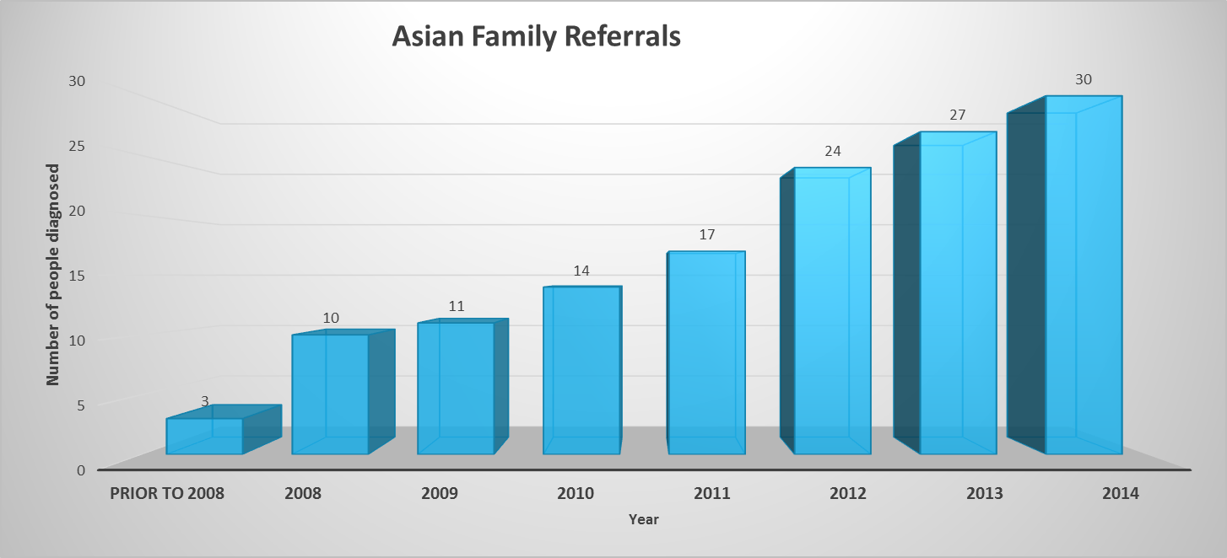
The aim of the project
Breaking down Barriers is aimed at facilitating patient organisations and support groups to join together and share examples of good practice. Then developing new guidelines to highlight effective ways to support families who are at increased risk of having children with a genetic condition but who are unlikely or unable to access mainstream services. We will not only focus on South Asian families, although the information we gathered throughout the AMS may be useful to other organisations and will aid our understanding as we begin to work within different communities.
We believe that patient organisations and support groups are best placed to develop the skills needed to engage with families, particularly as these support groups are generally the ones who have a greater understanding of the impact of living with a genetic condition.
Why is this project necessary?
There are projects and services around the UK focusing on working with families from diverse backgrounds, however these services can be patchy and they often fail to effectively communicate the impact of inherited conditions, leaving families feeling confused*. These are often being driven by health professionals and while they may be benefiting small groups of people in specific locations, there is a clear need for a national project to benefit larger numbers of people and communities and to develop new policies and practices. We believe the success of the AMS was due to the fact that it was being delivered by people who were directly affected by the condition, ‘Experts by experience’, and therefore were able to demonstrate empathy and understanding due to their own experience of living and coping with AS.
We would like to expand this work further and include families from a range of diverse communities. Genetics is a complicated topic to understand and this project aims to identify the information and support available and will examine reasons as to why some families may not engage with health providers. Our primary aim is to provide families with the information they need about the reproductive choices available to them to enable them to make informed choices about future pregnancies and to raise important awareness of genetics.
Discussions regarding the project with patient organisations, support groups and umbrella organisations such as Genetic Alliance UK have been positive and there is an awareness of the need to improve accessibility to services for some minority communities and increase knowledge around genetics. We are confident that the enthusiasm that has already been demonstrated towards this project will help us to achieve our aims and will provide crucial benefit to families living with genetic conditions.
How will the project be delivered?
Kerry Leeson-Beevers is supported by an Advisory Panel of Experts who bring a wealth of knowledge and experience to the project:
Name | Job Title | Place of Work | Location
Shamshad Hanif | Patient Representative | Specific area of expertise – Sanfilippo Syndrome | Bradford
Dr Peter Corry | Retired Paediatrician and current CCG member | Bradford Clinical Commissioning Group | Bradford
Dr Aamra Darr | Director & Senior Research Fellow | Genetics Communication Diversity & University of Bradford | Bradford
Dr Denise Williams | Consultant Clinical Geneticist | Birmingham Women’s Hospital | Birmingham
Amy Simpson | Research Associate | Genetic Alliance UK | London
Jane Young | Director | The Sylvia Adams Charitable Trust | Hatfield

Earlier this year we invited patient organisations and support groups who provide support to families living with a genetic condition to apply to be involved in this project. The Advisory Group selected eight organisations to take part in this three-year project.
- AKU Society (Alkaptunuria Society)
- BBS UK (Bardet Biedl Syndrome UK)
- EDS UK (Ehlers-Danlos Support UK)
- ED Society (Ectodermal Dysplasia Society)
- HDA (Huntington’s Disease Association)
- Jnetics (Jewish Genetic Conditions)
- SC Society (Sickle Cell Society)
- SWAN UK (Syndromes without a Name UK)
We will work closely with each organisation examining their current practices and highlighting any barriers they feel are in place. We will be arranging workshops to share examples of good practice, inviting speakers to develop our shared understanding and working together to develop each individual organisation. Kerry and the Advisory Panel will be available to offer advice and support throughout the duration of the project and will regularly share information and link to additional resources that may be useful.
Collectively, we will develop good practice guidelines which will be disseminated to a wide variety of people working within this field.
The first workshop was held on the 18th July in London with representatives from each of the organisations taking part. Feedback from the event was extremely positive and there was a great deal of enthusiasm within the room. One workshop delegate said “Really well run and informative. Sparked a fire to push more to help more people!” It is evident that each organisation wants to do their very best to ensure they are providing good quality and accessible services to all of the individuals and families they support. We have started to identify the current barriers that exist which may be preventing people from accessing services and are beginning to explore possible solutions. Following on from this workshop, each organisation will now submit an action plan stating how they plan to develop their work and once these have been assessed by the Advisory Panel, the Sylvia Adams Charitable Trust will award funding to support their work.
We look forward to seeing how this important project develops!
ASUK would like to thank the Sylvia Adams Charitable Trust for their continued support. They are not only financially supporting the project, they are working closely with ASUK to monitor progress and plan ahead to ensure it is a great success.
Please contact Kerry if you would like any further information about this project.
*Reference sourced from http://link.springer.com/article/10.1007/s12687-015-0252-2
Darr, A., Small, N., Ahmad, W.I.U. et al. J Community Genet (2016) 7: 65. doi:10.1007/s12687-015-0252-2
Awareness Raising
We are seeking to improve awareness of ASUK, and network with our current and potential partners in a number of ways in order to help all our families and members. In recent months this has been happening both in the UK and in Europe.

On the 7th January ASUK National Development Manager, Kerry Leeson-Beevers had the opportunity to have an ASUK information stand at the Cardiovascular Information Day in Liverpool. This proved to be a useful awareness raising opportunity as many medical professionals who were there had never heard of Alström Syndrome.
On the 19th January 2016 Kerry attended the Rare Disease UK Annual General Meeting. The focus of the meeting was rare disease research and they launched their new report looking at how public and major funding bodies support research into rare diseases. You can find out more via their website http://www.raredisease.org.uk/agm2013.htm
On the 29th January Kerry attended the Findacure workshop 'Navigating the Highly Specialised Technologies Programme' at the National Council for Voluntary Organisations. She also attended a focus group meeting at the event which discussed clinical trials and repurposed drugs for rare diseases. You can find out more about the work of Findacure via their website http://www.findacure.org.uk/
On the 19th February 2016, Iram and Marie attended the Rare Disease Day Event at the Think Tank Museum in Birmingham, raising awareness through an ASUK information stand.
As part of the Rare Disease Day events, Birmingham Children's Hospital raised awareness of rare conditions from the 22nd - 29th February 2016. On the 27th February, ASUK were invited to have an information stand at the Hospital and we were very proud to be part of this event for another year (Marie, raising awareness pictured right).
On the 23rd February ASUK Family Support Manager, Iram attended the Rare Diseases in Paediatrics event in Birmingham.
On the 29th February ASUK Chair, Michelle Hough attended the Findacure Scientific Conference 2016 in London. The conference focused on Drug Repurposing for Rare Diseases, and seeking to create a forum that brings together patient groups, clinicians, researchers, biotech companies, and the pharmaceutical industry to discuss the role that drug repurposing can play in the future of rare disease treatment.
On the 3rd March ASUK Office Manager, Catherine Lewis attended the International Rare Diseases Research Consortium (IRDiRC), Small Population Clinical Trials Task Force meetings at the European Medicines Agency in London. The goal of this Task Force is to advance discussions on ways to optimise and improve commonly adopted approaches and to reach agreement between the different stakeholders on appropriate small population studies. ASUK is ensuring patients voices and needs are heard at every stage of this process. You can find out more about this work and the report via their website http://www.irdirc.org/activities/current-activities/tf-spct/
On the 10th March Iram attended the Kidz to Adult in the Middle event in Coventry.
This free exhibition event is dedicated to children and young adults with disabilities and special needs, their families and the professionals who work with them. The event also included many information sessions and seminars.
You can find out more via their website http://www.disabledliving.co.uk/kidz/middle
In March Marie attended the Genetic Disorders UK Leadership Symposium. This event enabled charities to come together to learn from each other's experiences, share knowledge and hear from interesting speakers about a full range of important topics. Many topics this year focused on ‘transition’ so Marie's knowledge and experience was useful.
In April Kerry attended the Findacure workshop about 'Sustainable Development for Rare Disease Charities'. You can find out more about the workshop via the link below http://www.findacure.org.uk/category/news/
In April Iram presented ‘Living with a Rare Disease’ at the University of Birmingham. This was part of the MSc Genomic medicine programme. Iram has been providing information for students on this programme about living with a rare condition.
From the 12th – 16th May, ASUK Chair Michelle Hough and Trustee Kez Hayat attended the Alström Syndrome International Conference in Plymouth, Massachusetts, USA. The event was attended by families and professionals from around the world to network and learn more about this rare condition.
On the 27th and 28th May Kerry attended the European Conference on Rare Diseases and Orphan Products (ECRD) in Edinburgh. Kerry was also on one of the panels discussing the 'Clinical Trials of the Future'. The theme this year was 'Game Changers in Rare Diseases Delivering 21st century healthcare to rare disease patients: Together we can change the future!' With 500 organisations in attendance from 48 European Countries this was a fantastic opportunity to come together and exchange experiences, knowledge and connect with members of the rare disease community. Please follow the link to find out more http://www.rare-diseases.eu
On the 8th June Kerry was honoured to be presenting at the EURORDIS Summer School in Barcelona. Sharing together experience and knowledge as she had previously attended as a student herself, so it was a fantastic opportunity to share her own experiences.
In June Kerry attended the Findacure workshop on How Rare Disease Patient Groups Can Work with Researchers. This was an interesting event to look at ways we can develop our research further and sharing knowledge and ideas together to learn from each other’s experiences.
Guess who met Tony Hadley!!
On the 28th June Kerry was delighted to attend an evening reception at Downing Street with Samantha Cameron to celebrate the 40th Anniversary of RP Fighting Blindness. Kerry gives her thoughts ‘It was inspiring to see the research developments which have been made and the great work which has been achieved over this time.’ Tony Hadley also attended the event and Fiona Copeland from Primary Ciliary Dyskinesia (pictured right) - Great awareness raising!!
You can find out more about RP Fighting Blindness via their website http://www.rpfightingblindness.org

Happy Eid!
What is Ramadan?
Ramadan is the 9th month of the Islamic lunar year and is the month of fasting. Fasting is a duty upon all adults and healthy Muslims. In the UK this year Ramadan took place from 6th June to 6th July. This means that no water or food is to be consumed from sunrise to sunset, this totals to twenty one hours per day without food or drink. People that are ill, those that are travelling, pregnant and breast feeding women may be exempt.
One of the main benefits of Ramadan is an increased awareness of God. It is an opportunity for self-purification and reflection and a renewed focus on spirituality; and for compassion for those in need of the necessities of life. Muslims also appreciate the feeling of togetherness shared by family and friends throughout the month. Perhaps the greatest practical benefit is the yearly lesson in self- restraint and discipline that can carry forward to other aspects of a Muslim’s life such as work and education.
What happens when Ramadan ends?
The end of Ramadan is marked by the festival of Eid-Ul-Fitr, this year Eid took place on 6th July. ASUK would like to wish all our families who celebrated this religious festival a Very Happy ‘Eid Mubarak’.
ASUK Annual General Meeting
We would like to invite you all to our next Annual General Meeting which will take place on the 5th November 2016 in Birmingham (venue to be confirmed). Please keep an eye on our website and social media sites for further information.
Save the Date!
We are delighted to announce that the ASUK Conference 2017 will be taking place on the 6th and 7th October 2017, full details will be confirmed shortly. Please put the date in your diaries as we would love to see you all there! Please contact Catherine Lewis on 01803 613117 or email Catherine.lewis@alstrom.org.uk to register your interest.
THANK YOU to Our Fantastic Fundraisers!
A HUGE THANK YOU to everyone who continues to support our great cause! The numbers of people being diagnosed with Alström Syndrome is increasing so please get in touch if you would like help to arrange a fundraising event; we also have spaces available in the Silverstone Half Marathon and the London Bupa 10,000 run. These funds raised really do make a huge difference and ensure we can support families throughout the year.

Well done to Chris White and his wife (pictured left) who successfully completed the Edinburgh Marathon. Please support inspirational Chris who over the last few months has been completing many events including 6 Tough Mudders and the Edinburgh Marathon all in aid of Alström Syndrome UK. What a Challenge!
Please follow the link to Chris's Just Giving page where you can sponsor him in a safe and secure way to show your support and raise funds for our great cause!
https://www.justgiving.com/fundraising/Chris-White41
Every year, fantastic fundraiser David Lunt (pictured right) runs in the Virgin London Marathon to raise money for a number of charities which includes ASUK.
This year David set himself a real challenge by aiming to complete 8 Marathons in two weeks! his first one being the Marathon des Sable where he ran 7 Marathons in 6 days in temperatures between 30 to 50 degree’s heat!
David completed this challenge and has again raised £1,000 each for the 5 Charities he is running in aid of.
A HUGE THANK YOU to David!

ASUK offer a help-line during office hours and an answer phone service at all other times where calls are promptly returned by our experienced Family Support team;
Please call 01803 613117 / 01709 210151
Kerry Leeson-Beevers
Tel: 01709 210151 / 07716135940
Email: Kerry.leeson@alstrom.org.uk
Catherine Lewis
Tel: 01803 613117 / 07970071675
Email: Catherine.lewis@alstrom.org.uk
Marie McGee
Marie works part-time, normally on a Friday
offering transition support to young people and their families
Tel: 07812 173953
Email: marie.mcgee@alstrom.org.uk
Jane Biglin
Jane works part-time, normally on a Tuesday and Wednesday
offering support to individuals and families who live in the South
Tel: 07714 798413
Email: jane.biglin@alstrom.org.uk
Congratulations to Iram on the birth of her son, we wish her and her family all the very best

Please feel free to contact any member of the team
Registered Office
Our registered address is 31 Shearwater Drive, Torquay, Devon TQ2 7TL
You Tube, Twitter and Facebook
ASUK now have a dedicated You Tube page http://www.youtube.com/alstromsyndromeuk
Please keep up to date with Alström Syndrome UK via twitter @AS_UK and also via our dedicated facebook page www.facebook.com/alstromsyndromeuk , please click ‘like’ to show your support and spread the word!
Please visit our website www.alstrom.org.uk to keep up to date with our latest news.

Registered Charity no 1071196 Registered Company Limited by Guarantee 3557191

