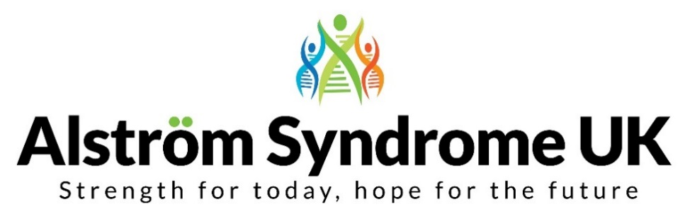
News, Views and Useful Links!
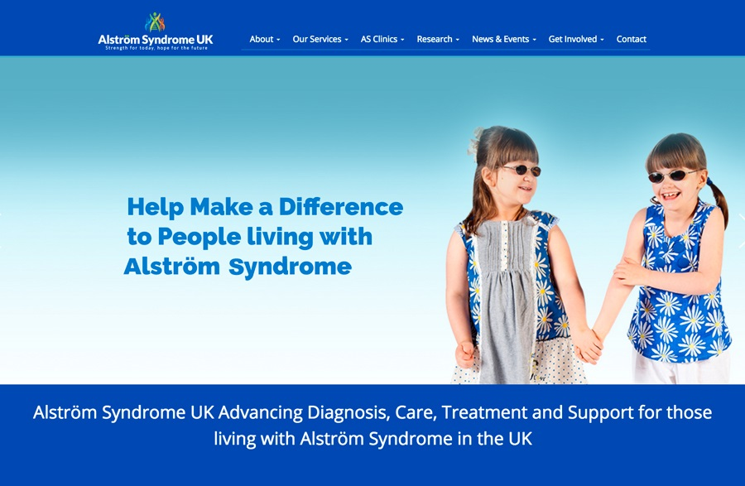
Have you seen our updated website?

We hope our new website will bring the Alström community and professionals together. Our aim is to make it accessible, useful and informative. You will find a wealth of information to learn more about this complex condition. We will be keeping it up to date with evidence based research and practice to improve the lives of those with Alström Syndrome and those who care for them.
Please tell us about your experiences and any topics you would like to see on the website. Feedback is always welcomed.
Charities stand strong together – ‘NO cuts to NHS services!’
Many of you will be aware that we have raised some concerns, alongside other charities about the likelihood of restricting NHS treatments for people facing rare complex diseases. Alongside about 30 other health charities from the Specialised Healthcare Alliance, we voiced our concerns and co-signed a letter addressed to the Prime Minister, Theresa May. This letter detailed the impact that these new measures would have on services. We have, this week received a letter from Theresa May confirming that NHS England will NOT be restricting treatments.
We will be ensuring that patients’ voices are heard and NHS England do what they say now and in the future.
The Prime Ministers response can be found on the ASUK website http://www.alstrom.org.uk/prime-minister-writes-to-asuk/ Please feel free to circulate this letter to your family, friends and supporters.
You can find out more about this campaign via the Guardian newspaper, who have written an article ‘Charities call for NHS to stop rationing critical care’ https://www.theguardian.com/society/2017/feb/18/charities-stop-nhs-rationing-critical-care
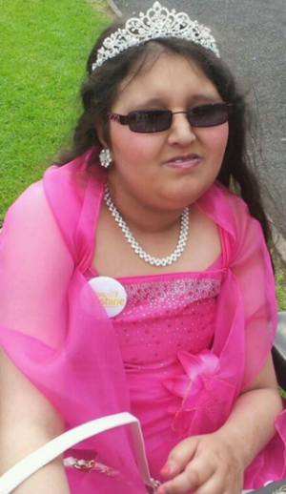
Support this Inspirational Family!
Please support Sue Manzoor whose beautiful niece, Maariyah sadly passed away in December, shortly before her 17th birthday. In Maariyah's memory the family have decided to raise awareness of Alström Syndrome by running in the Great Birmingham 10K run.
A HUGE THANK YOU to the family for supporting Alström Syndrome UK.
Please show your support and visit their Just Giving fundraising page http://www.justgiving.com/princessmaariyah
You Can Do It! – Computer Training
Does the world of computers, the internet and emails fill you with dread? Then a charity called ‘UCanDoIT’ may be able to help. They teach people with disabilities how to use computers and navigate the internet. All sessions are on a one to one basis in your own home. Further information can be found on their website http://www.ucandoit.org.uk/
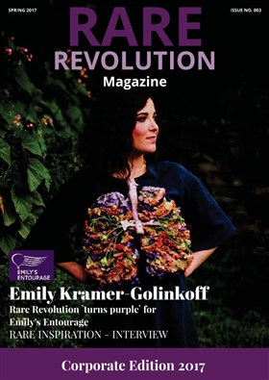
Creative Explorer needed!
Thank you to Rare Revolution magazine who featured ASUK in their corporate responsibility edition of their digital magazine. This enabled charities to ‘pitch’ their ideas to businesses who may have the expertise to help. We advertised for a ‘Creative Explorer’ to bring ideas to life in the form of a digital app to aid diagnosis of Alström Syndrome.
You can follow the link to subscribe to Rare Revolution and receive these quarterly magazines free into your inbox http://www.rarerevolutionmagazine.com/
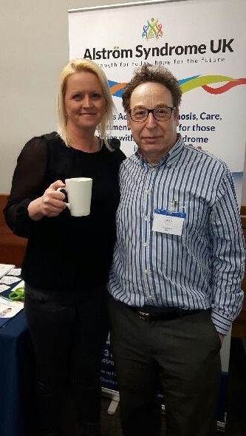
Enjoying a cup of tea at the
Rare Disease Day Tea Party!
ASUK attended the Rare Disease Day, Tea Party on the 30th March 2017 in London.
This was a great opportunity to raise awareness through our new resources and network with organisations from the ‘rare disease community’. ASUK National Development Manager, Kerry Leeson-Beevers is pictured left with Richard Lynn, Scientific Coordinator from British Paediatric Surveillance Unit (BPSU) enjoying a cuppa!
Kerry was also pleased to represent ASUK at the FP7 clinical trials and research workshop, at the European Medicines Agency on the 29th March 2017 in London. The workshop brought together Patient Organisations, Regulators, Researchers and Industry to develop further understanding about small population clinical trials and drug development for rare diseases.

Let’s Talk and Share!
On the 20th March 2017 it was International Day of Happiness! Talking about your worries is important, whether it's with a friend, family member, or ASUK family support team. NHS Choices have brought together six tips to help with life's ups and downs. Have a look! http://www.nhs.uk/Conditions/stress-anxiety-depression/Pages/feel-better-and-happy.aspx

Family Day of FUN!
New College Worcester are holding their Family Day on the 1st May 2017 from 10:00am – 2:30pm. If you have a child with a visual impairment and would like a fun day of activities and look around this specialist college, then come along. Please follow the link to their website to find out more http://www.newcollegeworcester.co.uk/family-day?eventdateid=110
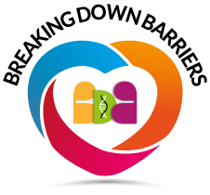
Breaking down Barriers, logo is unveiled!
The Breaking down Barriers project focuses on developing supportive and inclusive services for individuals and families affected by genetic conditions. Providing opportunities for people to learn and talk about genetics to enable them to make informed choices about their future. The advisory board are pleased to launch their new logo and feel it reflects the meaning of this diverse project.
Understanding genetics together in our diverse Britain
Let’s Get Creative!
With Easter just around the corner, why not create some tactile Easter eggs. Have a look on the Paths to Literacy website for ideas http://www.pathstoliteracy.org/strategies/colorful-eggs-tactual-book-beginning-braille-readers~
You could also visit http://www.redtedart.com/ which is a fantastic resource of craft ideas for children, one of my favourites are these cute tissue paper chicks! (pictured right)
There are so many ideas, such as using plastic eggs which can be decorated with tactile foam and jewel stickers to decorate your home ready for Easter.
From everyone at ASUK
we would like to wish you an Eggciting Happy and Healthy Easter!
ASUK would love to hear from you, send us your news, articles or any links that you think others would find useful. Get in touch by email Catherine.lewis@alstrom.org.uk or give me a call on 01803 613117.
Best Wishes
Catherine
From us all at ASUK
Thank you for your support
https://www.justgiving.com/alstromsyndromeuk

Further information can be found at www.alstrom.org.uk

