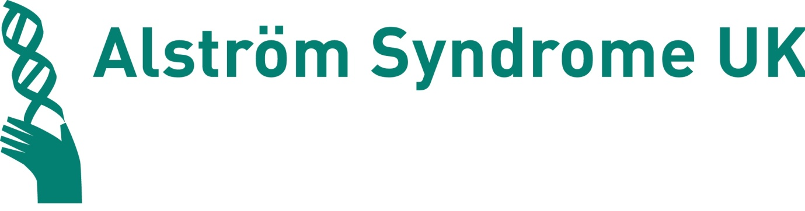

Annual Report and Accounts
For the year ended 31st March 2013



Registered Charity Number 1071196
Registered Company Ltd by Guarantee No 3557191

Alström Syndrome UK
31 Shearwater Drive
Torquay S Devon TQ2 7TL
Tel 01803 613117
email: info@alstrom.org.uk
www.alstrom.org.uk
References and administrative information

Trustees
Michelle Hough (Chair)
Trevor Parkin (Vice Chair)
Mark Millais
Alexander Griffiths Rayson
Kevin Goodwin
Julie Beck
Dawn Mayes
Curtis Vasey
Liz Little

Chief Executive
Kay Parkinson

Registered Office
31 Shearwater Drive, S Devon
TQ2 7TL

Charity Number 1071196
Company Number 3557191

Bankers
Lloyds TSB, Paignton- Branch

Trustees report
Year ended 31st March 2013
The Trustees have pleasure in presenting their report and audited financial statements
for the company for the year ended 31st March 2013.

Alström Syndrome
Alström Syndrome is a very rare inherited condition which affects the body’s metabolism with particular impact on all major organs including the heart, lungs, kidneys and liver. Dilated cardiomyopathy is often detected in young babies and often leads to premature death. Kidney failure may also occur. During childhood, patients suffer deteriorating eyesight which may include nystagmus and photophobia which often leads to blindness. Hearing loss and Type 2 diabetes is also common.

Because the condition unfolds gradually from birth and the different manifestations vary from individual to individual, correct diagnosis is often delayed leading to suboptimal treatment and a failure to anticipate future developments. There are presently just over 850 cases known worldwide, approximately 60 in the UK although the history of poor diagnosis referred to above almost certainly hides many more.

Structure, governance and management
Alström Syndrome UK is a registered charity and company limited by guarantee which formed in 1998 after the founder Mrs Kay Parkinson’s children were diagnosed aged 15 and 18. She was told it was extremely rare and only 12 other patients were then known. Over the past fifteen years the numbers known to the charity have grown to 60 and the charity has developed many services to support them. The major achievement has been the recognition by the NHS National Commissioning team, of the excellence of the multi-disciplinary clinics which have been set up by the charity in conjunction with Birmingham children’s hospital and the Queen Elizabeth Hospital, Birmingham for adults. These clinics are the first in the world for this condition.

New Trustees are appointed by the existing Trustees and serve for three years after which they may put themselves forward for re-appointment. A minimum of three Trustees must be present at each meeting for decisions to be made.

At the quarterly, Trustees meetings the board agree the broad strategy and areas of activity for the charity, which have taken account of families and patients views and opinions which are always sought at the Annual Family Conference. The day to day running of the charity is delegated to the Chief Executive.

The Trustees are assisted from time to time with input from Professor Timothy Barrett clinical lead for the Alström’s children clinic at Birmingham children’s hospital and Dr Tarek Hiwot adult clinical lead at the Queen Elizabeth Hospital, Birmingham and Trustees would like to formally express their gratitude for their dedication to Alström patients. The Alström Syndrome multi-disciplinary clinics have now moved successfully across to the QEH from Torbay Hospital and are making significant progress in treatments, diagnosis and pioneering research.

Trustees all undergo child protection training before joining the Board. New Trustees are given a copy of the memorandum and articles of association and copies of the Charity Commission guidance “The Essential Trustee: What you need to know” and Charities and Public Benefit”

Trustees give of their time freely and are required to disclose all relevant interests and register them with the Chief Executive and in accordance with the charities policy withdraw from decisions where a conflict of interest arises.

Sadly Kevin Goodwin, one of our Trustees and a very active member of ASUK passed away in March 2013. Despite having Alström Syndrome and the challenges this inevitably brings, Kevin worked tirelessly to ensure people affected by Alström Syndrome had hope and a better future.

Funding Structure
The charity has a service level agreement with the National Commissioning Group to provide national co-ordination of the multi-disciplinary clinics and family support. ASUK organises families’ accommodation and helps with travel arrangements. We also agree to maintain the web site with the latest medical information and circulate clinic dates. ASUK also agree to provide medical information in the newsletter. The charity reports monthly to the NCG about these activities.

BBC Children in Need funded a full-time Child Development post until December 2012.
Grants have been obtained to fund the Asian Mentoring Scheme and support Transition.
All monies raised by families go into a separate account and is used solely for their use.
From January 2011, ASUK received funding from the EU as a partner in an EU WABB (Wolfram, Alström and Bardet Biedl) project.

Objects of the Charity and activities for the public benefit
The objects of the charity are governed by the company’s memorandum and articles of association, Trustees have referred to the general guidance on public benefit when reviewing the charities objectives which are as follows:

a) The relief of sickness of persons with Alström Syndrome, in particular but not exclusively by the provision of support, advice and information for such persons as their families, carers and those working with affected individuals.
b) The promotion of research into Alström Syndrome and related syndromes, both in the UK and abroad, and the public dissemination of the useful results thereof.
Over the year Alström Syndrome UK has worked towards its charitable objectives in the following ways:

- Providing advice and support to those affected by Alström Syndrome and /or their families to help them access the disability benefits to which they are entitled
- offering an individual advocacy service through home visits ,face to face meetings, support at multi-agency meetings, in writing, by telephone or e-mail in areas of special educational need, independent living and care needs
- arranging activity holidays
- organising a National Conference
- organising a medical and scientific conference
- providing grants in cases of hardship
- funding research

Alström Syndrome Clinics
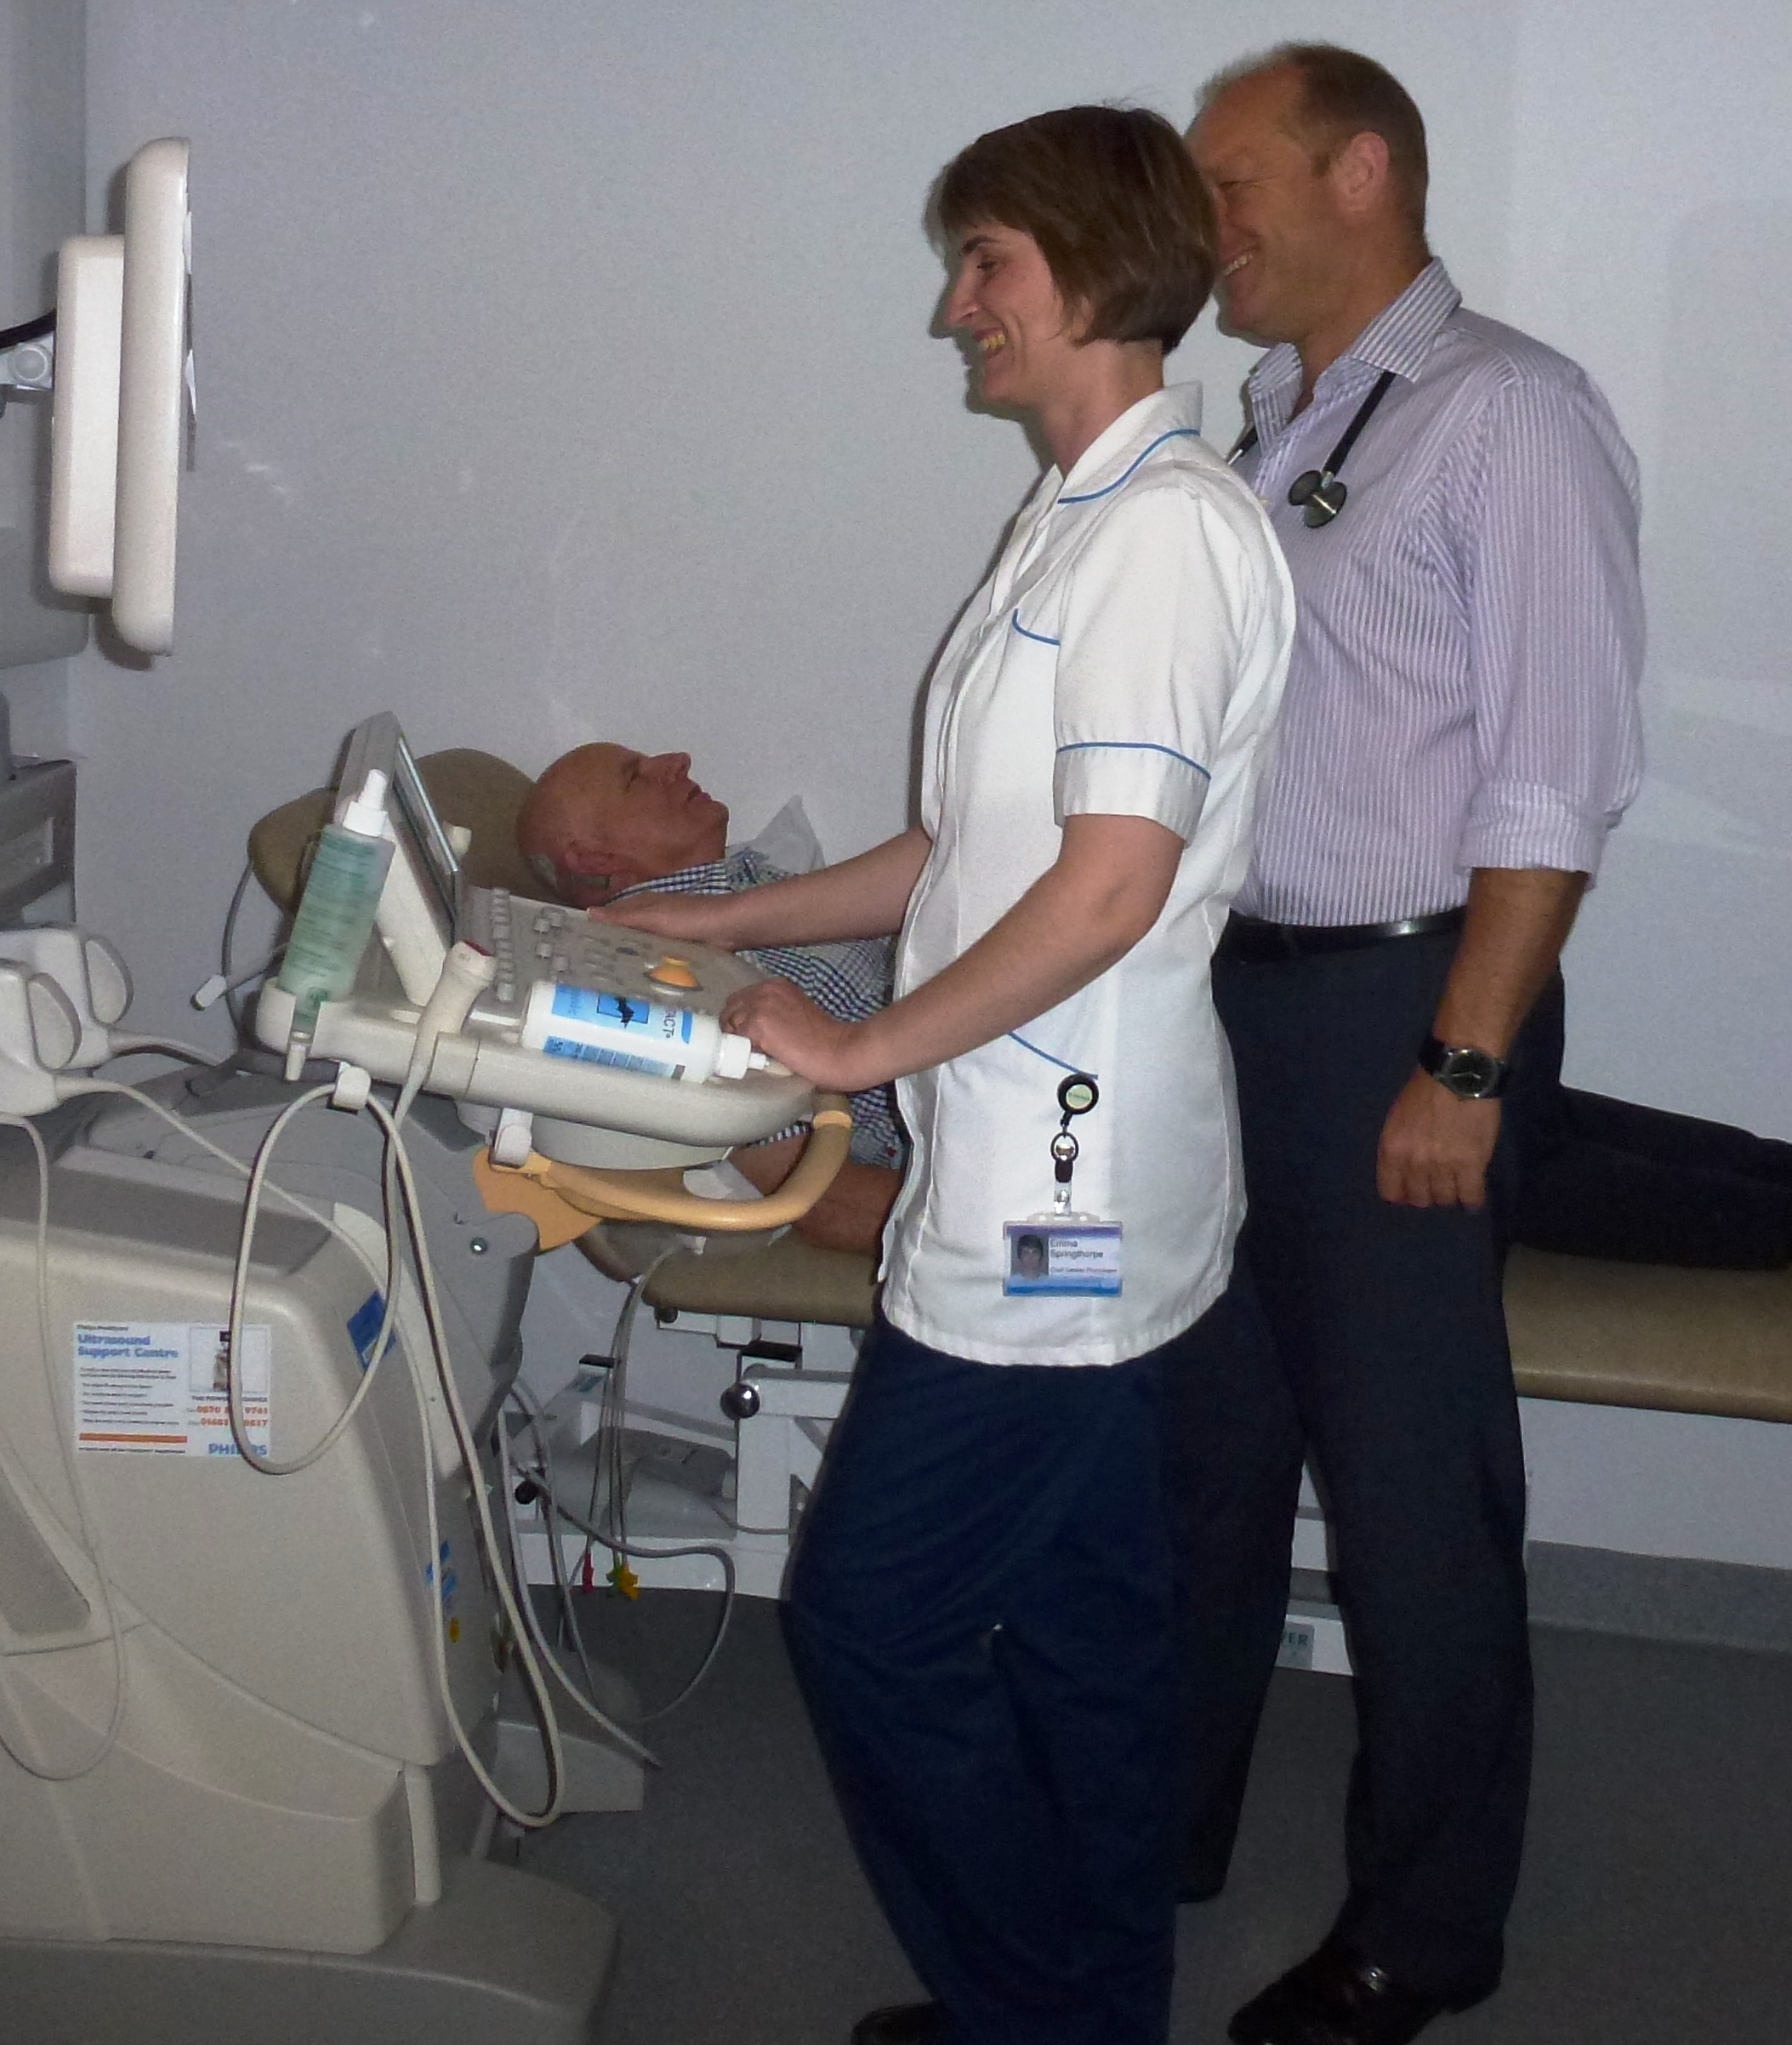

Until 2006, the Alström Syndrome condition was managed on a voluntary basis usually alongside the annual family conference by doctors who were willing to give their time freely to help patients. In 2006 Birmingham Children’s Hospital and Torbay Hospital received funding from the National Specialised Advisory Service which is now named NHS England. This designation changed overnight the provision of services to Alström patients from ad hoc clinics to well organised multi-disciplinary clinics which are held quarterly. Alström Syndrome UK charity was funded as an equal partner in the service in 2008.

In 2012, the adult clinics moved successfully to the Queen Elizabeth Hospital, Birmingham from Torbay Hospital. The Trustees would like to express their thanks to all the professionals involved at Torbay Hospital in making this transfer a success.

Chair’s Report on Trustees Activities 2013
Michelle Hough

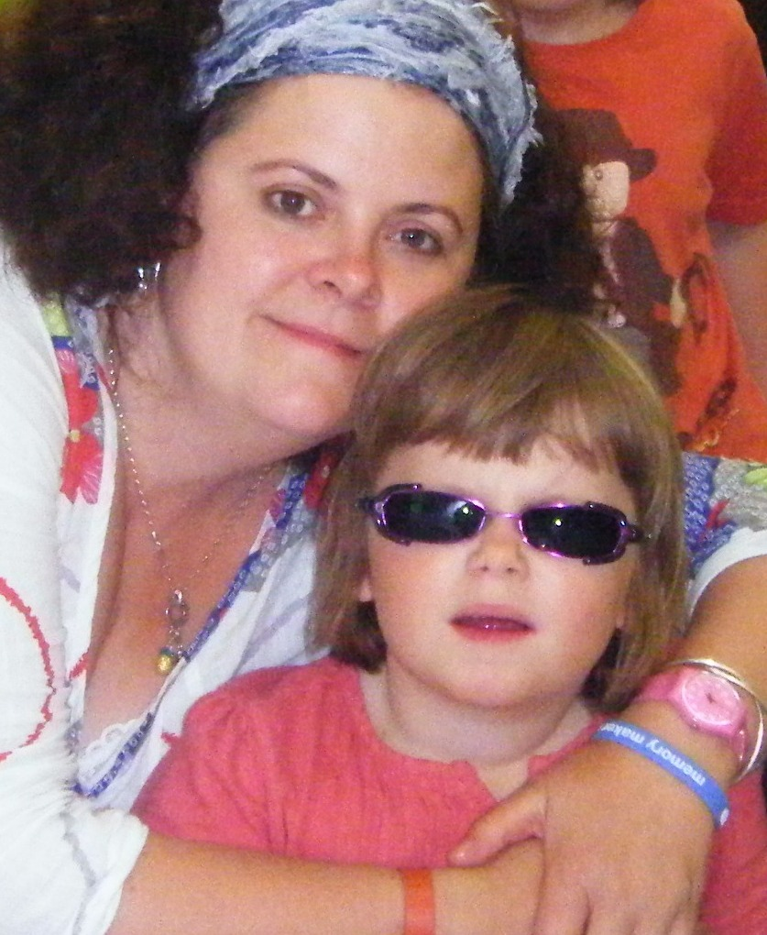
The past year has been filled with exciting research developments which have enabled me for the first time, as a Mother of a child affected by Alström Syndrome to envisage remarkable treatments and a positive future for all people suffering with this condition. One of the major highlights this year was gaining the EURORDIS Patient Organisation Award 2013. This is in recognition of all the hard work which ASUK have achieved for patients and their families across Europe.

Alström Europe launched by ASUK Chief Executive, Kay Parkinson has gone from strength to strength and has brought together expertise and support groups throughout Europe under a new co-operative venture. This will hopefully lead to further research projects and awareness raising throughout Europe.

The Big Lottery research project has enabled ASUK to progress the research into this ultra rare condition in partnership with South Devon Healthcare NHS Trust, Birmingham Children’s Hospital NHS Trust, Cambridge University and Queen Elizabeth Hospital, in the long term this project will enable a greater understanding of the condition.

It is an honour to now be in a position to ensure that families like ours are full supported, and to be able to work together with the families, medical professionals and researchers to push for treatments for the wide range of conditions that Alström Syndrome presents.

Alström Syndrome UK is still a life limiting condition, presenting with a wide range of devastating symptoms. The specialised clinics ASUK initiated and deliver in partnership with the Hospitals have proved their effectiveness showing an increase in life expectancy for those diagnosed; we still however have a long way to go to ensure everyone affected in the UK is diagnosed.

Alström Syndrome UK continues to grow due to the passion and personal dedication of our team, as a patient led charity we continue to have the patients at the forefront of our thoughts.

Special Needs Home Conversion
Mark Millais is exploring and learning more about how to best adapt homes for those living with Alström Syndrome. He is researching courses to attend which would further his knowledge.

Young Adult Activity Breaks
Alex Griffiths-Rayson has assumed the role of organizing activities and building supportive relationships for the Young Adult patient group.

Website development
The ASUK website is undergoing a full re-vamp, carried out by external contractors. The content and style of the new site has been under the control of the Board. Kevin Goodwin has been in day-to-day contact with the developers to ensure the content is accessible for those with dual sensory. Kevin sadly passed away in March 2013, Kevin’s resilience, determination and hard work for ASUK will never be forgotten and he will be truly missed by everyone who had the pleasure to know him.

A time for Change and Growth
Kay Parkinson
Founder and Director, Alström Syndrome UK and Alström Syndrome Europe
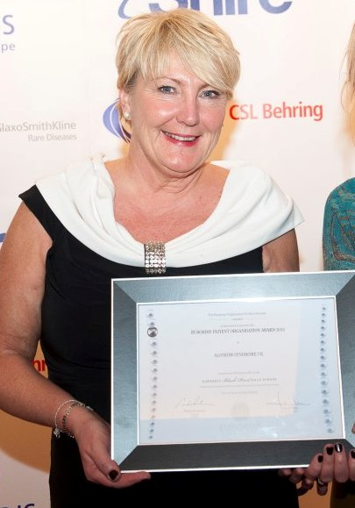

The last year saw many changes here at ASUK, some thrust upon us and others planned. Increasingly for our small charity barriers created, bureaucratically, financially or managerially which prevent our progress have taken up much of our time.
We have faced these challenges as always “head on” and have emerged at the end of the year with a more dynamic management structure and vibrant and engaged trustee board as well as new partnerships formed in the UK and across the EU.

Moving into the area of larger grants has been a huge learning curve for ASUK and the experiences gained through managing and delivering the Big Lottery medical and scientific grant will hold us in good stead for the future. Although this grant did not turn out entirely as we would have liked, progress will be made in 2014 into turning it into what our families envisaged as well as plans for links with EU and International databases. The skin samples are already being requested by pharmaceuticals who wish to develop new drugs for the treatment of Alström Syndrome.

Stepping down as CEO gave me much more time to develop EU links and it is with this in mind that John and I have travelled extensively across Europe raising awareness of Alström Syndrome and developing face to face working with pharmaceutical companies as well as doctors interested in Alström Syndrome. We are sure that benefits from this work will be seen in the next report. We are grateful for the support of Queen Elizabeth Hospital and the Children’s Hospital Birmingham as well as NHS England Commissioners in our efforts to further develop the clinical service.

A great honour and recognition for our work was given by EURORDIS who voted Alström Syndrome UK their Patient Organisation of the Year for 2013 for outstanding services for Alström patients. Increasingly our role is taken up through networking and delivering talks across the EU. It will only be through these networks that we will gain the patient numbers to develop clinical trials for new drugs which could prove life-saving for our patients.

So, 2012-13 became the year that AS UK made huge in- roads into the EU, developed further the role of the emerging AS EU through collaborations on two large Horizon 2020 grants which will be submitted in 2014. Recognised the need for developing highly educated contractors to help continue to deliver our vision and re-organised and developed a dynamic trustee board who have been re-structuring our world-class service to meet the needs and demands of 2014.

I am confident we go forward stronger and better equipped and would like to personally thank those who helped us reach this point, in particular Julia Scott who has built up a strong support network from small and medium sized grant making trusts.

My role now is primarily to develop EU and International links as well as supporting our new Board of Trustees; I am as always available to talk with anyone on any issue.

Kerry Leeson-Beevers
Alström Syndrome UK, Development Manager Report

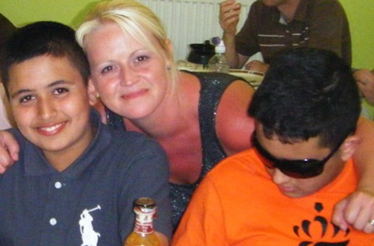

2012 – 2013 has been a very busy and successful year; however, we have also experienced great sadness after the loss of three of our members. We continue to provide support to their families and despite the fact they have passed away, they are still very much a part of our charity and will always remain in our hearts.

I continue to thoroughly enjoy my role within ASUK and I am extremely proud of our achievements this year. The Asian Mentoring Scheme continues to be a great success and again we have seen an increase in numbers. Seven new members have joined ASUK this year and 6 of those are Asian children and young people.

We hope that our interventions will aid quicker diagnosis, so patients have the opportunity to attend our specialized multi-disciplinary clinics. We have already seen a decrease in the average age of diagnosis, this is encouraging and we do hope that our effort in raising awareness is making an impact.

We all continue to try and find new and effective ways to raise awareness of the condition. I have attended numerous events, delivered presentations, made radio appeals, appeared on sky TV, made links within various communities and professional bodies and had articles published in magazines, newsletters and on websites. We do hope that our efforts in this area will help identify any new patients and alert people to the symptoms of Alström Syndrome.

I continue to liaise with health, education and social care to support families in their local area and I attend numerous education and social care review meetings.

I also work closely with Birmingham Children’s Hospital and attend all children’s clinics to support families. Professor Barrett now invites me to all post clinic meetings to evaluate the service and discuss any areas for improvement and issues affecting our families. I also liaise between Birmingham and local teams when any health issues arise.

I have been working with Professor Barrett (BCH Clinic Lead), Dr. Hiwot (QEH Clinic Lead) and Marie McGee (BCH Transition Coordinator) to develop transition and we now have a transition pathway in place and documents to support young people and their families.

Thanks to the efforts of Julia Scott, we have continued to receive funding for the Asian Mentoring Scheme and together we have worked hard on building positive relationships with our funders and report to them on a regular basis. I made an application to Jeans for Genes for funding to produce a DVD entitled ‘Living with Alström Syndrome’, this was successful and the DVD will be ready by the end of 2013.

I have recently become a member of the Council for Disabled Children and I continue to represent EURORDIS on the Paediatric Committee at the European Medicines Agency.
I have attended numerous conferences and events to further increase my knowledge of relevant issues, policies and changes in legislation that affect families and we have also organized outings and events for families and have visited theme parks, attractions and pantomimes.

In February 2013, I was promoted to Acting Chief Executive Officer and I look forward to the challenges this new role entails.

As always, the most enjoyable part of my work is the direct involvement I have with children, young people, adults and their families.

Catherine Lewis MInstF
Alström Syndrome UK, Child Development Officer until Dec 2012
Administrator and Event Coordinator Dec 2012 onwards

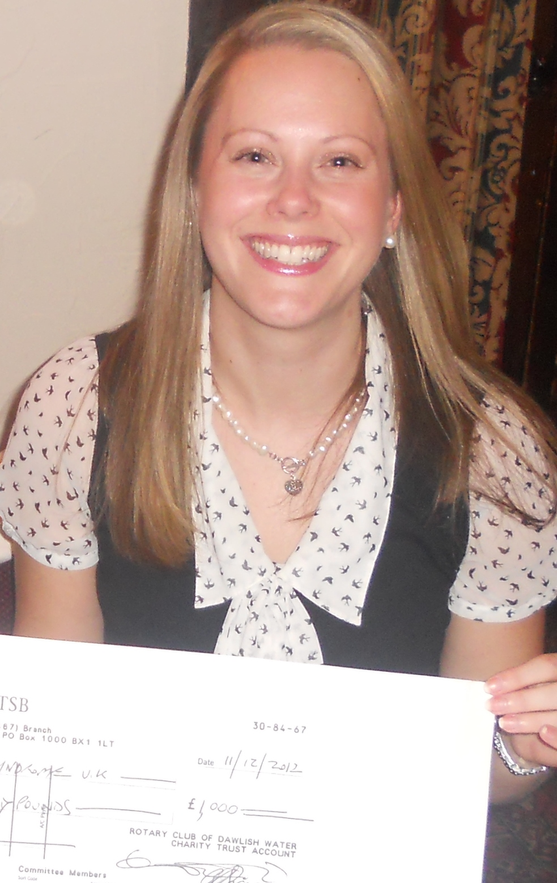

The Child Development role concluded in December 2012 and has been funded for three years through a grant provided by Children in Need. This has been a very rewarding role that has enabled me to build relationships and support families throughout the UK.

It is always a privilege to support families who are affected by Alström Syndrome, although this at times can be very challenging when battling Social Services or Local Authorities for funding which families are entitled to. Families really appreciate the support this role offers in times when they feel isolated with the complexities of the benefits and funding systems.

It has also been a pleasure to support families through a variety of activity breaks which have enabled youngsters affected by Alström Syndrome to experience an exciting range of activities, providing fun, relaxation and confidence building. These breaks have included the Calvert Trust adventure break on Exmoor, Harry Potter Studio Tour, Snoezelen Sensory work shop, Drayton Manor Theme park trip, Tenacious Sailing Adventure and many more.

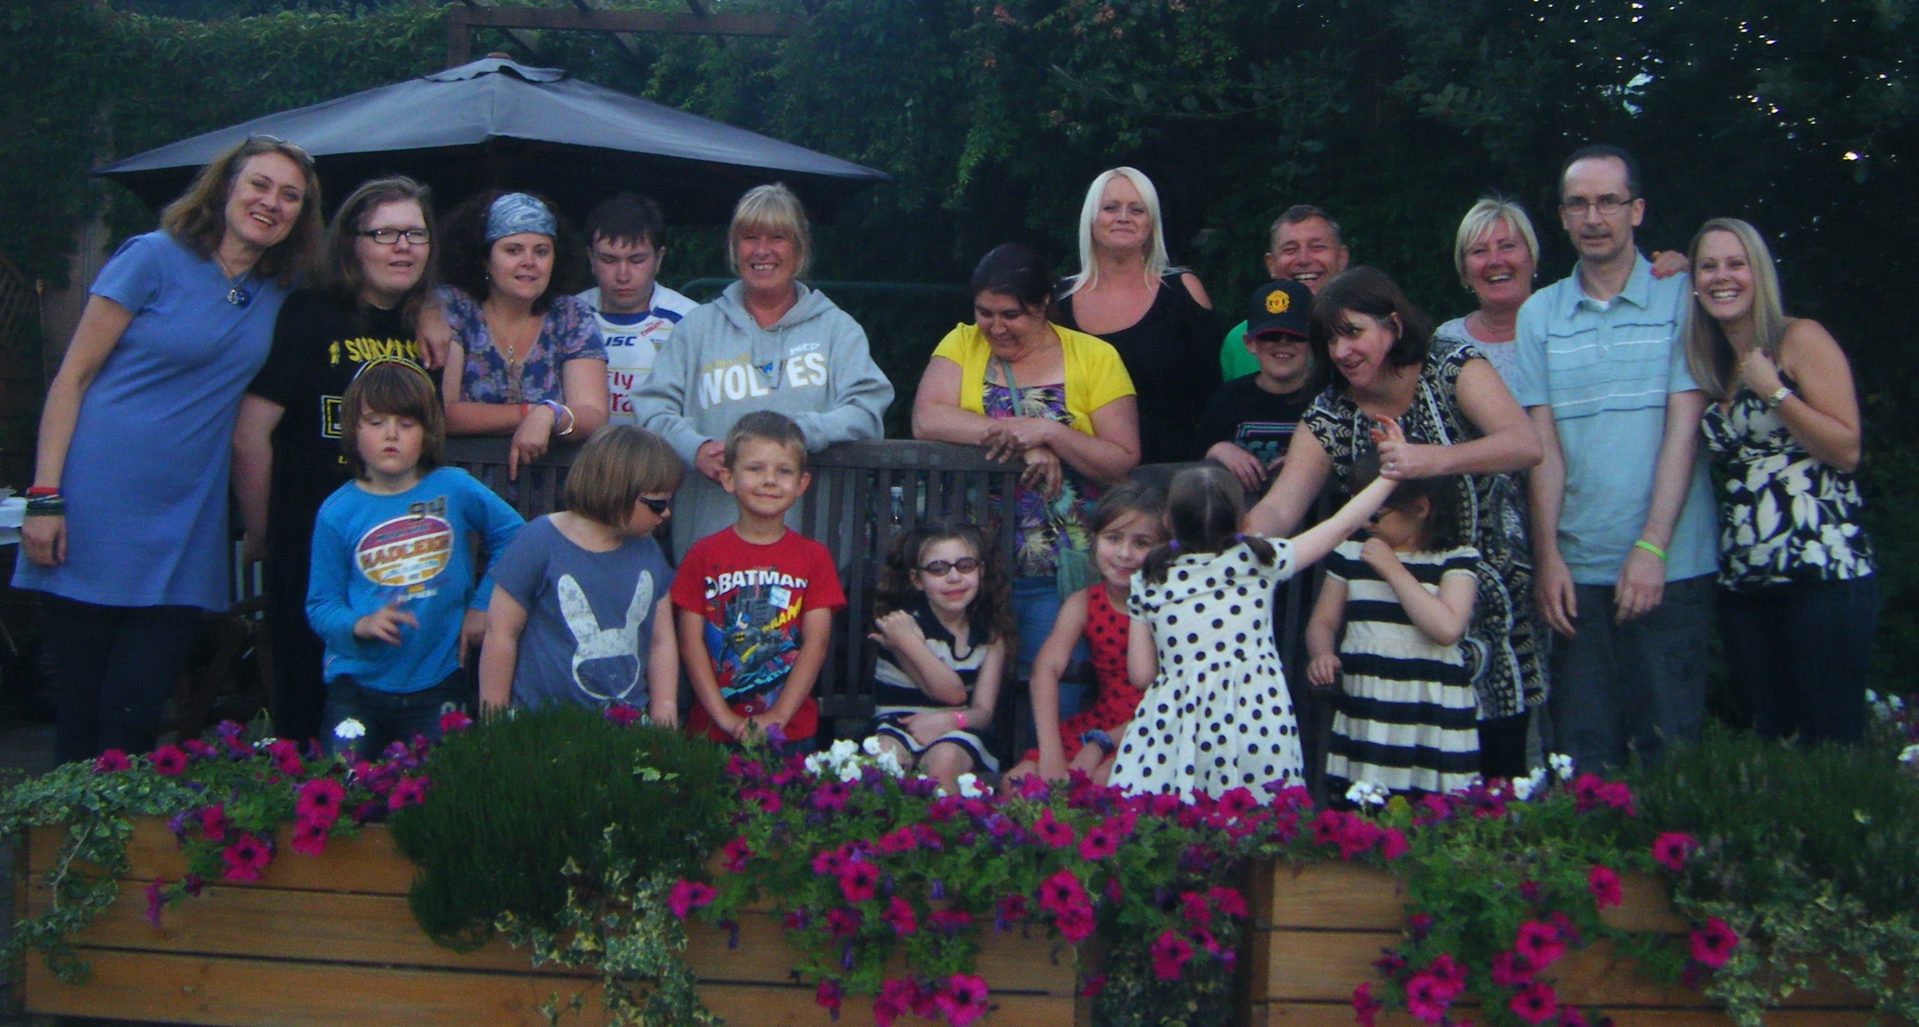

Awareness raising has been an important part of my current role and this has been achieved through a monthly e-newsletter and developing a new and exciting website, with includes regular updates for both families and professionals alike. This has also been achieved through contacting Schools, Hospitals and Social Services to explain more about the condition and the work of the charity.

I have worked closely with the Inherited Metabolic Team at the Queen Elizabeth Hospital, Birmingham to ensure that the AS adult clinics run smoothly and the patients needs and accommodation provisions are met.

In 2013, the first ASUK calendar was produced which showcased precious images of children and young people who are affected by Alström Syndrome. This enabled ASUK to raise funds for families, gain sponsorship and raise awareness of this ultra rare condition. Our thanks go to the very kind support given by our sponsors; New College Worcester, RNIB Pears Centre, Hear First and Frankham Consultancy Group Ltd.

I will continue to strive to promote the needs of people affected by Alström Syndrome and support all Trustees and Contractors in their roles.

Iram Shah
Alström Syndrome UK, Family Support Worker
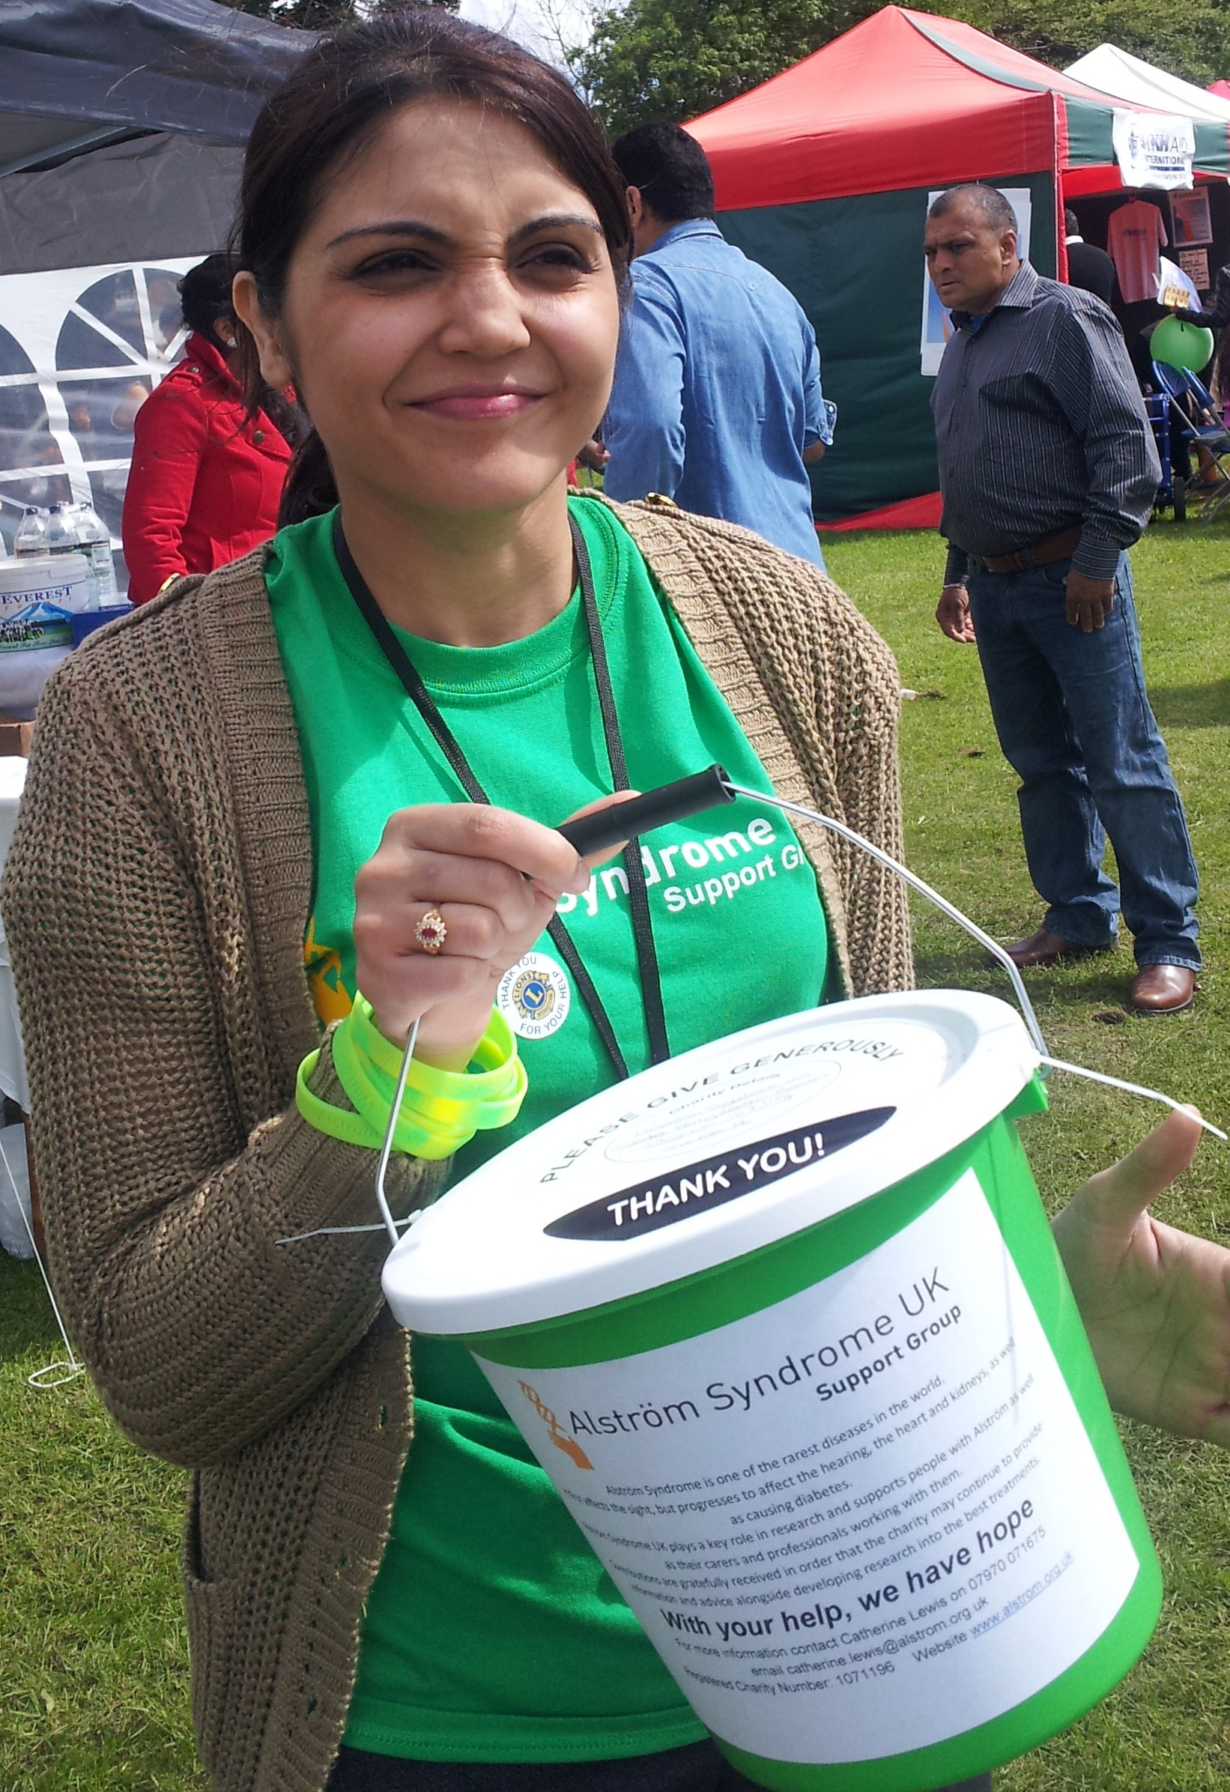

The year 2012-2013 has been quite a rollercoaster of a year for me. Juggling work alongside being a Mother of a child who is affected by Alström Syndrome, along with the happiness of graduating in my degree with a successful 2:1 grade. However, I have strived to work at my level best with all families and professionals within ASUK. I feel that I have been successful in working closely alongside our families to give my support, being an advocate in and out of clinics and giving encouragement.

I enjoy my role as family support worker and I love being part of a diverse team. I have found by working closely with education, health and other professionals it has boosted my confidence to voice any concerns which our families may be facing. I also like to think that being part of the Asian culture has given me the opportunity to be able to break any barriers our Asian families may have regarding concerns about consanguineous marriages.

I thoroughly enjoy working alongside Kerry and I am proud to be part of the Asian Mentoring Scheme, I hope to see our working relationship flourish and that we are all successful in our goal to further raise awareness within and outside the U.K. I also feel that the Asian Mentoring Scheme has helped the Asian minority, and through our radio appeals and being a representative on an Asian family channel on sky has further increased awareness raising; however we have more work to do to achieve further awareness and quicker diagnosis.

I have recently taken up the opportunity to stand up as representative on behalf of ASUK for the Ciliopathy alliance. This will be an exciting new learning curve for me and I look forward to meeting many new contacts and professionals.

Finally I am looking forward to many years of working as part of the team of ASUK and hope that my role will make a positive difference to families, professionals and everyone within our field of work.

Fundraising Report
Catherine Lewis MInstF

Despite a continually challenging financial environment Alström Syndrome UK has continued to generate funds through grant making trusts, family fundraising and grant applications.

Through the efforts of our Fundraiser Julia Scott, Trusts and Foundations have continued to support ASUK. In particular, the Asian Mentoring Scheme has been very well supported by many Trusts such as the Sylvia Adams Trust. Also many have supported the continuation of the activity breaks for children and young people including the Whirl Wind Trust who contributed towards a Sailing adventure.

Families have continued to support Alström Syndrome UK and this has enabled the charity to provide activity breaks for young people and special memories for families. One truly inspirational challenge was when patients, family members and health professionals came together for the 200 mile cycle ride, from Torbay Hospital to the Queen Elizabeth Hospital, Birmingham. This was to raise awareness of the AS clinic move and also to raise vital funds. The event raised over £16,000 and more importantly inspired others to participate in events, which they didn’t think possible.

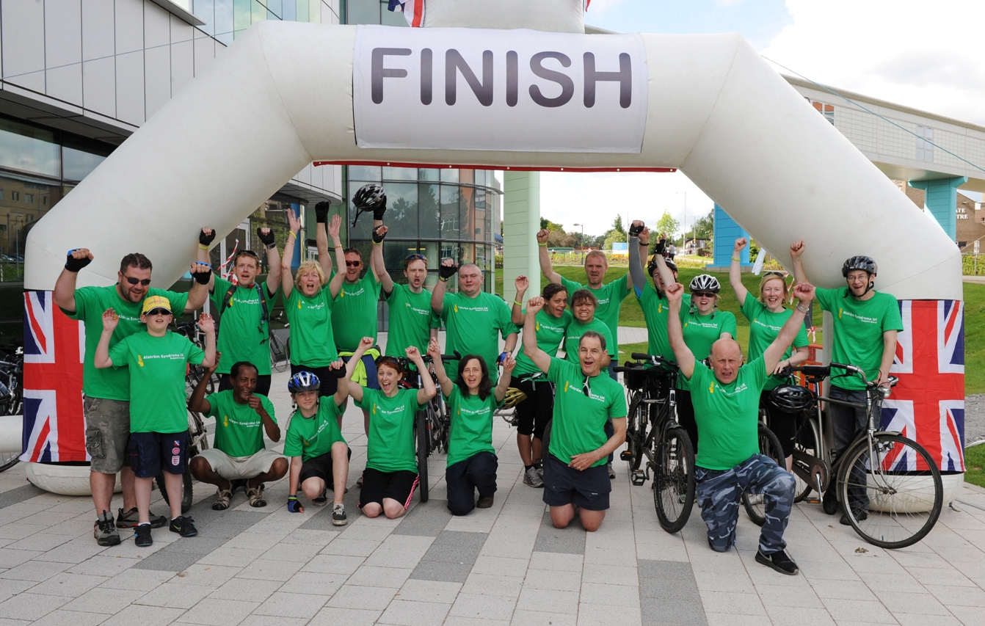

The Trustees of ‘ASUK’ are extremely grateful for all the volunteers who give their time freely to support the charity and all the families who continue to support our great cause. The generosity of individuals, companies and charitable trusts and foundations have helped the charity continue its vital work. Our heartfelt thanks go to everyone who has supported ASUK throughout the year, without this support our work would not be possible.

Development of Research
Big Lottery Funded Research Project “Bringing Hope to Alström Patients”
Update 2012 - 2013

In 2009, the Big Lottery Fund awarded ASUK £344,232 to lead this 3 year research project into Alström Syndrome. The project got underway in July 2010 together with our partners, South Devon NHS Trust, Birmingham Children’s Hospital NHS Trust and Cambridge University Institute of Metabolic Science, we have begun the most comprehensive study of Alström Syndrome ever undertaken. Uniquely, this project combines clinical studies with basic cell biology investigations.

This is a unique collaboration which will deliver:
- The first wide ranging, structured research programme into Alström Syndrome
- The first national clinical database of Alström Patients
- The first Alström Syndrome tissue bank
- The first ever stem cell research into Alström Syndrome

Importantly we expected
- to discover more people who have never before been correctly diagnosed with AS and therefore not been given the best treatments
- To be able to improve management of this difficult to treat condition
- To be able to better predict the course of the disease
- To take the first steps to genetically engineered treatments
The Big Lottery research project finished in December 2013 and although the process of ASUK gaining access to the clinical database has been challenging, we can now move forward on a positive note. The Queen Elizabeth Hospital are working towards the information and database being transferred to the QEH so that all relevant professionals can gain access and continue the research for further development.

We would like to say thank you to all patients who have given their time to this research project. Families still want to be actively involved in these studies and skin biopsies are still being donated which have been sent to Cambridge University where they can be successfully made into cell lines.

This research and data will be developed alongside AS EU so we can correlate more information to enable future treatments and better management of this devastating condition.

Report Signed on behalf of the Board of Trustees

Signature 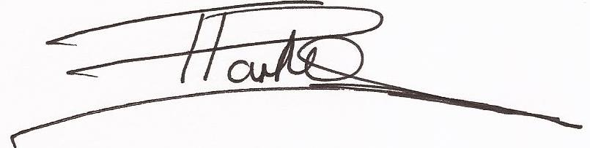

Trevor Parkin (ASUK Vice Chair)

Date 29.01.2014

Alström Syndrome UK - Financial Statements for the Year Ended 31 March 2013

Statement of Financial Activities |  |  |  |  |  | Unrestricted Funds |  |  |  |  | Restricted Funds |  |  |  |  | Total  2013 |  |  |  |  | Total  2012 |  |  |  |  |  | See Note
 |  |  |  |  |  | £ |  |  |  |  | £ |  |  |  |  | £ |  |  |  |  | £
Incoming Resources
Incoming Resources From Generated Funds: -
 | Voluntary Income |  |  |  |  | 50,300 |  |  |  |  | 35,610 |  |  |  |  | 85,910 |  |  |  |  | 71,537 |  |  |  |  |  | 2
 | Activities For Generating Funds |  |  |  |  | 0 |  |  |  |  | 0 |  |  |  |  | 0 |  |  |  |  | 0
 | Investment Income |  |  |  |  | 1,906 |  |  |  |  | 0 |  |  |  |  | 1,906 |  |  |  |  | 2,639 |  |  |  |  |  | 3
Incoming Resources From Charitable Activities |  |  |  |  |  | 0 |  |  |  |  | 257,326 |  |  |  |  | 257,326 |  |  |  |  | 273,663 |  |  |  |  |  | 4
Other Incoming Resources |  |  |  |  |  | 0 |  |  |  |  | 0 |  |  |  |  | 0 |  |  |  |  | 0
Total Incoming Resources |  |  |  |  |  | 52,206 |  |  |  |  | 292,936 |  |  |  |  | 345,142 |  |  |  |  | 347,839
Resources Expended
Costs of Generating Funds
 | Costs of Generating Voluntary Income |  |  |  |  | 16,492 |  |  |  |  | 0 |  |  |  |  | 16,492 |  |  |  |  | 11,779 |  |  |  |  |  | 2
 | Fundraising Trading - Costs of Goods Sold & Other Costs |  |  |  |  | 0 |  |  |  |  | 0 |  |  |  |  | 0 |  |  |  |  | 0
 | Investment Management Costs |  |  |  |  | 221 |  |  |  |  | 0 |  |  |  |  | 221 |  |  |  |  | 0 |  |  |  |  |  | 3
Charitable Activities |  |  |  |  |  | 18,195 |  |  |  |  | 311,375 |  |  |  |  | 329,570 |  |  |  |  | 329,322 |  |  |  |  |  | 4
Governance Costs |  |  |  |  |  | 3,584 |  |  |  |  | 0 |  |  |  |  | 3,584 |  |  |  |  | 3,352 |  |  |  |  |  | 5
Other Resources Expended |  |  |  |  |  | 3,860 |  |  |  |  | 0 |  |  |  |  | 3,860 |  |  |  |  | 1,387 |  |  |  |  |  | 6
 | Total Resources Expended |  |  |  |  | 42,352 |  |  |  |  | 311,375 |  |  |  |  | 353,727 |  |  |  |  | 345,840 |  |  |  |  |  | 7
 | Net Incoming/Outgoing (-) Resources Before Transfers |  |  |  |  | 9,854 |  |  |  |  | -18,439 |  |  |  |  | -8,585 |  |  |  |  | 1,999
Transfers
Gross Transfers Between Funds |  |  |  |  |  | 0 |  |  |  |  | 0 |  |  |  |  | 0 |  |  |  |  | 0
 | Net Incoming Reources Before Other Recognised Gains & Losses |  |  |  |  | 9,854 |  |  |  |  | -18,439 |  |  |  |  | -8,585 |  |  |  |  | 1,999
Other Recognised Gains / Losses
Gains on Revaluation of Assets for Charity's Own Use |  |  |  |  |  | 0 |  |  |  |  | 0 |  |  |  |  | 0 |  |  |  |  | 0
Gains / Losses on Investment Assets |  |  |  |  |  | 0 |  |  |  |  | 0 |  |  |  |  | 0 |  |  |  |  | 0
Actuarial Gains / Losses on Defined Benefit Pension Schemes |  |  |  |  |  | 0 |  |  |  |  | 0 |  |  |  |  | 0 |  |  |  |  | 0
 | Net Movement in Funds |  |  |  |  | 9,854 |  |  |  |  | -18,439 |  |  |  |  | -8,585 |  |  |  |  | 1,999
Reconciliation of Funds  Total Funds Brought Forward |  |  |  |  |  | 44,604 |  |  |  |  | 169,117 |  |  |  |  | 213,721 |  |  |  |  | 211,722
 | Total Funds Carried Forward |  |  |  |  | 54,458 |  |  |  |  | 150,678 |  |  |  |  | 205,136 |  |  |  |  | 213,721
Balance Sheet |  |  |  |  |  |  |  |  |  |  |  |  |  |  |  | 2013 |  |  |  |  | 2012 |  |  |  |  |  |  | See Note
 |  |  |  |  |  |  |  |  |  |  |  |  |  |  |  | £ |  |  |  |  | £
Fixed Assets
 |  |  | Total Fixed Assets |  |  |  |  |  |  |  |  |  |  |  |  | 0 |  |  |  |  | 0 |  |  |  |  |  |  | 10
Current Assets
 | Stocks & Work-in-Progress |  |  |  |  |  |  |  |  |  |  |  |  |  |  | 0 |  |  |  |  | 0
 | Debtors |  |  |  |  |  |  |  |  |  |  |  |  |  |  | 5,131 |  |  |  |  | 9,176 |  |  |  |  |  |  | 11
 | Investments |  |  |  |  |  |  |  |  |  |  |  |  |  |  | 135,000 |  |  |  |  | 127,540 |  |  |  |  |  |  | 12
 | Cash at Bank & In Hand |  |  |  |  |  |  |  |  |  |  |  |  |  |  | 81,961 |  |  |  |  | 83,426 |  |  |  |  |  |  | 13
 |  |  | Total Current Assets |  |  |  |  |  |  |  |  |  |  |  |  | 222,092 |  |  |  |  | 220,142
Liabilities
 | Creditors - Amounts Falling Due Within 1 Year |  |  |  |  |  |  |  |  |  |  |  |  |  |  | 16,956 |  |  |  |  | 6,421 |  |  |  |  |  |  | 14
 |  |  | Net Current Assets or Liabilities |  |  |  |  |  |  |  |  |  |  |  |  | 205,136 |  |  |  |  | 213,721
 |  |  | Total Assets less Current Liabilities |  |  |  |  |  |  |  |  |  |  |  |  | 205,136 |  |  |  |  | 213,721
 | Creditors - Amounts Falling Due After 1 Year |  |  |  |  |  |  |  |  |  |  |  |  |  |  | 0 |  |  |  |  | 0
 | Provisions for Liabilities & Charges |  |  |  |  |  |  |  |  |  |  |  |  |  |  | 0 |  |  |  |  | 0
 |  |  | Net Assets or Liabilities |  |  |  |  |  |  |  |  |  |  |  |  | 205,136 |  |  |  |  | 213,721
The Funds of the Charity
 | Restricted Funds |  |  |  |  |  |  |  |  |  |  |  |  |  |  | 150,678 |  |  |  |  | 169,117 |  |  |  |  |  |  | 15
 | Unrestricted Funds |  |  |  |  |  |  |  |  |  |  |  |  |  |  | 54,458 |  |  |  |  | 44,604 |  |  |  |  |  |  | 15
 |  |  |  |  |  |  |  |  |  |  |  |  |  |  |  | 205,136 |  |  |  |  | 213,721
Notes to the Statement of Financial Activities & Balance Sheet

1 | Accounting Policies - The principal accounting policies are summarised below. The accounting policies have been applied consistently throughout the year and in the preceding year.
 | - Basis of Accounting
 | The financial statements have been prepared under the historical cost convention and in accordance with the Companies Act 1985 and the Statement of Recommended Practice : Accounting and Reporting by Charities issued in March 2005
 | - Fund Accounting
- Unrestricted funds are available for use at the discretion of the trustees in furtherance of the general objectives of the charity.
- Restricted Funds are subjected to restrictions on their expenditure imposed by the donor.
 | - Incoming Resources
All incoming resources are included in the statement of financial activities when the charity is entitled to, and virtually certain to receive, the income and the amount can be quantified with reasonable accuracy. The following policies are applied to particular categories of income:
- Voluntary income is received by way of grants, donations and gifts and is included in full in the Statement of Financial Activities when receivable. Grants, where entitlement is not conditional on the delivery of a specific performance by the charity, are recognised when the charity becomes unconditionally entitled.
- Investment income is included when it is earned.
- Incoming resources from grants, where related to performance and specific deliverables, are accounted for as the charity earns the right to consideration by its performance.
 | - Resources Expended
Expenditure is recognised on an accrual basis as a liability is incurred. Expenditure includes any VAT which cannot be fully recovered, and is reported as part of the expenditure to which it relates:
- Costs of generating funds comprise the costs associated with attracting voluntary income and the cost of investing and trading for fundraising purposes.
- Charitable expenditure comprises those costs incurred by the charity in the delivery of its activities and services for its beneficiaries. It includes both costs that can be allocated directly to such activities and those costs of an indirect nature necessary to support them.
- Governance costs include those costs associated with meeting the constitutional and statutory requirements of the charity and include the audit fees and costs linked to the strategic management of the charity.
- The nature of the Charity is such that all costs are allocated directly to the expenditure categories of the SoFA without need for apportionment
 | - Fixed Assets
 | The nature of the Charity is such that it holds no fixed assets.
2 | Voluntary Income - Income relates to monies kindly donated by individuals and charitable organisations either for specific purposes (restricted funds) or for the general benefit of the Charity (unrestricted funds). Expenditure relates to the cost of engaging a professional fund raiser to generate such income.
3 | Investment Income & Costs - Interest earned on monies invested with various investment organisations (see Note 10). Against which are the costs of organising and accounting for these investments.
4 | Charitable Activities - The majority of the Charity's activities are funded by specific grants and donations, the main ones being: -
- National Commissioning Group - funds the service agreement between the Charity and London Strategic Health Authority (as host Health Authority to the National Commissioning Group) to maximise access to NHS services and provide support and information to Alstrom patients and their families.

- Children In Need - funding to cover the cost of a Child Development post to December 2012.

- Big Lottery - grant (reference C165AA1447) to fund major research into Alstrom Syndrome over a three year period ending July 2013.

- EU-WABB - amount set aside to meet the Charity’s contribution to an EU funded joint research project with two other related charities.

- One In A Million Fund - a fund established with a long term aim of raising £1m for future research into Alstrom Syndrome.

- Chloe Staddon Holiday & Equipment Fund – donation to provide holidays, outings and specific equipment to Alstrom patients and their families.

- Financial Assistance Grant Fund – amount set aside to provide financial support to Alstrom patients and their families based upon an assessment of need.

- Childwick Trust - donation to provide financial assistance to patients travelling to attend clinics.

- Whirlwind Charity - donation to fund the creation and publication of a promotional video.

- Various donations to fund the extension of the Charity's work into the Asian community to identify new patients and to bring them under the umbrella of the Alstrom Syndrome support framework.
 | Income and expenditure for each activity is included in Note 15.
5 | Governance Costs - costs relating to the general running of the Charity as opposed to the direct management function. Includes directors’ costs, preparation of statutory accounts etc.
6 | Other Costs - relate specifically to the cost of providing financial assistance and support to patients in need.
7 | Total Resources Expended – this is stated after charging the following services which are engaged on an external contract basis:-
 |  |  |  |  |  |  |  |  |  |  |  |  | 2013 |  |  |  |  |  |  | 2012
 | Executive Services |  |  |  |  |  |  |  |  |  |  |  | 53,900 |  |  |  |  |  |  | 48,900
 | Family Liaison Services |  |  |  |  |  |  |  |  |  |  |  | 29,740 |  |  |  |  |  |  | 29,740
 | Special Needs Services |  |  |  |  |  |  |  |  |  |  |  | 55,792 |  |  |  |  |  |  | 32,367
 | Child Development Services |  |  |  |  |  |  |  |  |  |  |  | 22,747 |  |  |  |  |  |  | 13,396
 | Financial & Administrative Services |  |  |  |  |  |  |  |  |  |  |  | 6,065 |  |  |  |  |  |  | 9,500
 | Professional Fund Raising Services |  |  |  |  |  |  |  |  |  |  |  | 10,208 |  |  |  |  |  |  | 10,032
 |  |  |  |  |  |  |  |  |  |  |  |  | 178,452 |  |  |  |  |  |  | 143,935
8 | Trustee Remuneration & Third Party Transactions – no Trustee received any remuneration during the year or the previous year. No Trustee or other person related to the Charity had any personal interest in any contract entered into by the Charity during the year or the previous year.
9 | Taxation - the Charity is exempt from tax on income and gains falling within section 505 of the Taxes Act 1988 or s256 of the Taxation of Chargeable Gains Act 1992 to the extent that these are applied to its charitable objects. No tax charges have arisen in the Charity.
10 | Fixed Assets - the Charity does not own any fixed assets. Contracted services engaged by the Charity provide their own accommodation from which to carry out their services.
11 | Debtors - the following amounts are included in the accounts to cover monies owed to the Charity which will be repaid within the next financial year: -
 |  |  |  |  |  |  |  |  |  |  |  |  | 2013 |  |  |  |  |  |  | 2012
 | Loan to Alstrom Syndrome - Europe |  |  |  |  |  |  |  |  |  |  |  | 5,000 |  |  |  |  |  |  | 0
 | Prepayments and accrued income |  |  |  |  |  |  |  |  |  |  |  | 131 |  |  |  |  |  |  | 9,176
 |  |  |  |  |  |  |  |  |  |  |  |  | 5,131 |  |  |  |  |  |  | 9,176
12 | Investments - these are investments held primarily to provide an investment return for the Charity: -
 |  |  |  |  | Balance 1 April ‘12 |  |  |  | Interest in Year |  |  | Invested in Year |  |  |  |  | Matured in Year |  |  |  |  |  | Balance 31 March ‘13
 | Birmingham Midshires - Fixed Rate Saving |  |  |  | 52,540 |  |  |  | 1,103 |  |  | 0 |  |  |  |  | 53,643 |  |  |  |  |  | 0
 | Carter Allen - Term Deposit Account |  |  |  | 75,000 |  |  |  | 803 |  |  | 85,000 |  |  |  |  | 75,803 |  |  |  |  |  | 85,000
 | Virgin - Charity Deposit Account |  |  |  | 0 |  |  |  | 0 |  |  | 50,000 |  |  |  |  | 0 |  |  |  |  |  | 50,000
 |  |  |  |  | 127,540 |  |  |  | 1,906 |  |  | 135,000 |  |  |  |  | 129,446 |  |  |  |  |  | 135,000
13 | Cash - Monies held in various bank accounts available for investment and to meet day-to-day running expenses.
14 | Creditors - relates to accruals and deferred income due within the next financial year.
15 | The fund balances held by the Charity at 31 March 2013 were as follows: -
 |  |  |  |  |  |  |  |  | Balance 1 April ‘12 |  |  |  | Grant in Year |  |  |  |  |  | Expenditure in Year |  |  |  |  | Balance 31 March ‘13
 | National Commissioning Grant |  |  |  |  |  |  |  | 0 |  |  |  | 133,605 |  |  |  |  |  | 133,605 |  |  |  |  | 0
 | Big Lottery |  |  |  |  |  |  |  | 61,375 |  |  |  | 98,978 |  |  |  |  |  | 96,489 |  |  |  |  | 63,864
 | BBC Children In Need |  |  |  |  |  |  |  | 14,724 |  |  |  | 15,692 |  |  |  |  |  | 30,416 |  |  |  |  | 0
 | EU-WABB |  |  |  |  |  |  |  | 32,440 |  |  |  | 9,051 |  |  |  |  |  | 9,360 |  |  |  |  | 32,131
 |  |  |  |  |  |  |  |  | 108,539 |  |  |  | 257,326 |  |  |  |  |  | 269,870 |  |  |  |  | 95,995
 | Other Restricted Grants & Donations
 | One In A Million Fund |  |  |  |  |  |  |  | 15,690 |  |  |  | 0 |  |  |  |  |  | 0 |  |  |  |  | 15,690
 | Chloe Staddon Holiday & Equipment Fund |  |  |  |  |  |  |  | 16,145 |  |  |  | 0 |  |  |  |  |  | 10,201 |  |  |  |  | 5,944
 | Financial Assistance Grant Fund |  |  |  |  |  |  |  | 2,750 |  |  |  | 0 |  |  |  |  |  | 0 |  |  |  |  | 2,750
 | Childwick Trust |  |  |  |  |  |  |  | 1,849 |  |  |  | 0 |  |  |  |  |  | 1,849 |  |  |  |  | 0
 | Whirlwind Charity |  |  |  |  |  |  |  | 0 |  |  |  | 1,610 |  |  |  |  |  | 1,610 |  |  |  |  | 0
 | Goldsmiths Company |  |  |  |  |  |  |  | 0 |  |  |  | 0 |  |  |  |  |  | 0 |  |  |  |  | 0
 | Mollie Croysdale Trust |  |  |  |  |  |  |  | 240 |  |  |  | 0 |  |  |  |  |  | 240 |  |  |  |  | 0
 | Clydesdale & Yorkshire Bank |  |  |  |  |  |  |  | 73 |  |  |  | 0 |  |  |  |  |  | 73 |  |  |  |  | 0
 | Sir Jules Thorn Charitable Trust |  |  |  |  |  |  |  | 1,000 |  |  |  | 1,000 |  |  |  |  |  | 863 |  |  |  |  | 1,137
 | Rayne Foundation |  |  |  |  |  |  |  | 2,463 |  |  |  | 0 |  |  |  |  |  | 2,463 |  |  |  |  | 0
 | Simply Health |  |  |  |  |  |  |  | 3,943 |  |  |  | 0 |  |  |  |  |  | 1,136 |  |  |  |  | 2,807
 | Sylvia Adams Trust |  |  |  |  |  |  |  | 13,425 |  |  |  | 15,000 |  |  |  |  |  | 20,070 |  |  |  |  | 8,355
 | Evan Cornish Foundation |  |  |  |  |  |  |  | 3,000 |  |  |  | 0 |  |  |  |  |  | 3,000 |  |  |  |  | 0
 | Sovereign Healthcare CT |  |  |  |  |  |  |  | 0 |  |  |  | 1,000 |  |  |  |  |  | 0 |  |  |  |  | 1,000
 | Allergan Foundation |  |  |  |  |  |  |  | 0 |  |  |  | 10,000 |  |  |  |  |  | 0 |  |  |  |  | 10,000
 | Carmen Butler Charteris CT |  |  |  |  |  |  |  | 0 |  |  |  | 2,000 |  |  |  |  |  | 0 |  |  |  |  | 2,000
 | Austin & Hope Pilkington Foundation |  |  |  |  |  |  |  | 0 |  |  |  | 1,000 |  |  |  |  |  | 0 |  |  |  |  | 1,000
 | J K Stirrup CF |  |  |  |  |  |  |  | 0 |  |  |  | 1,000 |  |  |  |  |  | 0 |  |  |  |  | 1,000
 | Constance Green |  |  |  |  |  |  |  | 0 |  |  |  | 1,000 |  |  |  |  |  | 0 |  |  |  |  | 1,000
 | Millichope Foundation |  |  |  |  |  |  |  | 0 |  |  |  | 2,000 |  |  |  |  |  | 0 |  |  |  |  | 2,000
 | Total Restricted Grants & Donations |  |  |  |  |  |  |  | 169,117 |  |  |  | 292,936 |  |  |  |  |  | 311,375 |  |  |  |  | 150,678
 | Non-Restricted Grants & Donations |  |  |  |  |  |  |  | 44,604 |  |  |  | 52,206 |  |  |  |  |  | 42,352 |  |  |  |  | 54,458
 |  |  |  |  |  |  |  |  | 213,721 |  |  |  | 345,142 |  |  |  |  |  | 353,727 |  |  |  |  | 205,136

Financial Statements Signed on behalf of the Board of Trustees

Signature
Trevor Parkin (ASUK Vice Chair)
Date 29.01.2014

Independent Examiner's Report to the Trustees of Alstrom Syndrome UK

I report on the accounts of the Charity for the year ended 31st March 2013, which are set out above.

Respective Responsibilities of Trustees and Examiner
The trustees (who are also the directors of the company for the purposes of company law) are responsible for the preparation of the accounts. The trustees consider that an audit is not required for this year under section 144(2) of the Charities Act 2011 (the 2011 Act) and that an independent examination is needed. As the Charity's gross income exceeded £250,000, the2011 Act requires that the examination be undertaken by a professionally qualified accountant. I therefore confirm that I am qualified to undertake the examination by being a qualified member of the Chartered Institute of Public Finance and Accountancy.

Having satisfied myself that the charity is not subject to audit under company law and is eligible for independent examination, it is my responsibility to:
- examine the accounts under section 145 of the 2011 Act;
- to follow the procedures laid down in the general Directions given by the Charity Commission under section 145(5)(b) of the 2011 Act; and
- to state whether particular matters have come to my attention.

Basis of Independent Examiner's Report
My examination was carried out in accordance with the general Directions given by the Charity Commission. An examination includes a review of the accounting records kept by the charity and a comparison of the accounts presented with those records. It also includes consideration of any unusual items or disclosures in the accounts, and seeking explanations from you as trustees concerning any such matters. The procedures undertaken do not provide all the evidence that would be required in an audit and consequently no opinion is given as to whether the accounts present a 'true and fair view' and the report is limited to those matters set out in the statement below.

Independent Examiner's Statement
In connection with my examination, no matter has come to my attention:

- which gives me reasonable cause to believe that, in any material respect, the requirements:

- to keep accounting records in accordance with section 386 of the Companies Act 2006; and
- to prepare accounts which accord with the accounting records, comply with the accounting requirements of section 396 of the Companies Act 2006 and with the methods and principles of the Statement of Recommended Practice: Accounting and Reporting by Charities

have not been met; or

- to which, in my opinion, attention should be drawn in order to enable a proper understanding of the accounts to be reached.

Chris Boid
Chartered Institute of Public Finance & Accountancy

32 Alma Row
Whiston
Rotherham
S60 4HT
15 August 2013

