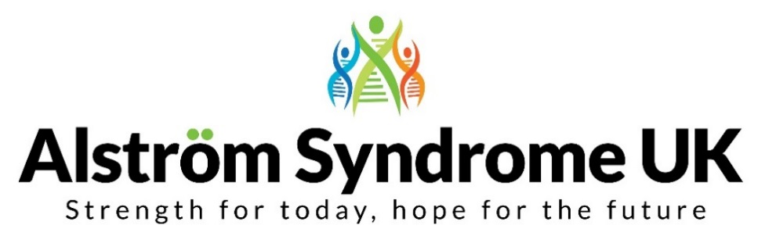
News, Views and Useful Links!
ASUK making connections around the world
We have been busy bees developing the new ASUK website to make it easier to navigate, find and share information and connect families, professionals and anyone with an interest in Alström Syndrome.
Have a look at the Family Support pages, where you can find useful resources to guide you through the maze of benefits and support services. As well as not forgetting about the fun things you enjoy and highlighting organisations which provide accessible activities and breaks in the UK. Please get in touch if you have suggestions of organisations that you have found helpful and we can add to these resources.
Have you seen the revolving globe at the bottom of the home page? – You can see people are viewing the website from all over the world!
Let’s connect
Have you heard about Disease Maps?
These maps connect people with the same condition around the world. Alström Syndrome UK have added their details and wouldn’t it be fantastic if we all added our information so we can see everyone around the globe. Have a look on the website to find out more https://www.diseasemaps.org/alstrom-syndrome/map/
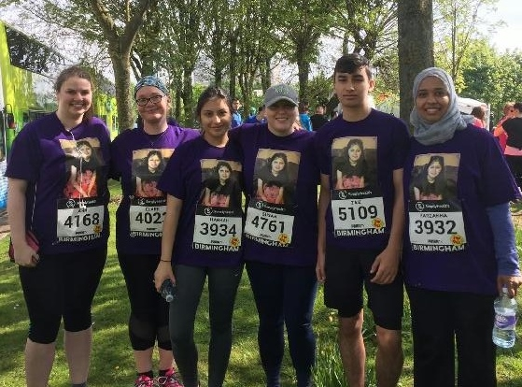
Inspirational family – what an achievement!
In Maariyah's memory, her family and friends decided to raise awareness of Alström Syndrome by running in the Great Birmingham 10K run. The run took place on Sunday 30th April 2017 and they all finished the race, what an achievement!
A HUGE THANK YOU to the family for supporting Alström Syndrome UK. You can still show your support and visit their Just Giving fundraising page http://www.justgiving.com/princessmaariyah
The family have currently raised over £1,500!
Fancy a family day at Alton Towers?
The charity, Victa are offering the chance for families to have a fun-filled trip at Alton Towers theme park on the 11th August 2017. The cost is reduced to £5 per person (1 parent/carer goes free, children under 5 are free). If you are interested, complete an application form by the 6th June 2017, which is available on the Victa website http://www.victa.org.uk/family-day-alton-towers/ Please get in touch if you would like any support completing the application.
‘Let’s Get Moving’
The Let’s Get Moving project is now in full swing. We have sent out the welcome packs including a FitBit fitness tracker to gather information about exercise habits.
One of our members who is taking part explains ‘I have now had the Fitbit for a month and love it. I discover more about the app ever week. I'm still getting to the gym weekly despite not having a guide dog at present. Also, starting using the treadmill again twice a week and walk daily.’
Dr. Richard Paisey will be gathering the data from the FitBits and information packs to analyse how a healthy diet and exercise may affect people with AS. Send your information to Dr. Paisey at Richard.paisey@alstrom.org.uk or if you would like to speak to him about the project you can call him on 01626 354758. Please get in touch if you would like to find out more or be involved.
Would you like to get out and about, running or walking?
British Blind Sport have launched a ‘Find me a Guide Database’ where anyone over the age of 18 who is affected by a visual impairment can search for a guide in their area to support them with running or walking. All guides are fully trained and DBS checked. You can find more about the work of British Blind Sport via their website http://www.britishblindsport.org.uk/
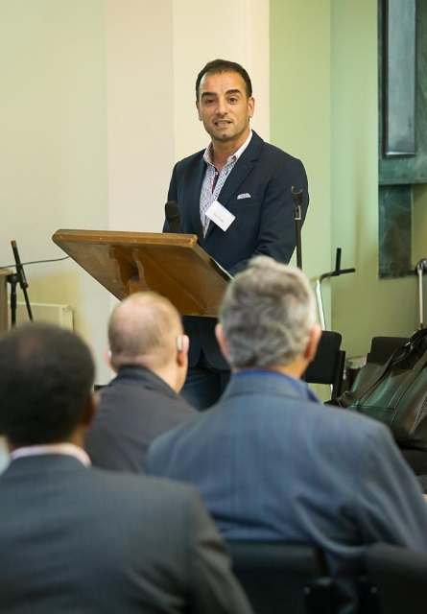
International speakers confirmed!
The ASUK 18th Family and Professional ‘Health, Happiness and Well-being’ conference will take place on the 6th and 7th October 2017, at the Aston Conference Centre in Birmingham. This will bring the Alström community together to share stories, hear about the latest research and clinical developments and meet up with other families.
We are delighted to announce that Dr. Pietro Maffei from Italy will be one of our keynote speakers discussing the current research and clinical developments in Europe plus there will be an update on the UK trial for patients with Alström Syndrome.
For early birds-The Holiday Inn Snowhill in Birmingham have kindly agreed special discounted rates for families coming to the conference. Please get in touch with Catherine Lewis to book.
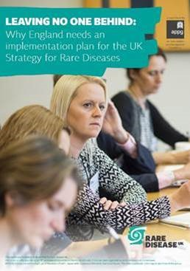
ASUK joins UK Rare Disease Policy Board – Improving services for all
ASUK is delighted to announce we are now on the UK Rare Disease Policy Board.
ASUK is involved to help improve services for people with Alström Syndrome and others affected by rare conditions in the UK. The All Party Parliamentary Group (APPG) on Rare, Genetic and Undiagnosed Conditions published a report calling on the Department of Health to implement the Strategy for Rare Diseases and improve services for people affected by rare conditions.
You can follow the link to read the full report https://www.raredisease.org.uk/media/2757/final-for-website.pdf
The work of the UK Rare Disease Policy Board will include the continuing development of the Strategy for Rare Diseases, ensuring the 51 commitments from the strategy are being met. The UK Strategy for Rare Diseases highlights the way we can improve the lives of all those with rare diseases in the UK by 2020. It details 51 commitments and each part of the UK will take action and develop plans to implement the strategy, working together to pool resources, knowledge and experience where possible.
You can find out about the 51 commitments from the Rare Disease Strategy by following the link to the Rare Disease UK website: https://www.raredisease.org.uk/uk-strategy-for-rare-diseases
(Front cover of the report, picture kindly provided by Rare Disease UK/Josh Tucker.)
Contact a Family, introduce their birth to five parenting workshops
Contact a Family offer useful resources and information for families including information about benefits, welfare rights, local services and support, activities and education. They have also received funding to provide workshops about early years entitlements, visit their website to find out more https://www.cafamily.org.uk/news-and-media/introducing-our-birth-to-five-parenting-workshops/ The Contact a Family Freephone helpline for parents and families is 0808 808 3555.
New funding rules for children with SEND
Special Needs Jungle provides useful information about special educational needs and disability issues faced by children and their parents. They have produced an article about the new funding rules for Children with Special Educational Needs to try and help families navigate all these changes https://www.specialneedsjungle.com/explaining-new-funding-rules-for-early-years-children-with-send/
If you would like individual help with entitlements in education contact
ASUK National Transition Coordinator, Marie McGee. You can get in touch with Marie by email marie.mcgee@alstrom.org.uk she would love to hear from you.

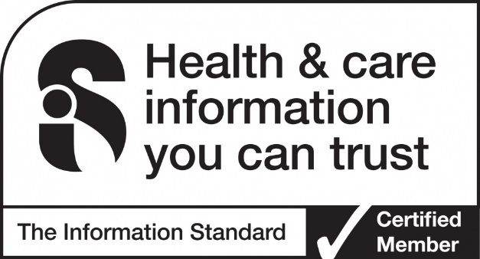
Information you can trust!
ASUK is committed to providing information you can rely on as being accurate and trustworthy.
ASUK has been assessed as meeting the standards of The Information Standard and continues to be a certified member.

ASUK would love to hear from you, send us your news, articles or any links that you think others would find useful. Get in touch by email Catherine.lewis@alstrom.org.uk or give me a call on 01803 613117.
Best Wishes
Catherine
From us all at ASUK
Thank you for your support
https://www.justgiving.com/alstromsyndromeuk

www.alstrom.org.uk

