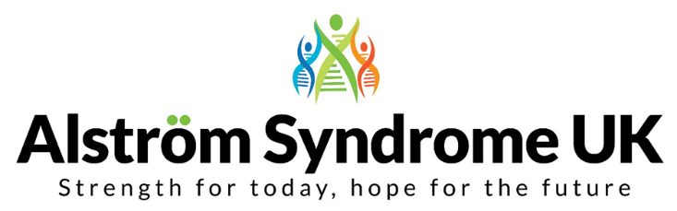
Health, Happiness and Wellbeing Conference 2017
Friday 6th October – Scientific Symposium
Saturday 7th October - Family and Professional Conference
Aston Conference Centre and Hotel Birmingham B4 7ET
Introduction
This 18th conference hosted by Alström Syndrome UK (ASUK) aims to bring together the research and practice in managing this ultra-rare condition. The conference offers the Alström community the chance to get together, share stories and hear about the latest research in the UK and more widely. It will offer the opportunity for clinicians, educationalists, academics, individuals affected, and their families the chance to network and find out what is happening in areas of research and treatment.
Key note speakers will include leading clinicians, academics and presentations from people who have personal experience of this complex condition.

Booking Details
Full Name: Job Title:
Organisation:
Address:
Telephone Number: Mobile Number:
Email address:
Which day(s) will you be attending (please tick all that apply):

Friday 6th October 2017 Scientific Symposium – 2:00 pm – 6:00 pm
Friday evening - networking buffet from 6:30 pm

Saturday 7th October 2017 Family and Professional Conference – 9:00 am – 17:30 pm
Saturday evening – Networking dinner and entertainment 18:00 pm

Lunch, evening meals and refreshments will be provided throughout, please list any dietary requirements:
Please email the completed booking form by the 1st July 2017 to Catherine Lewis at Catherine.lewis@alstrom.org.uk
alternatively please post to Alström Syndrome UK, 31 Shearwater Drive, Torquay, Devon TQ2 7TL
Please return your booking form promptly so we can ensure a place is reserved for you.
We look forward to seeing you all there!

