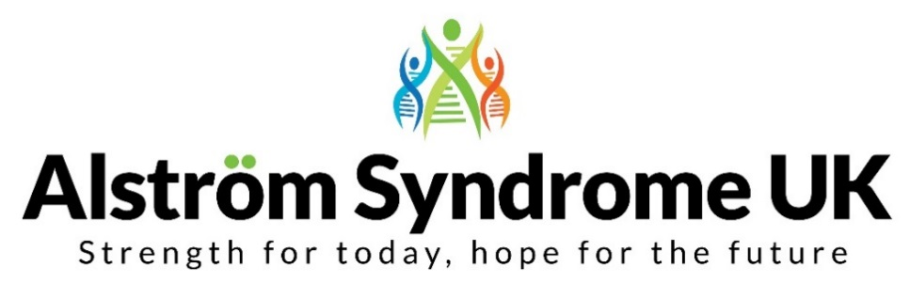
News, Views and Useful Links!

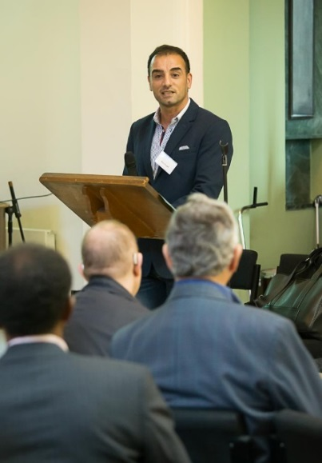
Families and Professionals from across Europe register for our unique event!
We are delighted to announce that families and professionals from across Europe will be attending our ‘Health, Happiness and Wellbeing’ conference on the 6th and 7th October 2017 at the Aston Conference Centre in Birmingham. The conference will begin with a Scientific Symposium from 1:30 pm on Friday 6th October and will conclude after an evening of entertainment and celebrations on Saturday 7th October 2017.
Many organisations will be demonstrating their services and products; Deafblind UK, Sense, Sight and Sound Technology, HumanWare, New College Worcester, Orcam Technologies and many more will be exhibiting and on hand throughout the event on Saturday.
The event aims to bring together families, individuals and professionals to learn more about this ultra-rare condition. This is a unique opportunity to hear about pioneering research and clinical developments, take part in interactive workshops and learn from each other’s experiences; as well as meeting up with other families and friends. Join us for either or both days, with thanks to our sponsors the events are FREE!

There is still time to book your place! Conference booking forms and agendas can be found on our website http://www.alstrom.org.uk/asuk-conference-book-today/ if you are having any difficulties completing the booking form or if you would like the information in an alternative format such as Braille, please call or email me.

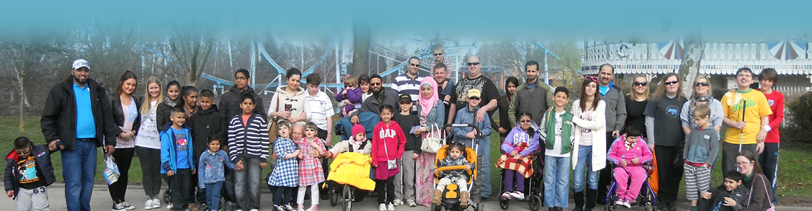

We look forward to seeing you all there!
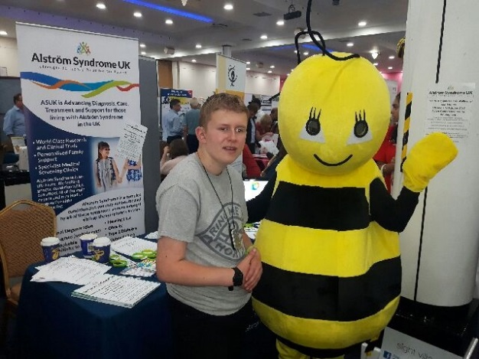
Queen Alexander College, Sight Village 2017
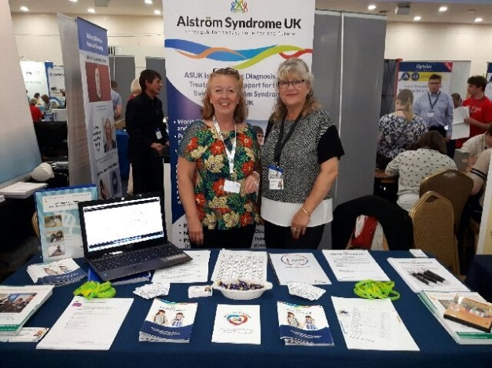
On the 18th and 19th July, ASUK exhibited at the Sight Village event in Birmingham. These events are free to attend and host the latest technology and products for people who are visually impaired. It also offers the chance to gather information and advice. Kerry Leeson-Beevers and her son Kion, gave a talk about ‘'Living with a dual sensory loss - a mother and sons perspective'. This workshop explored the experiences and challenges faced throughout childhood and growing up. This was a wonderful opportunity to network with other relevant organisations and gain useful information for our families. Kion (pictured right) discovering Bumblebee products from British Wireless for the Blind Fund and Ann and Carrol pictured showcasing our services at the ASUK Information stand.
You can find out more via the QAC website. We will be exhibiting again at the Sight Village event in Manchester on the 27th September 2017. If you are attending, pop by the stand and say hello! http://www.qac.ac.uk/exhibitions.htm

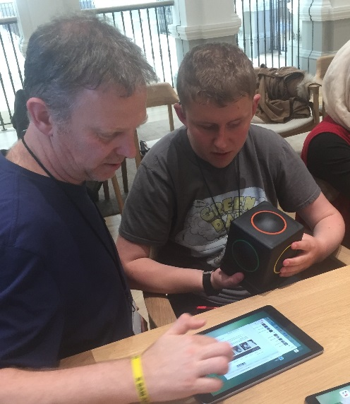
ASUK Transition week-end with a difference
On the 1st July 2017, young people and their families embarked on a transfer week-end with a difference. In preparation for moving across to the adult services at the Queen Elizabeth Hospital in Birmingham, youngsters were welcomed at the Rare Disease Centre at the QEH to meet the team and familiarise themselves with the facilities. ASUK supported families to get to know one another, sharing experiences and knowledge through a fun game of bowling and over dinner.
Families also had the opportunity to try out new accessible technology during an Apple workshop.
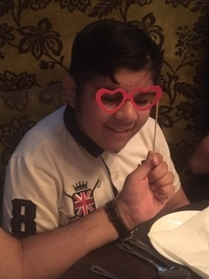

‘Transferring to adult services can be a daunting prospect for many youngsters and their families, so we wanted this to be a positive experience not only through providing support and information, but also the chance for families to have fun together’.
The week-end was kindly funded through Children in Need.

It’s what you can do that counts
Chris shares his thoughts on climbing, proving it is what you can do that counts.

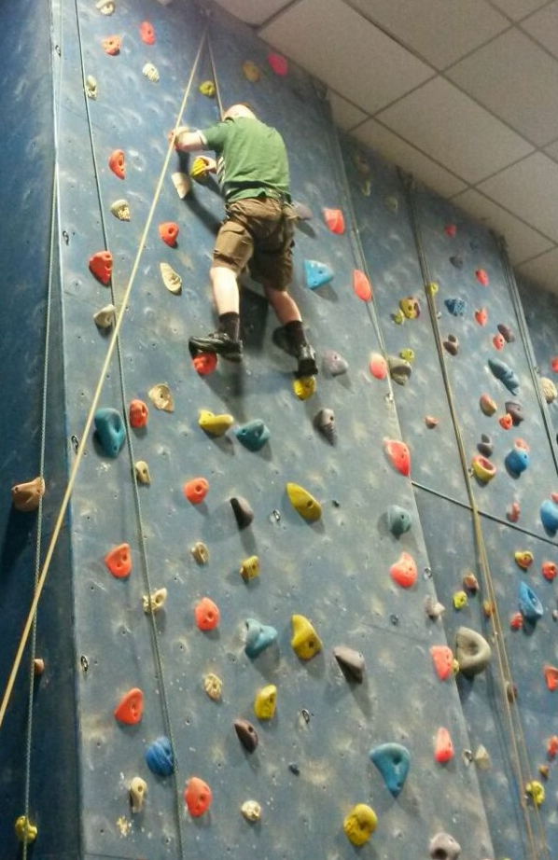
“On Friday 25th August, I went along, with a local Visually Impaired group of 9 people, to Westview Leisure Centre in Preston, Lancashire to have a go at Indoor Rock Climbing. I was a bit hesitant as I wasn’t sure what was going to happen. The instructor told us all about the climbing wall. You basically get into a harness that you wear around your thighs and waist and it’s attached to a big rope, like a tow-rope.

Before they let me near the harness, I had to do some exercises to warm up my muscles. The harness was quite comfortable and felt like I was sitting in a seat. Once the rope was attached I started to climb the wall. I had to feel for grooves and holes in the boulders on the climbing wall. The holes were all different sizes and different heights. I had to pull my body up by using my hands and feet.

At the first attempt, I couldn’t reach the top. My hands and legs turned to jelly and I came back down to floor level. It was quite a strenuous exercise. At the second attempt, I got over my fears and just kept reaching for the next hole to place my hand in then reached for the next hole for my foot to fit in. I reached the top in about 15 minutes. When I got to the top the instructor was there with me and we abseiled down to the ground together. This meant descending to the ground backwards by pushing my feet against the wall, holding the rope and sliding down to the ground with the rope between my legs. It was very exciting and I am doing it all again next month.”

If you are interested in finding out more about this sport have a look at The British Mountaineering Council their ‘Disability Needn’t Stop You Climbing’ article shows what is possible and where to find further information if you are interested https://www.thebmc.co.uk/disability-neednt-stop-you-climbing

ASUK will be presenting at the Asterix End Symposium
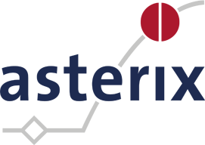
ASUK are delighted to be attending the Asterix End Symposium on the 18th and 19th September 2017 in the Netherlands.
The focus will be on the ‘New Methodology for clinical trials in rare diseases’ and ASUK National Development Manager, Kerry Leeson-Beevers will be presenting on the role of patient engagement in clinical research. Ensuring patients voices are heard at every stage.

Asterix (Advances in Small Trials dEsign for Regulatory Innovation and eXcellence) is an EU funded research project focusing on the development of more efficient and effective research projects to ensure rare diseases have the same opportunities as more common conditions. This is through studying new drugs, treatments and investigating further to learn more about rare diseases.
Asterix actively encourage the voice of patients throughout the research process, acknowledging that often in the field of rare diseases, it is the patients and family members who know more about their condition than the medical professionals involved. ASUK is a member of their Patient Think Tank group to ensure patients voice is always at the forefront of any developments; ensuring patient perspectives are considered when clinical trials are being designed.

You can find out more about the work of Asterix and further information about the symposium via their website http://www.asterix-fp7.eu/

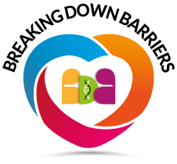
Breaking down Barriers logo and website revealed
ASUK have developed a project called ‘Breaking down Barriers’ funded by the Sylvia Adams Trust which aims to work with other charities to develop supportive and inclusive services for individuals and families affected by genetic conditions.
Have a look at the new website to find out more about this project and the fantastic work being achieved.
http://breaking-down-barriers.org.uk/

Have your voice heard!
Have your say in the Genetic Alliance UK survey to share your experiences, concerns and challenges when applying for insurance.
We know from many families how tricky applying for insurance can be at times, so by taking part in this survey useful resources can be compiled to assist families with future applications. Please follow the link to the Genetic Alliance website to find out more http://www.geneticalliance.org.uk/our-work/living-and-education/insurance-and-genomics-now/

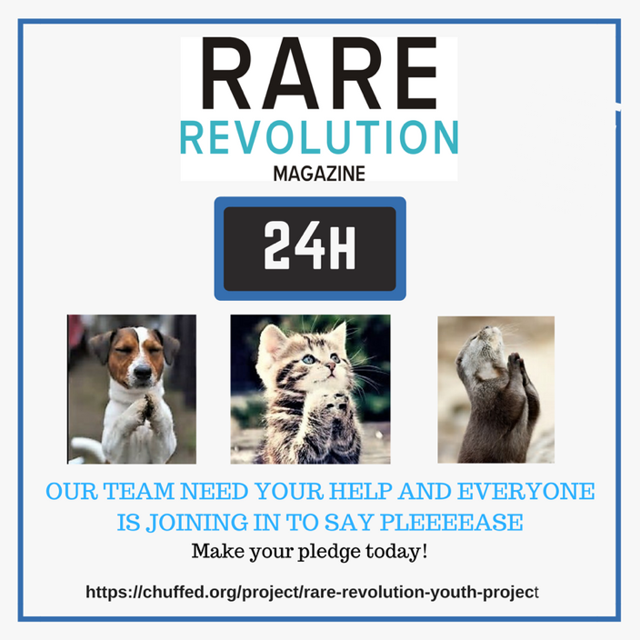
Youth Magazine needs your support
Rare Revolution Magazine produce a free digital magazine for the rare disease community. They would like to expand the magazine to include a youth magazine to ensure the voice of young people is always heard. The youth editorial team has been chosen and are ready to go, it is the support and funding to make the project a reality that is now needed. Please follow the link to pledge your support and find out more about this new initiative. https://www.chuffed.org/project/rare-revolution-youth-project

ASUK would love to hear from you, send us your news, articles or any links that you think others would find useful. Get in touch by email Catherine.lewis@alstrom.org.uk or give me a call on 01803 368871 / 07970 071675.
Best Wishes
Catherine
From us all at ASUK
Thank you for your support
https://www.justgiving.com/alstromsyndromeuk
www.alstrom.org.uk

