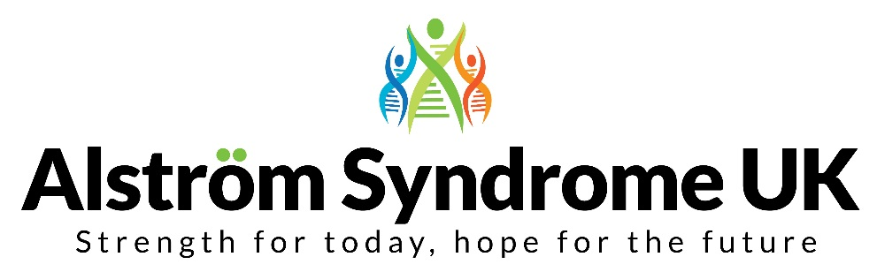

4 St Kitts Close, Torquay, Devon, TQ2 7GD  
Tel: 01803 368871 / 01709 210151  
Email: [info@alstrom.org.uk](mailto:info@alstrom.org.uk)  
Website: [www.alstrom.org.uk](http://www.alstrom.org.uk)  
Charity no: 1071196  
Company no: 3557191

**Dear Applicant,**

Thank you for your interest in the Breaking Down Barriers Project Outreach Officer position with Alström Syndrome UK (ASUK). This is a new role at ASUK and reflects our ambition to further develop the support that we offer to patient organisations; individuals affected by genetic disorders and those who love and care for them. This project is made possible through the commitment, funding and support that we receive from The Sylvia Adams Charitable Trust.

We recognise that individuals and families can become isolated and may not always receive the support and the treatment they require. The Breaking Down Barriers project works with people from ethnic minority communities to improve access and understanding. We are supporting organisations to develop resources and promote access to services to enable families to make informed choices about their future.

The ability to speak and read Urdu and/or Punjabi and a willingness to work flexibly and to travel will be essential. Knowledge and experience of providing support to families affected by genetic disorders will be an advantage, as will experience of interpreting and translating information.

Most importantly, if you are compassionate and determined and want to make a positive impact on people’s lives we would encourage you to apply.

Kindest Regards

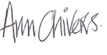

Ann Chivers

Chief Executive Officer

Alström Syndrome UK