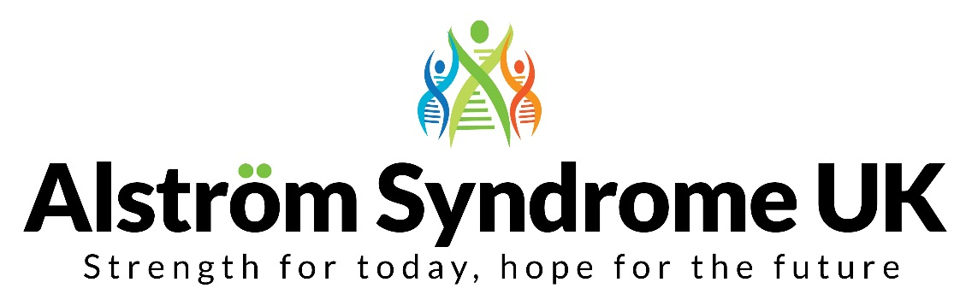

Project Outreach Officer

Job Description

Purpose of the role
The Project Outreach Officer will provide support and expertise to patient and community organisations, to enable them to successfully engage with their members. Many of the individuals and families are affected by genetic disorders and experience barriers to accessing mainstream services. There will be a particular focus on families from minority ethnic groups to ensure everyone receives an equitable service and to empowered people to make informed choices.

Appointees must:

- have an understanding of genetic conditions and genetic inheritance
- be able to speak and read Urdu and/or Punjabi as they will be expected to review translated information and provide an interpreting service for families who do not speak English as a first language
- have respect and sensitivity for the religious and cultural beliefs of individuals and families

Responsible to:
The Chief Executive

Line Manager
The National Development Manager / Project Lead

Location
The registered office of Alström Syndrome UK is 4 Kitts Close, Torquay, Devon, TQ2 7GD and the Project Lead is based in Rotherham, South Yorkshire. The Project Assistant/s will work from their home location but will be expected to attend meetings, visit organisations and provide support in various locations throughout England.

Contract
This is a temporary twelve month contract with potential to extend.

Salary
The salary range is £10,800 - £14,522 dependent upon experience, knowledge and skills.
(The full-time equivalent scale for this role is £18,000 - £24,203).
Terms and Conditions of Service

- This is a 0.6 role, 3 days per week and there can be some flexibility around the working days.

- Evening and weekend work may be required alongside some overnight stays. Relevant and agreed expenses can be claimed.

- The post holder is expected to participate in appropriate team meetings and attend training events relevant to their specific roles and responsibility.

- There is a three month probationary period.

- Two references will be required

- An enhanced DBS check will be required

Specific Areas of Responsibility

- Provide support to the Project Lead of Breaking Down Barriers to raise awareness of the project including attending relevant meetings, conferences and events.

- Enhance the work of member organisations as requested by their management teams, and agreed by the Project Lead, including:

- Support in the planning and delivery of meetings and events to increase the engagement with families from ethnic minority communities and enabling them to access appropriate services

- Review and edit translated information

- Provide an interpreting service if required for individuals and families who do not speak English as their first language

- Support individuals and families to increase their confidence and independence

- Other relevant tasks as required by the Project Lead

General Areas of Responsibility

- The post-holder will be expected to further the aims and objectives of Alström Syndrome UK and to co-operate fully with policies and procedures of Alström Syndrome UK.

- The post-holder will be expected to act in accordance with Alström Syndrome UK's Equal Opportunity policies.

- The post-holder will be expected to assist with any reasonable duty at the request of the Chief Executive and Project Lead.

- The post holder will be based at home and is expected to be able to work flexibly dependent upon the needs of the project and the charity.

The responsibilities above form the core of the role; however, the employee may be asked to undertake additional activities from time to time.

Confidentiality

- The confidential nature of the work means that employees working for Alström Syndrome UK must maintain the strictest security in relation to documentation and ensure that confidentiality is maintained always, in accordance with relevant Data Protection and associated legislation.

- This role will be required to complete an enhanced Disclosure and Barring Service check

Health & Safety

- The post holder is expected to make themselves aware of and comply with Alström Syndrome UK’s Health & Safety Policy

This role profile is designed to identify principle responsibilities. The post holder is required to be flexible in developing the role in accordance with changes within Alström Syndrome UK’s management agenda and priorities.
Person Specification

The person appointed will be expected to have the essential experience, skills and abilities listed below. Items under the heading desirable will be valuable but those candidates who do not have these should not be deterred from submitting an application.

Knowledge, experience, skills and abilities

Essential

- Previous professional or personal experience of genetics or complex health conditions

- An understanding of at least one ethnic minority culture

- Able to speak and read Urdu and/or Punjabi
- Excellent communication skills, oral and written
- Ability to prioritise when faced with competing work demands
- Ability to work on own initiative
- The ability to encourage and empathise with newly diagnosed children, individuals and families.

- The ability to learn new skills and be guided by other professionals working in the field. Able to challenge when something is not fully understood or thought to be incorrect

- Willingness to undertake some work during unsociable hours

- Ability to travel long distances and to unfamiliar areas which may involve overnight stays

- Ability to develop good working relationships with support group representatives, colleagues, professional workers and the public.

Desirable

- Have a strong desire to improve the experiences and accessibility of services for people living with genetic conditions

- Genetic counselling experience
- Interpreting experience
- Experience of working in a health setting
- Experience of working with young people and/or vulnerable adults
- Experience of working in a mentoring or advocacy role
- General knowledge of the generic issues affecting support groups
- Knowledge of relevant voluntary organisations and statutory agencies
- Previous experience of project work
- Experience of working from home
- Experience of writing reports

Qualifications

Essential

- A minimum qualification, such as NVQ Level 3 in Health and Social Care or equivalent

