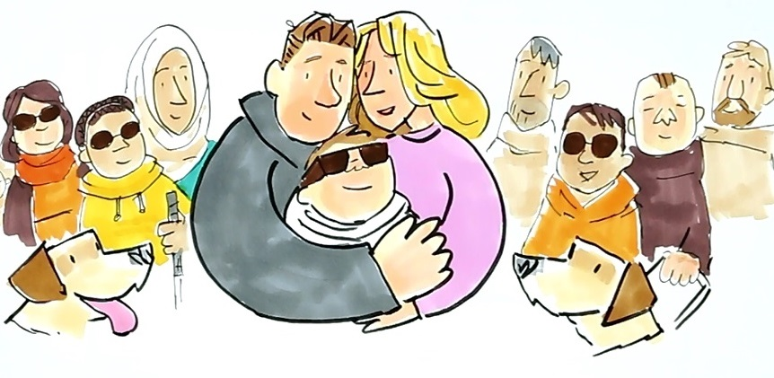Application Form
The information you provide on this form will help ASUK understand how we can best support you to organise and take part in a fun filled activity or adventure!
Please answer the questions below as fully as you can and return to liz.loughery@alstrom.org.uk or if you prefer to send a copy by post the address is: Alström Syndrome UK, 4 St Kitts Close, Torquay, Devon TQ2 7GD.
If you have any questions or need any help completing the form, please contact Liz and she will be happy to help! Email: Liz.loughery@alstrom.org.uk / Mobile: 07517 278 946.
Please note this is only for adults (18’s and over) with Alström Syndrome (plus a carer or personal assistant if required)
- Full Name:
- Date of Birth:
- Address:

- Telephone Number:
- Email Address:
- Using the space provided below please tell us about the activity that you would like do

- Using the space provided below please tell us why you have chosen this activity or adventure

- Please tell us how much your chosen activity will cost (approximately)

- How shall we contact you? (respond Yes or No)
- Email
- Letter
- Telephone

- How did you hear about this opportunity (tick which answer applies to you)
- Family Support Worker
- Letter
- ASUK Website
- Other

