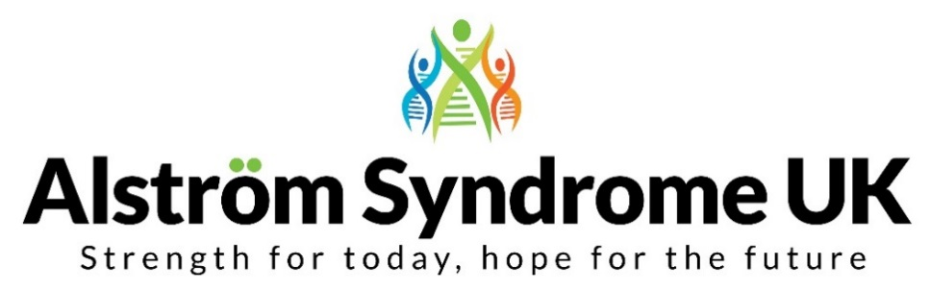
News, Views and Useful Links!

Travelling Blind; where will your adventure take you?
On the 7th March 2019, BBC Two broadcast a travel show with a difference, ‘Travelling Blind’. A heart-warming, insightful and emotional documentary capturing the journey of the inspirational Amar Latif, founder of Travel Eyes and comedian Sara Pascoe, as they embarked on an adventure across Turkey. Highlighting how we can use our senses to embrace life and every experience we encounter. The programme was both inspirational and funny as their very different worlds and personalities collide.

Has this programme inspired you to have your own adventure?
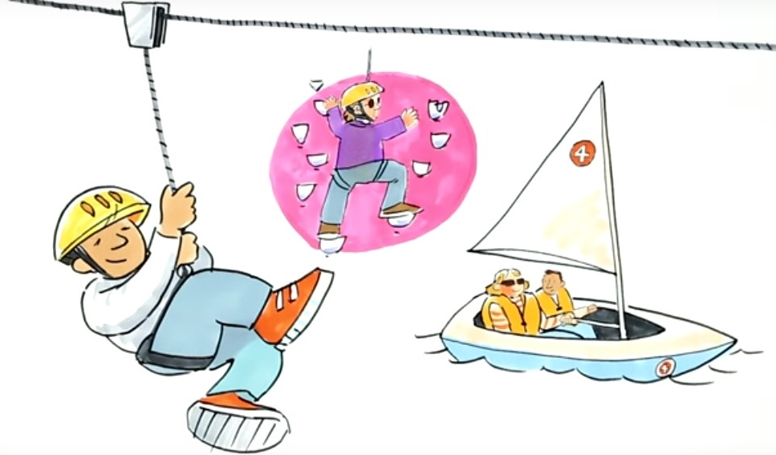

What is the Big Activity Challenge?
Apply for between £50-£500 to pay towards an active adventure or activity then, provide some photographs and write an article for the ASUK newsletter, telling us all about your experience. Such as how accessible it was, what you achieved, or even if you’re going to take it up as a new hobby. If you would rather tell us about your experience, we can help you produce a podcast for the ASUK website.

Who knows, you may inspire others to try out new activities too!

Reaching for the Skies!
We all know that despite the challenges that young people with Alström face, with a little support and encouragement they will try anything!
Flying a plane would be a dream come true for many people, being visually impaired and flying a plane… Hannah proves it’s all doable!! Funded through Children in Need, she had the opportunity to fly an aeroplane through the Aerobility programme www.aerobility.com.

You can read all about the flight in Hannah’s own words in our winter 2018 newsletter http://www.alstrom.org.uk/newsletters/

In case you missed ‘Travelling Blind’ you can download by clicking the link (available for a limited time) https://www.bbc.co.uk/programmes/m00031c7

Big Activity Challenge, apply today!
You can complete the application form which is available to download on our website and please get in touch if you would like any assistance completing the form. http://www.alstrom.org.uk/travelling-blind-where-will-your-adventure-take-you/

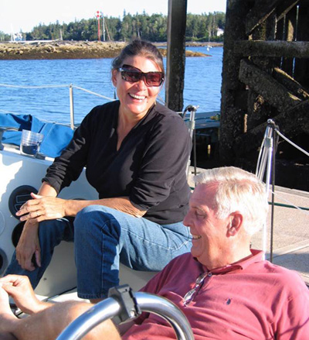
Jan’s Legacy Lives on
Watch the lovely story behind the newly opened, Jan D Marshall Centre of Excellence for Alström Syndrome, based at the Greater Baltimore Medical Centre at Harvey Institute for Human Genetics.
Robin Marshall’s (Executive Director of Alström Syndrome International) vision is to continue his late wife Jan’s work to uncover further insights into this ultra-rare condition. This has propelled Alström Syndrome International to establish the Centre, which will remain a wonderful tribute to Jan and a great step towards improved care and treatment.
https://embed.vidyard.com/share/Bg5rLwXrKfnJaMjKC4ZCCC

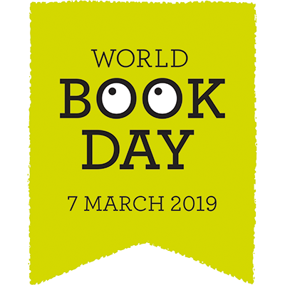
World Book Day
On World Book Day it’s all about sharing together the magic of books. RNIB would like every child to have the freedom to read by giving away World Book titles in either Daisy CD or Braille for FREE.
Get yours today, this will close at the end of March: https://www.rnib.org.uk/our-services/reading-choices/world-book-day-2019

LOOKfest! – looks great fun!
LOOKfest is an accessible summer festival for families. It will take place from the 26th - 29th July 2019, in rural Herefordshire. This festival is run by the charity LOOK UK, and the event is created by people who are affected by visual impairment, for people who are affected by visual impairment.
Lots of activities, shows and time to relax throughout the week-end of fun.
Have a look on their website for more information https://lookfest.org/

Be Quick! - International Camp, closing date approaching…
The 25th edition of the International Camp on Communication and Computers will take place at the Royal National College for the Blind, Hereford, from the 22nd – 31st July 2019.

This is an opportunity for youngsters aged between 16-22 years old to learn how Information and Communication Technology (ICT) and Assistive Technologies (AT) can enrich the lives of people who are blind or partially sighted. There will also be workshops focussed around CV writing, presentation skills and interview techniques. In addition to technology based sessions, the itinerary in previous years included hands-on skill based workshops such as dance, drama, music, goalball and cooking. Students from across Europe will also enjoy plenty of intercultural activities, communication and networking, planning for future studying and job integration, fun and leisure time activities.

VICTA are subsidising this trip but a contribution of £350 will be required, this will cover accommodation, food and entrance to ICC. If you are offered a place on this activity, a non-refundable deposit of £200 will be required for payment by 3rd May 2019 to secure your place.

If you would like to apply to attend ICC, the online application and further information can be found via the website link – the closing date for applications is the 5th April 2019 https://www.victa.org.uk/icc-2019/

Discounted Travel, Free Tickets, find out more…
RNIB has some useful advice about leisure and travel concessions which you may be eligible for, including information about the Blue Badge Scheme, free cinema and event tickets for your accompanying enabler and discounts via the disabled person’s rail card.

Take a peek on their website to find out more
https://www.rnib.org.uk/information-everyday-living-benefits-and-concessions-concessions/leisure-and-travel-concessions

Roaring good time on Rare Disease Day 2019!
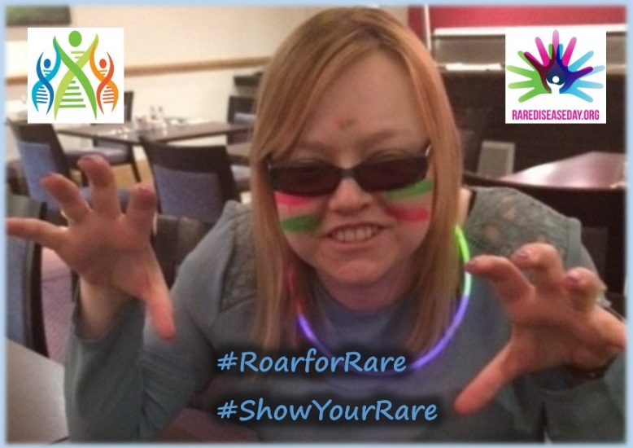
Rare Disease Day took place on the 28th February and this year its theme was ‘Bridging the gap between health and social care’. Both the children’s and adult clinics coincided with Rare Disease Day so it was a great opportunity for ASUK to raise awareness about the condition and how the specialised clinics make a difference. Families had a great time; creating posters, sharing their thoughts and having fun with face paint and nail polish!

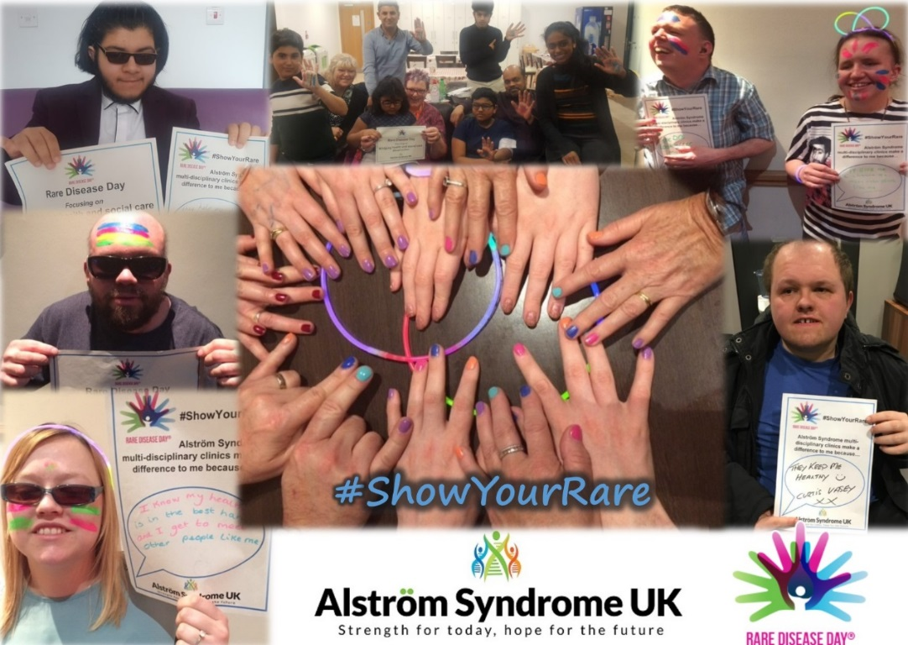

Honoured to be speaking at the House of Lords
Thank you to the Conservative Muslim Forum (CMF) for inviting us to speak at the House of Lords to share information about the important work of Breaking Down Barriers (BDB).

It was a fabulous evening with very interesting presentations from the CMF and from Jnetics who are one of the member charities of BDB. We discussed the role of BDB in supporting patient organisations, support groups and community networks to develop supportive and inclusive services and to work in collaboration to share examples of good practice and to develop accessible resources so that families understand genetic risk and can make informed choices.

Jnetics spoke about their GENEius Project and their plans to provide an education programme and carrier screening to people within their communities. CMF Chair, Mohammed Amin discussed genetic risk and the importance of genetic testing.

The evening concluded with a question and answer session. Representatives from different communities joined together to share their knowledge and experiences. We would like to say a big thank you to CMF for welcoming us to the forum, we look forward to future collaborations.

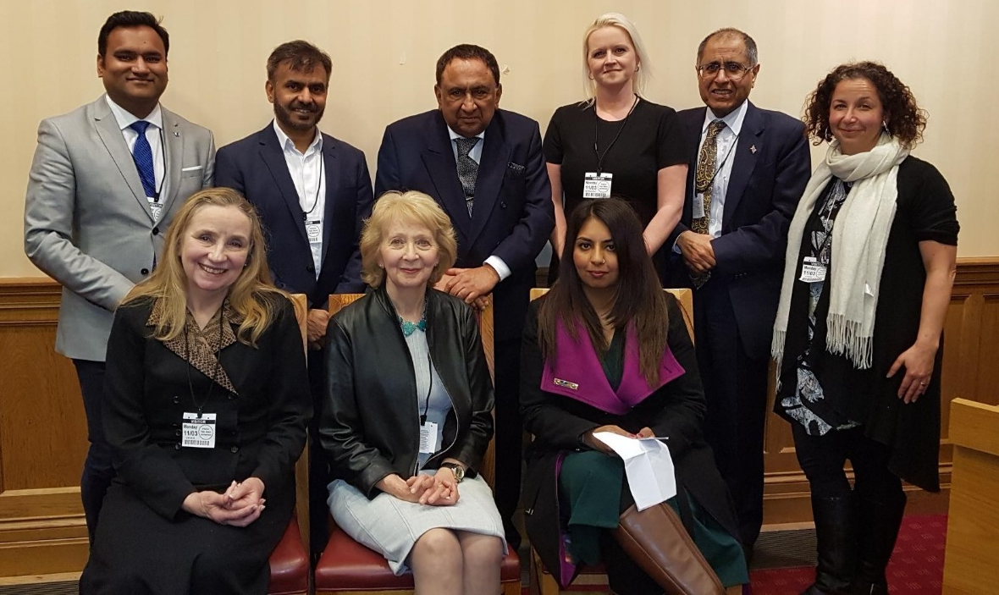

Top left to right
CMF Secretary – Faruk Miah, Immam Shakeel Kunwar, Lord Sheikh, ASUK National Development Manager and BDB Project Lead, Kerry Leeson-Beevers, CMF Chair – Mohammed Amin, Executive Director, Jnetics - Katrina Sarig
Bottom left to right
CMF Executive Member – Suzy Webb, Sylvia Adams Charitable Trust Director – Jane Young, BDB Community Engagement Manager - Asya Choudry

Calling for Government Action!

ASUK joined over 125 patient organisations who have signed the Rare Disease UK’s open letter, asking the Government to review and refresh the UK Strategy for Rare Diseases. This coincided with Rare Disease Day and has now been sent to Baroness Nicola Blackwood, the Minister in charge of rare diseases.

Baroness Blackwood presented at the Rare Disease UK, Westminster Reception for Rare Disease Day. She discussed her own diagnostic journey of having a rare, undiagnosed condition, for 30 years and the challenges it caused.
At the reception, she announced the new National Genomic Healthcare Strategy to ensure the UK can offer a predictive, preventative and personalised health and care service for people who are affected by rare diseases.

The full information about this Genomic Strategy can be found on the Gov.UK website:
https://www.gov.uk/government/news/health-minister-nhs-must-lead-the-world-in-genomic-healthcare

The promises are:
- every person with a rare disease will have a dedicated person responsible for coordinating their care

- every patient with a rare disease will be given an ‘alert card’, including information about their condition, treatment regime and contact details for the individual expert involved in their care

- every child with a rare condition will be transferred to appropriate adult services when they reach the age of 18, even if that adult service is not the commissioning responsibility of NHS England

Some of this is in place for people who are affected by Alström Syndrome but we must make more improvements to ensure everyone who is affected by Alström Syndrome is supported now and in the future.

Carers UK
With 6.5 million carers across the UK, it’s good to know where to get additional advice and support, should you need it. Charity, Carers UK offer advice, information, support and factsheets which can be downloaded from their website regarding benefits and support which is available.
Further information can be found on their website https://www.carersuk.org

Easy Fundraising – shopping has never felt so good!
Did you know that you can support Alström Syndrome UK by shopping online? Every time you shop online via easyfundraising at one of the 3,300 retailers including John Lewis, Aviva, Sainsbury’s and Booking.com, a donation will be made to Alström Syndrome UK, and it won’t cost you a penny.
Have a look on our website for more details, and get shopping today!
http://www.alstrom.org.uk/easy-fundraising-whilst-you-shop/

Take a peek!
Grab a cuppa and have a read through our latest newsletter, full of useful information and family stories. Read what is was like to ‘reach for the sky’ and fly a plane, apply for a ‘Big Activity Grant’ or let us know what you’re up to!
You can also catch up with any past copies you have missed – they are worth a peek! http://www.alstrom.org.uk/newsletters/

From us all at ASUK
Thank you for your support
https://www.justgiving.com/alstromsyndromeuk

