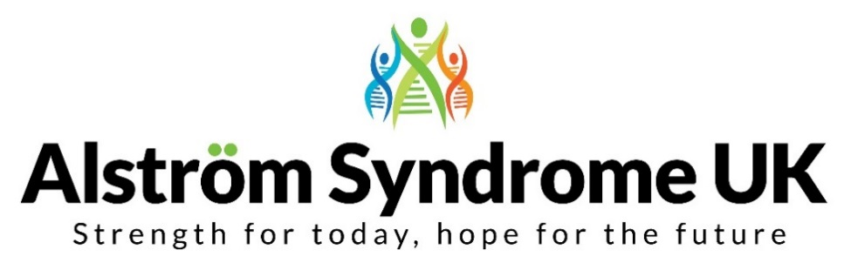
News, Views and Useful Links!

‘My Guide Dog and Me’
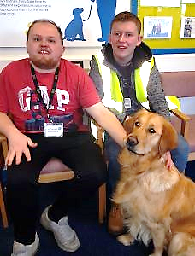
Have you ever wondered what having a guide dog is really like, how are you assessed and what training is involved?
Meet Kion and Curtis, they have both passed their guide dog assessment and are now on the waiting list to have their first guide dog…
Following their assessment, they were both invited to Shireview Guide Dog centre in Leeds (photo right) to get used to walking the dogs. They began learning how to look after a guide dog and their essential needs such as grooming. They were given lots of time throughout the visit to ask questions in preparation for the arrival of their guide dog.

We are all excited to find out who their new furry friend will be…
Follow their journey to discover the highlights and challenges along the way http://www.alstrom.org.uk/my-guide-dog-and-me/
Activities for all… Hi de Hi Campers!
Ever heard of Woodlarks Campsite?
They offer camping breaks for all abilities... in 12 acres of beautiful woodland and green spaces. From the 20th - 27th July 2019 they have a camp for people affected by visual impairment. It is open for all ages.
Sounds great fun, why not take a peek http://www.woodlarks.org.uk/…

Victa organise activities to bring together children, young people and their families who are affected by visual impairment to socialise and have fun. There is still time to apply for their summer activities; whether your ideal trip is a theatre trip to see an audio described version of Les Miserables, sailing the high seas on one of their adventure holidays or a fun family day – they have something for everyone. You can find further information and apply online https://www.victa.org.uk/victa-activities/

It's anyone's game!
Para sport Ambassador, Jonnie Peacock is inspiring others to have a go at sport, no matter what your ability
https://www.bbc.co.uk/sport/av/get-inspired/47629509

This is based around para sports ambition to create a fun and vibrant community for players, parents and coaches to share their experiences of para sport, and find useful hints, tips and information on inclusive opportunities across the UK.
Go to the para sport website and enter your postcode to find inclusive sports in your area https://parasport.org.uk/

Best things come to those who wait…
Braille Lego Blocks have been in the planning since 2011, but the first prototypes have been developed and are currently being tested so let’s keep our fingers-crossed that this goes well so we can see these being available next year…
It is hoped that these will enable children to learn Braille whilst having fun with their friends and classmates.
RNIB have the full news story on their website
https://www.rnib.org.uk/about-us/media-centre/latest-media-releases/lego-launch-braille-brick-concept

See us, Hear us, Notice us
Often it can be easy to forget that siblings, who have grown up with a brother or sister with a disability, have their own story to tell. They have often had challenges; high and lows and many siblings play a huge role in helping to support a sibling.
The Rainbow Trust Children’s Charity have started a campaign ‘See us, Hear us, Notice us’, they have produced a report which outlines why sibling support should be valued and funded more highly. You can find further information and the full report on their website https://rainbowtrust.org.uk/seeushearus
The charity Sibs also offers practical advice, information and support https://www.sibs.org.uk/

Biggest overhaul to the Blue Badge Scheme
Did you know that the Blue Badge scheme is to undergo the biggest changes since the 1970s?
From April 2019, the scheme will be expanded to include people with what is often described as ‘hidden disabilities’, such as mental health issues or autism.
Automatic entitlement to the Blue Badge will be extended to those in England who score 10 points under their Personal Independence Payment (PIP) mobility test of being "unable to undertake any journey because it would cause overwhelming psychological distress to the claimant".
Those who get PIP mobility for other reasons will not qualify for a Blue Badge automatically, but they may still be able to qualify for a Blue Badge if they fall into one of three groups:
- ‘They have an enduring and substantial disability, the effect of which is that the person is unable to walk or undertake a journey without it causing very considerable difficulty when walking’.

- ‘They have an enduring and substantial disability, the effect of which is that the person is unable to undertake a journey without there being a reasonably foreseeable risk of serious harm to the health and safety of that person or any other person’.

- ‘They have an enduring and substantial disability, the effect of which is that the person is unable to undertake a journey without it causing very considerable psychological distress to that person’.
People in England who fall into one of these three groups will qualify for a Blue Badge (regardless of whether they get PIP or not). However, to qualify they will need to be assessed by their local authority.
There are many disability rights campaigners championing these changes, but many people who currently have a Blue Badge, also feel there aren’t enough disabled parking spaces available.
The charity Disability Rights UK has further information on their website https://www.disabilityrightsuk.org/news/2019/january/we-welcome-extension-blue-badge-scheme-those-hidden-disabilities
Get in touch to let us know your thoughts and we can feature these discussions in the next e-news.
Breaking Down Barriers at the Luton Health Event
As part of the Breaking Down Barriers project, ASUK was delighted to host the Health Awareness and Genetics Event in Luton, alongside Flying Start Luton and Public Health Luton for families and professionals.
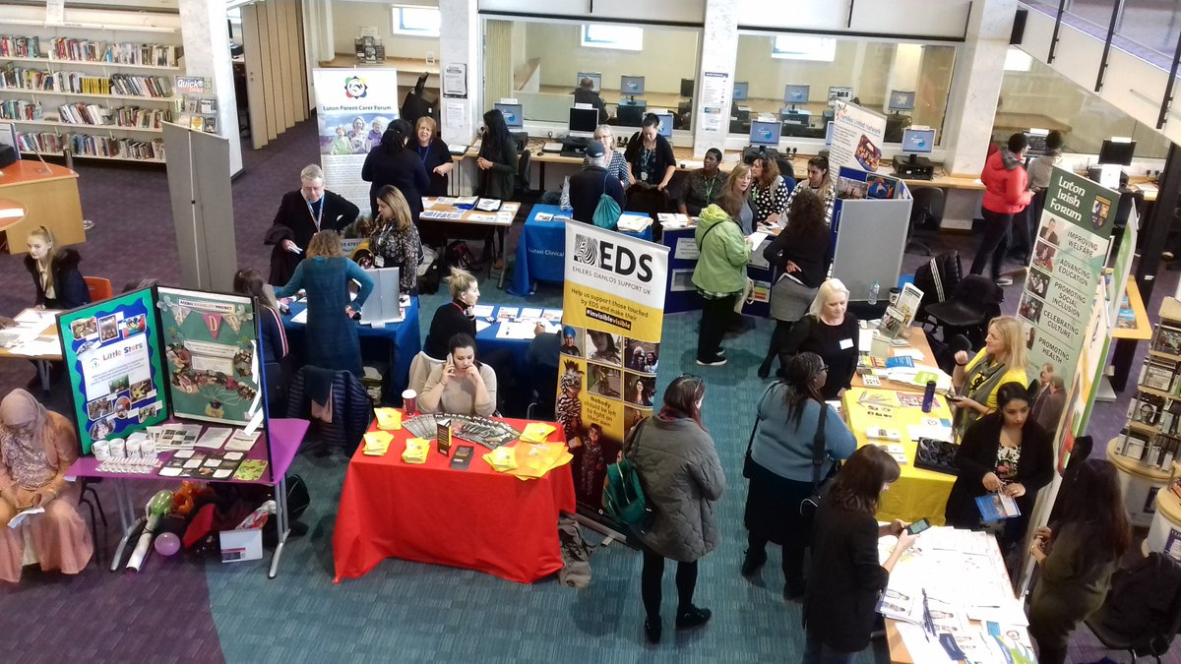

The event provided an opportunity to link services together and explore areas for development, especially in terms of referrals to genetic services.
For more information about the Breaking Down Barriers project go to
http://breaking-down-barriers.org.uk/
Alström Global
ASUK Trustee, Alex Griffiths-Rayson and ASUK Chief Executive, Ann Chivers are excited to be heading off to the Alström Syndrome International conference from the 2nd – 6th May 2019 in America. This is a great opportunity to meet families and professionals from around the globe, to discuss research opportunities and how we can work together to share experiences and knowledge to make a difference now and in the future. Keep up to date with the event at http://www.alstrom.org.uk/around-the-world-with-alstrom-alstromglobal/
You can follow us at the event on social media #AlstromGlobal
At the ‘heart’ of the matter
Cardiomyopathy UK hold several family information events throughout the year to enable people affected by cardiomyopathy and other heart conditions, to discover more and ask questions to the experts in this field. The events also give a good opportunity to meet other people affected and hear their experiences too.
Please go to the Cardiomyopathy website to find out more https://www.cardiomyopathy.org/open-days-2019/open-days-2019
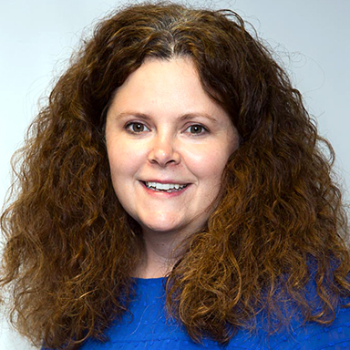
Thank you!
After many years on the Board of Trustees, and 7 years as the Chair of ASUK, Michelle Hough has decided to step-down from her role. Michelle has led many changes throughout her time on the Board and helped to raise further awareness of Alström Syndrome and campaigned for the rights of many people with disabilities.
Trevor Parkin, the Chair of ASUK thanked Michelle on behalf of the board:
‘We would all like to say a huge thank you to Michelle for the commitment and passion she has contributed, helping ASUK to grow and develop into a robust and stronger organisation. ASUK will always be grateful for your focus and creativity.’
We know this isn’t goodbye, as Michelle will still be campaigning and championing the cause of Alström Syndrome.

After Easter!
We know how tricky this time of year can be when you are trying to watch what you eat, here’s a few links to some tasty alternatives to try.

Diabetes UK have some delicious options for you to try, including Easter biscuits; https://www.diabetes.org.uk/guide-to-diabetes/enjoy-food/cooking-for-people-with-diabetes/seasonal-cooking/easter-recipes

Why not have a look on the Change 4 Life website, they have some eggsiting!! healthy alternatives and delicious meals for you to try https://www.nhs.uk/change4life/recipes

From us all at ASUK

Thank you for your continued support
https://www.justgiving.com/alstromsyndromeuk

