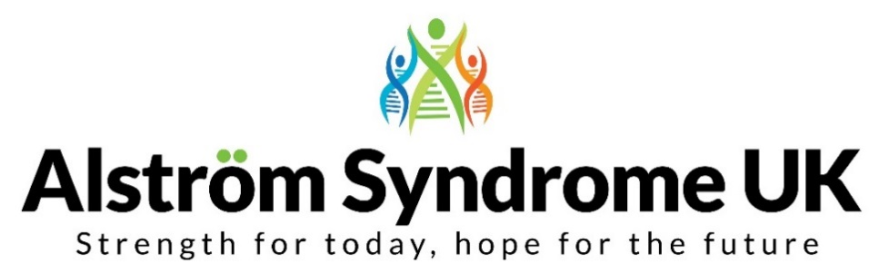
News, Views and Useful Links!

Around the World with Alström

ASUK Trustee, Alex Griffiths-Rayson and our Chief Executive, Ann Chivers set-off on the 30th April 2019 to attend the Alström Syndrome International Conference in Texas, USA. The event was spread over 5 days from the 2nd – 6th May 2019 and included family and professional seminars, workshops, and a chance to network with families and professionals.
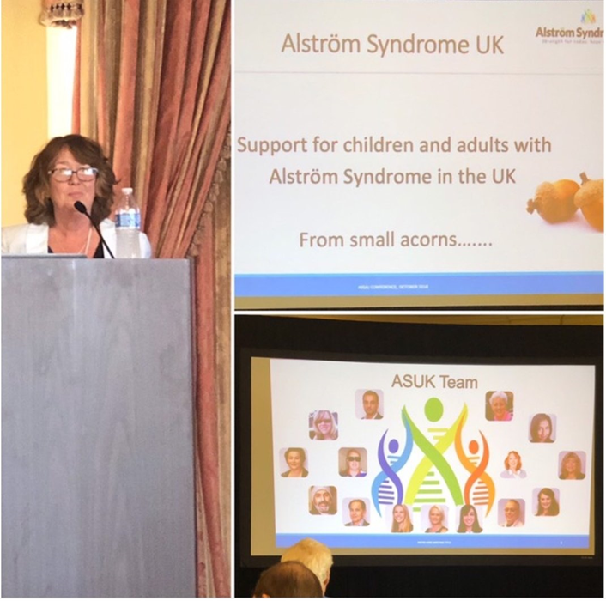
It was an opportunity for people affected by AS from all over the world to come together and share their experiences and meet other people affected by this ultra-rare condition.

We were very excited to be taking part as well as presenting. Ann talked about the journey of ASUK and how working together on a global scale can vastly improve awareness and research worldwide.

Ann and Alex enjoyed catching up with families, friends and professionals – they all had one thing in mind; improving the lives of people affected by Alström Syndrome.

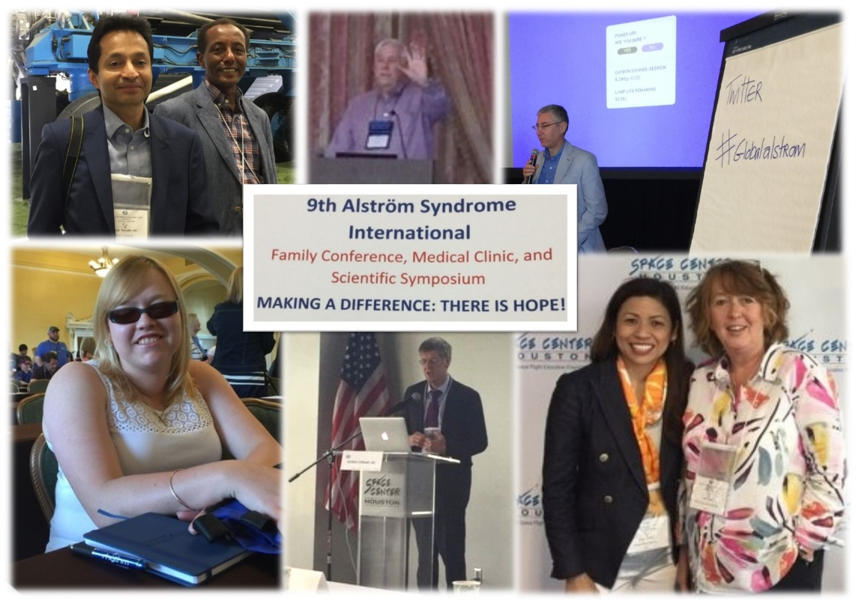

A huge thank you to ASI for inviting Alex and Ann to present.

Further photos and information about the event will be published in in our Summer newsletter.

Remember to use #AlstromGlobal
raising awareness together!

Bowled Over by the Adventure of a Lifetime
A personal account from Curtis Vasey and Taylor Vasey
“We have always wanted to watch cricket in a warmer climate and heard that England were playing Test Cricket in Barbados this year. We started planning how we would get there and how much it was going to cost. We successfully applied for the ASUK Big Challenge Grant to fund part of the trip, for this adventure of a lifetime. After much planning and excitement, the day arrived to start our journey to Barbados for 10 days of cricket and activities.
We caught the train to Gatwick Airport to board our flight to Barbados, leaving a cold, wet Scarborough behind us. Our brother, Rio and our Dad, Brian were part of our party of four. We had good seats on the plane and all sat together for the journey that lasted 8 and a half hours. The staff at Virgin Airlines were very helpful and the service was very accessible.
We landed in Barbados in the late afternoon and had pre-booked transport to take us from the airport to the hotel. The transfer took about an hour. The temperature was 29 to 30 degrees for the duration of the holiday.
The hotel staff were kind and helpful. Sadly, the hotel food wasn’t the best. We had a walk to explore the local area, on the first day. The beach was sandy and we could hear birds singing. There were lots of uneven, narrow paths and these went up and down. Negotiating the paths, was a challenge!
The cricket matches were an hour away so there was 2 hours travelling each day. We travelled by bus in a group, from the hotel to the Kensington Oval at Bridgetown and we sat in a general seated stand. We could hear the people in the party stand and listened to the cricket radio commentary on our own headphones. We took our own radios with us. The atmosphere was good, and the weather was warm, although we were sat in a shaded area. Sadly, the England cricket team lost all their matches against the West Indies, on all 4 days.
We didn’t have the opportunity to meet any current England test cricketers but did meet Darren Gough, a former England cricketer. Darren is involved in coaching from the side-lines, when not playing, and was helpful.
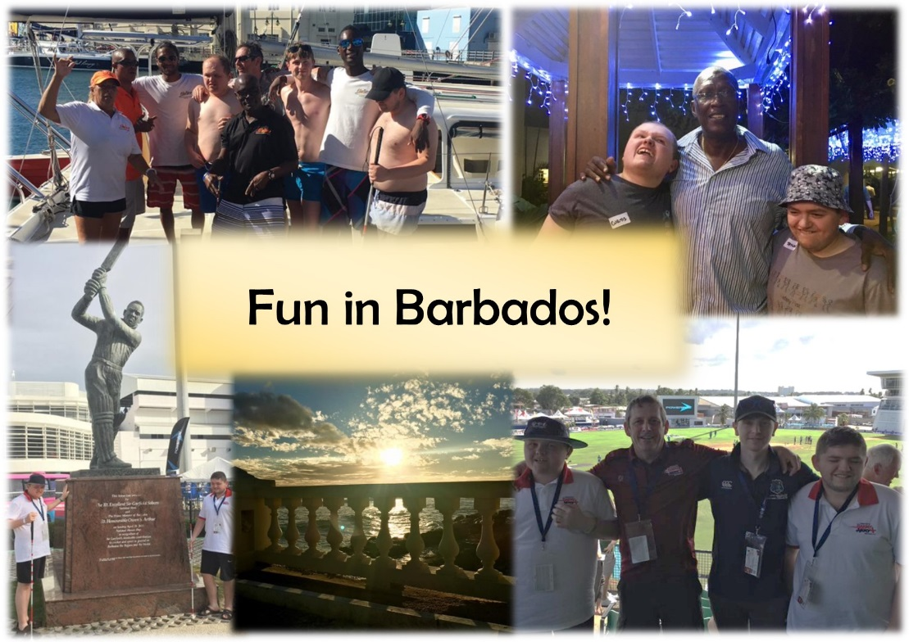
The all-inclusive trip on a Catamaran was the best event for us both. The trip lasted from 10am to 3pm. We set sail and the large boat headed out to sea. It was a very relaxing day trip. During the day, we enjoyed rum punch with fruit and fresh salmon. We were all able to enjoy the freedom of swimming in clear sea water with floats. It was great fun!”

“We took lots of photographs and would like to share a selection of them with you from our Big Challenge”.

Feeling inspired to have your own adventure?
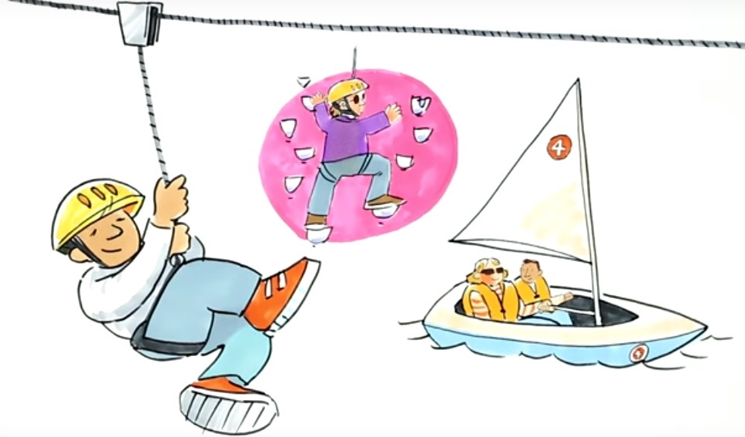

What is the Big Activity Challenge?

Apply for a small grant to pay towards an active adventure or activity then, provide some photographs and write an article for the ASUK newsletter, telling us all about your experience. Such as how accessible it was, what you achieved, or even if you’re going to take it up as a new hobby. If you would rather tell us about your experience, we can help you produce a podcast for the ASUK website.

Who knows, you may inspire others to try out new activities too!

What will inspire you?
Running, dancing or maybe sharing your favourite hobby…

Well done to David Lunt who once again ran in the Virgin London Marathon raising funds for several charities, including ASUK.
He raised a fantastic £250 for ASUK, thank you David!

Has David inspired you to make a difference, what about a dance-athon or sponsored silence! If you are not feeling as energetic as David what about a coffee morning with friends and family; nothing beats having a catch up over tea and cake, or raising vital funds through your hobbies, what about selling those knitted scarves!

Whatever inspires you, it will make a difference to the lives of those affected by Alström Syndrome now and in the future.

We would love to hear from you if you would like any help organising your fundraising event or if we can give you any information to help you fundraise.

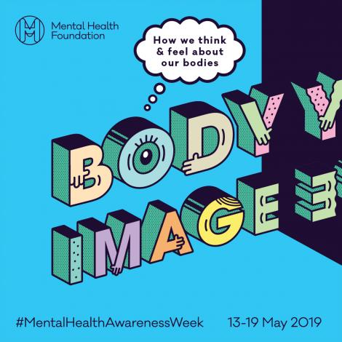
Don’t Suffer in Silence

Mental Health Awareness Week took place from 13th - 19 May 2019. The theme this year was ‘Body Image’ and how we think and feel about our bodies.

Body image issues and mental health issues can affect all of us at any age and at any time of our lives. During the week, the Mental Health Foundation published new research as part of their campaign for change.

Their research says that ‘over a third of UK adults have experienced anxiety or depression due to concerns about their body image. With social media attributing to 1 in 5 UK adults experiencing worry and concern about their body image following images posted on social media. It is easy to see how our body image can affect us daily and affect our mental health’.

Campaigners are highlighting the need for everyone to Be Body Kind and using effective regulation on how body image is portrayed. We all have a role to play in this to make change now and in the future.

You don’t need to suffer in silence, help is out there:
- The charity Mind provide information and support to empower anyone experiencing a mental health problem. They also offer top tips on how to support someone who is affected and they offer a help-line and legal-line to offer advice.
- The Samaritans offer a free 24-hour helpline dial 116 123, where calls are taken in confidence.
- Rethink Mental Illness offer advice, information and support in your local area.
- A new service has just been launched; ‘Shout for support in crisis’. This is the UK’s free 24/7 text service for anyone who is in crisis at any time.

Go to the ASUK website to find full information including links and helpline numbers:
http://www.alstrom.org.uk/mental-health-awareness-week-2019/

Rare Disease UK Report on Mental Health Impact
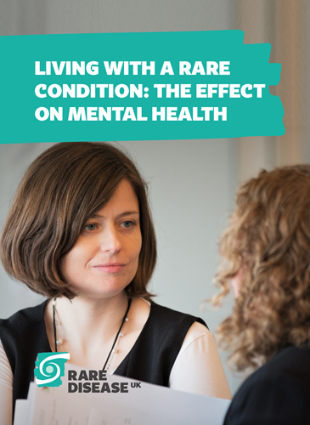
With many rare diseases being chronic, complex and often taking many years to diagnose, the effect on mental health can’t be underestimated. Living with a rare condition can have a huge impact on our lives, including anxiety, stress, low mood, emotional exhaustion and suicidal thoughts, for both the patient and the carer.
Our mental wellbeing is just as important as our physical health and Rare Disease UK set-out in 2018 to explore this further.

In 2018, Rare Disease UK published a report on the mental health impact of living with a rare disease. It sets out its findings and recommendations. You can read the full report here: https://www.raredisease.org.uk/wp-content/uploads/sites/7/2018/07/living-with-a-rare-condition-the-effect-on-mental-health-pdf.pdf?utm_source=hootsuite
It’s Time to Talk!

Did you get chance to watch the ‘Royal Team Talk’ programme on BBC One?
The Duke of Cambridge and professional footballers Gareth Southgate, Peter Crouch, Thierry Henry, Danny Rose and Jermaine Jenas tackled the importance of talking about men’s mental health in an open and honest discussion.

‘Mental health difficulties don’t discriminate, they can happen to ANYONE at ANYTIME.
Let’s take the time to listen and really share our experiences and thoughts with those close to us’.

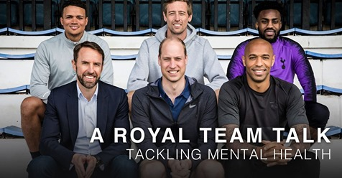

In case you missed the ‘Royal Team Talk’ on BBC One on Sunday, you can view for a limited time via the BBCiplayer.

https://www.bbc.co.uk/iplayer/episode/m0005d27/a-royal-team-talk-tackling-mental-health

'Who Put That There!'

It makes sense doesn't it, to remove obstacles, but our streets are littered with them, whether it is bins, cars or advertising boards. These all make it potentially dangerous for people affected by sight loss to navigate their way around.
The Royal National Institute for the Blind, RNIB has said that advertising boards or A-boards are the main cause of injury to blind people on our streets. Leaving people feeling vulnerable and isolated.
The organisation's campaign entitled ‘Who Put That There’ is aiming to encourage people to report A-board trip hazards.

Let's make everywhere accessible for everyone...

You can catch up on the full story by going to the BBC website and find out how you can get involved https://www.bbc.co.uk/news/uk-northern-ireland-politics-47707564

Go Mouse less!!

The 16th May 2019 marked the eighth Global Accessibility Awareness Day #GAAD.
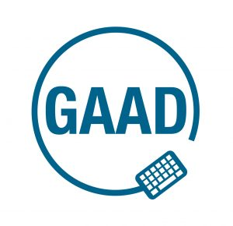
The day aims to get everyone talking, thinking and learning about how to make digital technology accessible and inclusive for all people affected by different disabilities.
Having accessible technology on our websites, mobile phones and web services such as Twitter and Facebook is so important to ensure we can all communicate easily and effectively. Being unable to do this, can leave people feeling isolated.

Let’s make technology accessible, but where do you start?

The organisation behind GAAD offer their advice and ask us to go ‘mouse less’ for an hour!
Further information can be found on our website including website links to GAAD, RNIB, DeafBlind UK and Ability Net, where you can find lots of top tips and advice.

http://www.alstrom.org.uk/gaad-go-mouseless/

ASUK Top Tips to ensure your Social Media reaches everyone:

- Add brief descriptions to your photos and images
(On Facebook this will need to be done within the posts, Twitter and Instagram this will be found in your settings, so descriptions can be added to the image)

Use CamelCase in hashtags
When you're using hashtags, always use CamelCase (capitalise the first letter of every word). For example, you would write #AlstromSyndrome, rather than #alstromsyndrome. It helps screen readers pick-out each word effectively
- Don’t use too many emoji’s – screen readers aren’t so keen on these
- Subtitles, should be available on videos
- Video audio, doesn’t necessarily need to be audio described as long as the audio provided is as important as the imagery and tells the same story.

What are your top tips?
Please get in touch we would love to hear from you.

The Valuable 500

Did you catch Caroline Casey, from the Valuable 500 on BBC One’s Breakfast show? Caroline Casey who is registered blind, explained how she hid her disability from her employers. 'The question is not how, but why?'

Caroline highlighted the need for more businesses to put disabilities on their agendas – Caroline says, ‘this could potentially unlock the 1.3 billion people affected by disabilities, globally. Adding ‘Surely inclusion can only help not hinder businesses...’

Do you know a business that could do more, why not send them the link to help them sign-up today https://www.thevaluable500.com/

ASUK Family Event

You will all be pleased to hear, ASUK are beginning to plan a family gathering to bring as many of us together as we can, for a day full of fun activities, useful information and interactive workshops.
We are currently looking at dates and making plans, but for now we can tell you the location will be somewhere central with easy travel links and sometime in October 2019.

Planning for the big event – tell us your ideas and views
Whilst we get stuck into planning the event, we’d love for you to share your thoughts with us about what you would like to see or do.

What would be your favourite activity; would it be holding an exotic animal, zorbing or something more chilled out like a yoga session?
Are there any organisations you would you like to see showcasing their services or products, such as Guide Dogs for the Blind or technology companies such as Apple or Orcam?
Join us in making this event extra special…
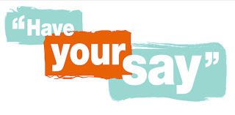

Please get in touch, Catherine is looking forward to hearing from you!
Her email address is Catherine.lewis@alstrom.org.uk, please ensure all your ideas and suggestions are sent in by the 1st July 2019 so we have plenty of time to plan.
From us all at ASUK
Thank you for your continued support
https://www.justgiving.com/alstromsyndromeuk

