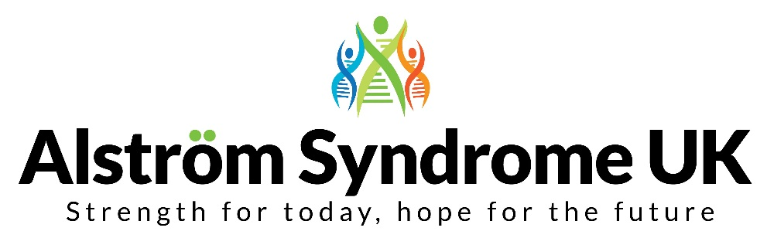

Equality and Diversity Form

Alström Syndrome UK is committed to equality and valuing diversity in its workforce and across all of its services. This includes building an accurate picture of the make-up of the workforce in encouraging equality and diversity, both for those we employ and for those who apply to work with us.

The information contained in this form will not affect your application in any way and is voluntary. We appreciate your cooperation.

The information you provide will be anonymised, confidential, and will be stored securely. It will only be used for statistical purposes.

Please get in touch if you would like the form in an alternative format such as large print or Braille.

Full Name:

Position applied for:

Date:

Gender Male Female Prefer not to say
Are you married or in a civil partnership? Yes No Prefer not to say
Age 16-24 25-29 30-34 35-39 40-44 45-49 50-54 55-59 60-64 65+ Prefer not to say
What is your ethnicity?
Ethnic origin is not about nationality, place of birth or citizenship. It is about the group to which you perceive you belong. Please tick the appropriate box:
White
English Welsh Scottish Northern Irish Irish
British Gypsy or Irish Traveller Prefer not to say
Any other white background, please write:

Mixed/multiple ethnic groups
White and Black Caribbean White and Black African White and Asian Prefer not to say Any other mixed background, please write:

Asian/Asian British
Indian Pakistani Bangladeshi Chinese Prefer not to say
Any other Asian background, please write:

Black/ African/ Caribbean/ Black British
African Caribbean Prefer not to say
Any other Black/African/Caribbean background, please write:
Other ethnic group
Arab Prefer not to say Any other ethnic group, please write:

Do you consider yourself to have a disability or health condition?
Yes No Prefer not to say
What is the effect or impact of your disability or health condition on your ability to give your best at work? Please write in here:

The information in this form is for monitoring purposes only. If you believe you need a ‘reasonable adjustment’ to carry out your role, then please discuss this during the recruitment process.

What is your sexual orientation?
Heterosexual Gay woman/lesbian Gay man Bisexual
Prefer not to say
If other, please write:

What is your religion or belief?
No religion or belief Buddhist Christian Hindu Jewish
Muslim Sikh Prefer not to say
If other religion or belief, please write:

What is your current working pattern?
Full-time Part-time Prefer not to say
What is your flexible working arrangement?
None Flexi-time Staggered hours Term-time hours
Annualised hours Job-share Flexible shifts Compressed hours
Homeworking Prefer not to say If other, please write in:

Do you have caring responsibilities? If yes, please tick all that apply
None Primary carer of a child/children (under 18)
Primary carer of disabled child/children
Primary carer of disabled adult (18 and over) Primary carer of older person
Secondary carer (another person carries out the main caring role)
Prefer not to say

Where did you hear about this vacancy?
ASUK Website Facebook Twitter Linked-in Third Sector advert
Public Sector advert
If other, please write:

Please return by email to Catherine Lewis at Catherine.lewis@alstrom.org.uk
or post to Alström Syndrome UK, 4 St Kitts Close, Torquay, Devon TQ2 7GD

