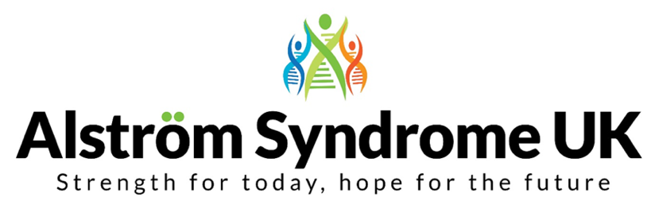

Alström Syndrome, Past, Present and Future
Saturday 19th October 2019 – Family Information Day
Holiday Inn, Birmingham M6, J7 - Chapel lane, Great Barr, Birmingham B43 7BG

The theme of this year’s get together is People Power!

ASUK would like to invite you to share your experiences, unite with old friends and have fun making new ones; as well as joining information sessions, demonstrations and workshops. We are very excited to announce you will be the first to see a live demo of the new patient registry!

During the event, we would also like to ask you to share your journey and experience of diagnosis, in the hope we can develop our understanding of what helps and hinders families and what information would be helpful for you and your loved ones. Since the 2017 conference there have been 10 people diagnosed with Alström Syndrome. There may be more people out there still to receive a diagnosis and we want to do all that we can to make sure people have access to the specialist medical care and support as soon as possible. We need your help so we can work together to help other families. As technology would say, what information needs to go into the sat-nav to help us all find our way?

Booking Details

Name:
Address:
Telephone Number: Mobile:
Email address:
Please list the names of everyone attending the conference and include the ages of any young people under the age of 18:

Whilst families share their journeys and connect during the day, children will be entertained with a day out at Drayton Manor Theme Park. Please list the names of any children wishing to attend and the name of the person supporting them on the day.
Name of Children attending and their ages Parent/ Guardian/ Volunteer
1. 1.
2. 2.
3. 3.
4. 4.
5. 5.
All food, refreshments and activities will be provided free of charge throughout Saturday.
Please let us know of any dietary requirements or allergies below:

Information Packs will be distributed at the event. Please indicate how you would like to receive your pack by deleting the options that don’t apply:
Standard Print Copy Large Print Copy (font size 16) Braille Copy
Which day(s) will you be attending | Number of adults attending | Number of children attending
Friday 18th October 2019 - Informal Get Together as families arrive
Saturday 19th October 2019 - Family Event 9:00 am – 17:30 pm
Saturday evening – Dinner and entertainment 18:30 pm until late
Early bird rate until 16th August 2019: If you need accommodation the Holiday Inn have offered an early bird rate of £65.00 per room, per night on a B&B basis, family rooms (sleep 2 adults and 2 children) and accessible rooms are available but these rooms are limited so please contact the hotel on 01604 931504, choose option 1 for reservations and quote AL1 Alström Syndrome UK to ensure the best rate.

Have you booked accommodation? Friday night
(Please delete one or both) Saturday night
No accommodation is needed

We continue to provide family events and activities free of charge to ensure as many families as possible can attend. Donations are always greatly received so we can continue delivering these vital services. Donations can be made easily and securely via our JustGiving page https://www.justgiving.com/alstromsyndromeuk

Please email the completed booking form to Catherine Lewis at Catherine.lewis@alstrom.org.uk
Alternatively please post to: Alström Syndrome UK, 4 St Kitts Close, Torquay, Devon TQ2 7GD
Please ensure booking forms are returned promptly to secure your place.

