A visit to Games of Thrones in Ireland – A trip of a lifetime!
A personal account from Amy Stannard-Tilley
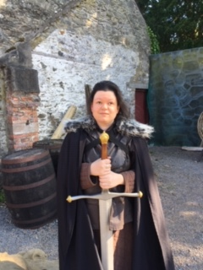
“I was full of excitement as we set off from my house of Friday 5th July for what was going to be a trip of a lifetime. The date by design being my 35th birthday. We reached the airport some time before we were due to fly. This plan was a good one as we had some fun when going through customs and then our plane was delayed twice so we arrived in Belfast later than planned. We took a taxi to our hotel complex, unpacked and as the weather was so warm decided to take a walk through Belfast centre.
The hotel we stayed in was perfectly located right in the heart of Belfast. I was eager to explore the place I had come to as a baby but being too young could not remember. We walked through streets going all the way down to the botanical gardens which were beautiful in the warm evening sunlight. We sat by a fountain in the grounds as birds in the trees all around us sung, as the sun fell down on the 18th century glass work of the tropical plant house standing nearby.
After walking through the gardens we went all the way up to where the Ulster museum was located so that we knew where we needed to go when we would return the next day. By this time, it was getting late so we walked back through town and found a little Thai restaurant for our meal before returning to our room. I knew I would have to be up early so quickly settled down to sleep but I was too excited for the next day so it took me a long time to fall asleep.
Saturday 6th July
Originally I decided that we should use public transport to get from the hotel to the Game of Thrones site to save money but found that for an extra payment we could arrange for a door to door service on Game of Thrones transport driven by an extra from the series who would act as our guide for the entire day. I would encourage anyone coming to the tour to do this if they can, as it was an incredible edition to my journey.
We weren’t due to be picked up until 1pm so we got ready and set off to have breakfast in the nearby pub. Choosing to sample a local delicacy, I tried Irish breads and really enjoyed them.
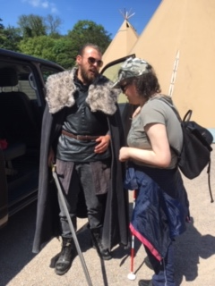
We then had a couple of hours free so we decided to explore another section of Belfast town, that we had not had time to explore the night before.
We walked through the town and came down to a square where they had a series of street performances which they were calling a Busk-a-thon. As we were walking down Sherieda (my PA) said she could hear them playing the tune from Game of Thrones. I unfortunately could not hear this but as we entered the square I could hear them playing Christmas songs. We listened for a while before heading for more of the city. We stopped in a shopping centre where we came across a monument with tropical plants and ferns that for some absurd reason had golden sheep in the middle. We sat on the bench and stared at the flock statues in complete and utter puzzlement. We then left the area and returned to the hotel positively bursting with excitement.
When the car pulled up our guide Jamie stepped out of the car dressed all in costume despite the extreme heat of the day! He was dressed in a gambeson and leather over tunic with full trousers that he wore whilst he was an extra in the series. I am so glad I chose to have them pick us up because on the way he told us all about the places we passed on the way and lots of anecdotes about being on set.
As we came up to the castle and its grounds he also enthralled us both with tales of behind the scenes and the crew while they had been filming the series. Jamie’s tales were both illuminating and truly fascinating. Once we reached our destination we rolled through the grand gates into the castle as Jamie told us of how they had changed the landscape and the troubles it had caused for him and all those on set to maintain as the series was filmed. We got out in the courtyard and this is where our actual trip began and what an experience it was!
A tour of many parts, the first was looking round the courtyard as Jamie told us about the real history of the main castle that had been used as Winterfell for the first three series. As we went around he had brought pictures of how it had looked in the series and as we moved around the buildings he explained what they had changed and why. He also explained where the green screens had been located in order to create the special effects used in the show. Sherieda described in detail what the buildings looked like now as well as what is in the images that he was showing us.
We then moved to the next part of the tour down at another castle that was used to create the twins and the land around that was used repeatedly as several different sets throughout the many series. On the way, we passed the river which fell down to a massive salt water lock as Jamie told us how it was used in the Game of Thrones and having learned that I was also interested in ancient history told me about the many islands in the lock and the ancient history of the area which was on both counts truly illuminating.
As we arrived at the second part of the tour we walked up through a small wood in to large fields surrounding the area that was used as Robert’s and Tyren’s war camps in the series. Jamie explained the tricks they used to make it appear that there were hundreds of tents in the scene. For me, this was where the magic happened…I had been explaining to Jamie how things were audio described in the series and what they had chosen to and not to audio describe and he started to describe both the pictures he had brought with him and what we were looking at in contrast with deep detail. He had been listening to Sherieda describe things to me as we were going round and he naturally picked up what she was doing. Without being asked he started describing all that was around us and what was different in the images he and brought. This just made things even more extraordinary and magical and meant that it was even more accessible for me than I could have ever imagined.
We finished this part on top of the castle that and been used to create The Twins in the series before returning back to the main castle. The next and final part of the experience which I did not think was part of our particular tour was that we got to dress up in replicas of the real costumes worn on set and then shoot on the archery range. These had been used by actors playing characters such as John Snow while actually filming the show. Despite how much audio description you get on TV it is something else entirely to actually wear clothing made using old techniques and fabrics. To actually wear them and feel what the garments feel like is a dream come true for someone like me who is a fabric crafter. As well as shooting arrows while still dressed in traditional clothes was a true experience. Our guide, Jamie aided me to fire the bow and although I was the first blind archer he had had, he was brilliant in describing what it was he was asking me to do and I had a great time on the range.
All too soon our time at Winterfell was up and because we had run well over time we did not have time to visit the souvenir shop to get mementos of our time there, this was the only disappointing part of the whole trip. I really did not want to take off the costumes or leave the place!
As we had been walking around I had been talking with our guide and found out that we had much in common as both of us had a love of all things mythological and ancient and medieval history. We were his last tour for the day and he offered to take us the long way back to the hotel so that we could drive passed a large prehistoric henge that was nearby. I thought we would just drive passed but instead he got me out and guided me to it and showed me a Dolmen which is an ancient structure found across Ireland. A final experience in a day that was full of unbelievable experiences. It was a day I will never forget.
Jamie dropped us back at our hotel over an hour and a half later than he should have finished work and we reluctantly said our goodbyes to the most amazing guide I’ve ever met. That night we went out for tea to an Indian restaurant before returning back to our room as again we would be up early the next day.
Sunday 7th July
We were up early on what was to be our last full day in Belfast. I would’ve loved to stay longer but as that was not possible, we woke early and set off after breakfast.
We visited the Ulster museum and the Game of Thrones tapestry which we had planned to see as part of our trip. On the way, we stopped off at the tropical plant house that was part of the Botanical gardens. Despite the heat inside being almost unbearable it was a fascinating place with a couple of tactile displays that were truly informative. A tactile display of the building that we were standing in was extremely interesting but what was very informative was a series of diagrams showing the life cycle of a fern leaf, something I had not even considered before.
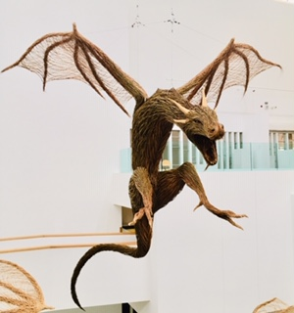
Walking through the entrance way of the museum we were greeted by a magnificent recreation in willow of the throne itself with a trio of dragons created by the same craftsman hanging from the ceiling several feet above. Unfortunately, I wasn’t able to get close or touch the throne as it was behind ropes. We took some time to go through the galleries dedicated to early Irish history that held several scenes of prehistoric history that was full of things I had never known and had a couple of interactive displays. I was so happy that I managed to identify the examples of fur and skin that were in one display. We progressed through the history of very early Ireland and as we moved through the displays found information about Dolmen’s that we had seen the day before.
When we came into the medieval section we found information about historical characters who I had been chatting with Jamie about the day before. When we finished learning about history of the area we moved to the exhibition we had really come to see. We entered the gallery where the tapestry, a massively long piece of embroidery, had been hung. We were not allowed to take pictures in the gallery, which was a bit of a shame but understandable due to what it has been made of.
When we walked in, Sherieda scanned a barcode on her phone which meant as we walked round she was given a record of what each of the images was depicting with its place in the series along with detail of the episode and some behind the scenes information as they were filming on set. It was worth its weight in gold as Sherieda, who has not seen all the series right up to its final end in series 8 which meant she could describe what the image was depicting with greater detail and accuracy. It allowed her to tell me what was going on in each image itself in contrast with the episode that it was representing and great detail of its colour and style as we moved from image to image. The interactive addition was a brilliant idea and it not only aided Sherieda but enhanced my enjoyment of the entire tapestry. For someone who is a lover of fabrics, especially tapestries, being able to see in the flesh an example of medieval style and technique it was truly an incredible part of my trip.
When we left the museum we walked back through Belfast to shop for gifts to take back home for friends and family before returning back to our hotel, very exhausted but very satisfied. Later that evening we had tea at a very fine Japanese restaurant before coming back to our room as we had to be up at a crazy time the next day.
Monday 8th July
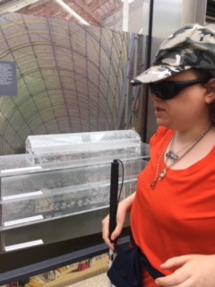
We left for the airport at a ridiculous hour! I was sad to be leaving Belfast, I would have loved to stay longer. When we reached the airport, our assistance on the Belfast side was far superior to Leeds and Bradford, as they stayed with us the entire way until we got on the plane. This was in complete contrast to the haphazard assistance we had had through Leeds and Bradford airport.
We arrived back in Leeds around midday and made our way home. We arrived to find Mum had put up a welcome home banner as she had been tracking us on the internet and knew when we would arrive.
Wow, what a trip!”

