News, Views and Useful Links!

ASUK Past, Present and Future Conference;
be quick to grab an early-bird rate!

Let’s celebrate 21 years together.
The planning for the ASUK conference on the 19th October is going well, and it is great to see lots of families are taking full advantage of the hotel’s early bird offer to join us for this informative day.

The event will be full of engaging presentations and interactive workshops, there will be opportunities to look at the best gadgets to support independent living and to find out about the technology our members find most useful. Why not bring along your gadgets or technology items which help you daily? and share your top tips in our interactive workshops.

You will also have the chance to network with other families and health professionals. After the day’s events, we will be having an evening meal together with our usual fun entertainment - last year’s disco went down a storm, so we have invited DJ Sam back again to help us celebrate 21 years together!

There is still time to book your place, but you only have until the 25th September 2019 to secure the early bird rate, so head across to the website to find full details of how to book http://www.alstrom.org.uk/save-the-date-19th-october-2019/

We look forward to seeing you all there!

A visit to Games of Thrones in Ireland, a trip of a lifetime!
A personal account from Amy Stannard-Tilley
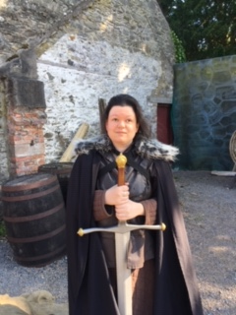
“I was full of excitement as we set off from my house of Friday 5th July for what was going to be a trip of a lifetime. The date by design being my 35th birthday. We reached the airport some time before we were due to fly. This plan was a good one as we had some fun when going through customs and then our plane was delayed twice so we arrived in Belfast later than planned. We took a taxi to our hotel complex, unpacked and as the weather was so warm decided to take a walk through Belfast centre.
The hotel we stayed in was perfectly located right in the heart of Belfast. I was eager to explore the place I had come to as a baby but being too young could not remember. We walked through streets going all the way down to the botanical gardens which were beautiful in the warm evening sunlight. We sat by a fountain in the grounds as birds in the trees all around us sung, as the sun fell down on the 18th century glass work of the tropical plant house standing nearby.
After walking through the gardens we went all the way up to where the Ulster museum was located so that we knew where we needed to go when we would return the next day. By this time, it was getting late so we walked back through town and found a little Thai restaurant for our meal before returning to our room. I knew I would have to be up early so quickly settled down to sleep but I was too excited for the next day so it took me a long time to fall asleep.
Saturday 6th July… read the full article on the ASUK website
http://www.alstrom.org.uk/game-of-thrones-trip-of-a-lifetime/
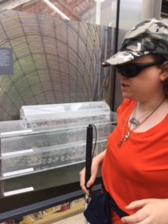
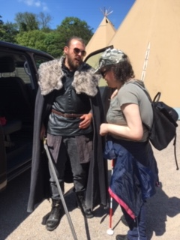
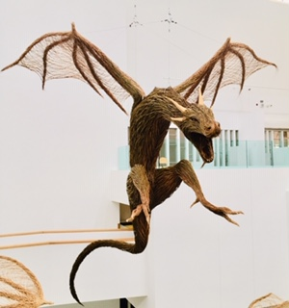

Feeling inspired to have your own adventure?
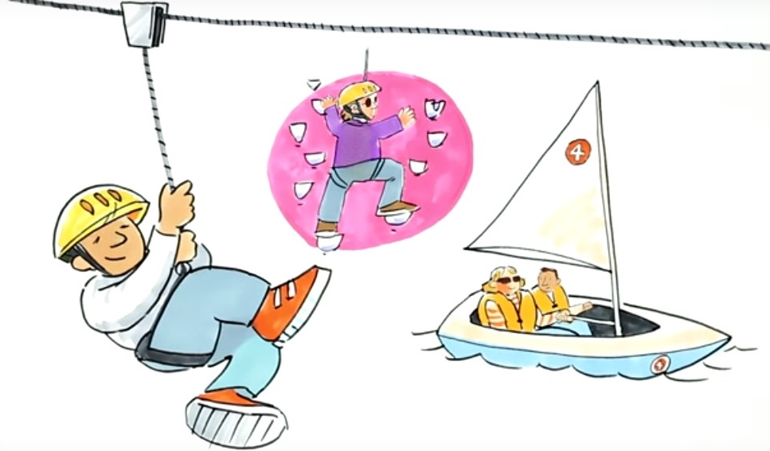

What is the Big Activity Challenge?
Apply for a small grant to pay towards an active adventure or activity then, provide some photographs and write an article for the ASUK newsletter, telling us all about your experience. Such as how accessible it was, what you achieved, or even if you’re going to take it up as a new hobby? If you would rather tell us about your experience, we can help you produce a podcast for the ASUK website.
Who knows, you may inspire others to try out new activities too!

Yes… you can fly!
Check this out, iFLY’s indoor skydiving, which is inclusive, accessible flying indoors for all – how fantastic! One of our members shows us how it is done!
https://www.iflyworld.co.uk/what-is-ifly/all-abilities/

We need you to make a difference today
Thank you to everyone who has sent their Early Years Questionnaires back. We have started to analyse the information we have received so far and are already identifying some interesting patterns of symptoms.
You still have time to make a difference today.
http://www.alstrom.org.uk/you-have-the-power-to-make-a-difference-in-just-15-minutes/
Parents Survival Guide
We all know parenting can be rewarding but at times it can be the greatest challenge. The charity Young Minds have resources and information to support parents and young people who are experiencing mental health difficulties. They also offer the ‘Parents Survival Guide’ which offers tips on how children can cope and where to find further help and support https://youngminds.org.uk/find-help/for-parents/

Carers need support too
Across the UK today 6.5 million people are carers, supporting a loved one who is older, disabled or seriously ill. That’s 1 in 8 adults who care, unpaid, for family and friends. Within our lifetime, there will be 9 million carers (source: CarersUK).
Looking after someone can be rewarding, but can be challenging and tough. Carers UK offer support, information and advice for carers across the UK and one of their factsheets which can give guidance on carers assessment is very helpful. https://www.carersuk.org/images/Factsheets/Assessments_-_England_factsheet_April2019.pdf

Accessible toolkit
Sadly, too many people still don’t get their health information in an accessible format which is suitable for their needs (i.e. Braille, audio, large print). The RNIB recognise this is an issue and as a result have developed a useful toolkit to help you get your information in your preferred format!
https://www.rnib.org.uk/campaigning/current-campaigns/accessible-information/accessible-health-information

Travel News!
Electric cars must make noise by 2021
New regulations mean all electric cars must produce an engine sound. It would be better if it was sooner than 2021, but at least it is a step in the right direction. This is welcomed news especially for people affected by visual impairment and hearing impairment but for all road users it's good news, accessibility for all...
https://www.bbc.co.uk/news/business-48815968

Pavement Parking
We often hear how accessibility problems can hinder people with disabilities, whether this is not being allowed into a restaurant due to having a guide dog or not being able to get around freely, or feeling unsafe due to shared spaces or vehicles parked on pavements.
We were pleased to hear that the Transport Committee have just published a report which recommends that all pavement parking should be banned across England. As well as recommending an awareness campaign to highlight the negative impact pavement parking can have on our society. This can lead to isolation and dangerous situations where people who are affected by disabilities are having to navigate the road to go around these vehicles.
Let's make everywhere accessible for all.
https://www.independent.co.uk/news/uk/home-news/car-parking-pavement-ban-britain-uk-government-a9096991.html

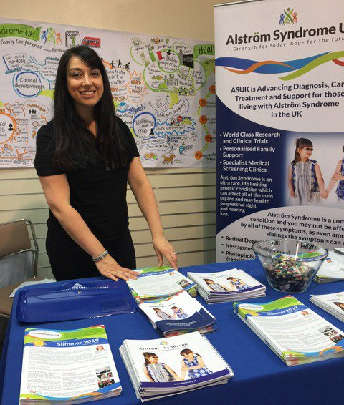
Sight Village here we come
The Queen Elizabeth Sight Village Central event took place on the 9th and 10th July 2019. This free event provides lots of technology, equipment and support information for everyone affected by a visual impairment.
ASUK attended with an information stand and led a discussion on transition. Where people could talk about their experiences of what helps and what hinders?
If you’d like to find out more feel free to contact us or click below for transition information on our website: http://www.alstrom.org.uk/growing-up/

It was a great opportunity for ASUK to raise awareness of this ultra-rare condition and to also meet up with other organisations in this sector who are doing fantastic work.
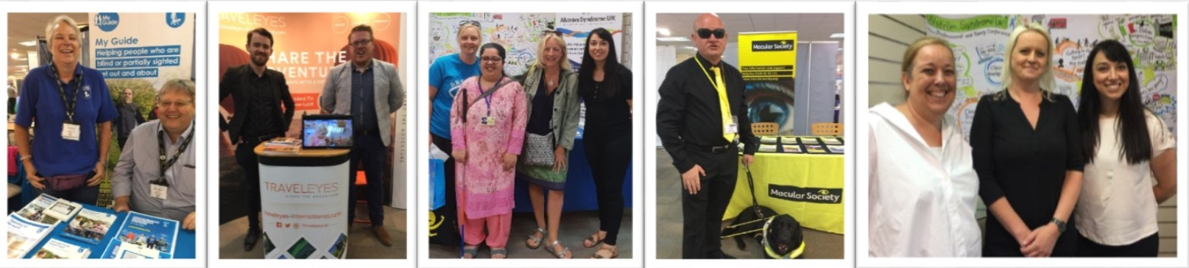
Such as (above photos left to right) Sue and Mike from Guide Dogs, Traveleyes, Aneeba from Bardet Biedl Syndrome, Colin and Woody from the Macular Society, and Jody from Wolfram meeting up with Kerry and Liz.

European Reference Networks
You may have heard of the term, European Reference Networks, or ERN’s and wondered what they are all about.
European Reference Networks are a virtual network of specialists and healthcare providers across Europe who aim to share knowledge and information they hold about rare complex conditions.
The hope is that this concentration of knowledge and information will improve the management and treatments for rare complex conditions.
Rather than having a group for every one of the over 6,000 rare diseases, they have been grouped into specific areas of expertise. Alström Syndrome currently is part of the group called Rare Endocrine ERNs (Endo-ERN).
Kerry, recently attended the Genetic Alliance UK conference about ERN’s; looking at how they are working in practice now, how this will evolve and looking at the future possible impact of Brexit.
You can find full information on the ASUK website
http://www.alstrom.org.uk/what-are-european-reference-networks/

Let's reminisce!!
Check out this poster, can you remember when we cycled 200 miles or when Nicola and her friends waxed a poor chap? How about when Chris got extremely muddy in the ‘Tough Mudder Challenge’ and when Lorna from Starbeck School and Nursery chopped her hair off!! We also can't forget David who continues each year to run in the Virgin London Marathon... and why I hear you ask - well it is to ensure our vital services can continue now and into the future.
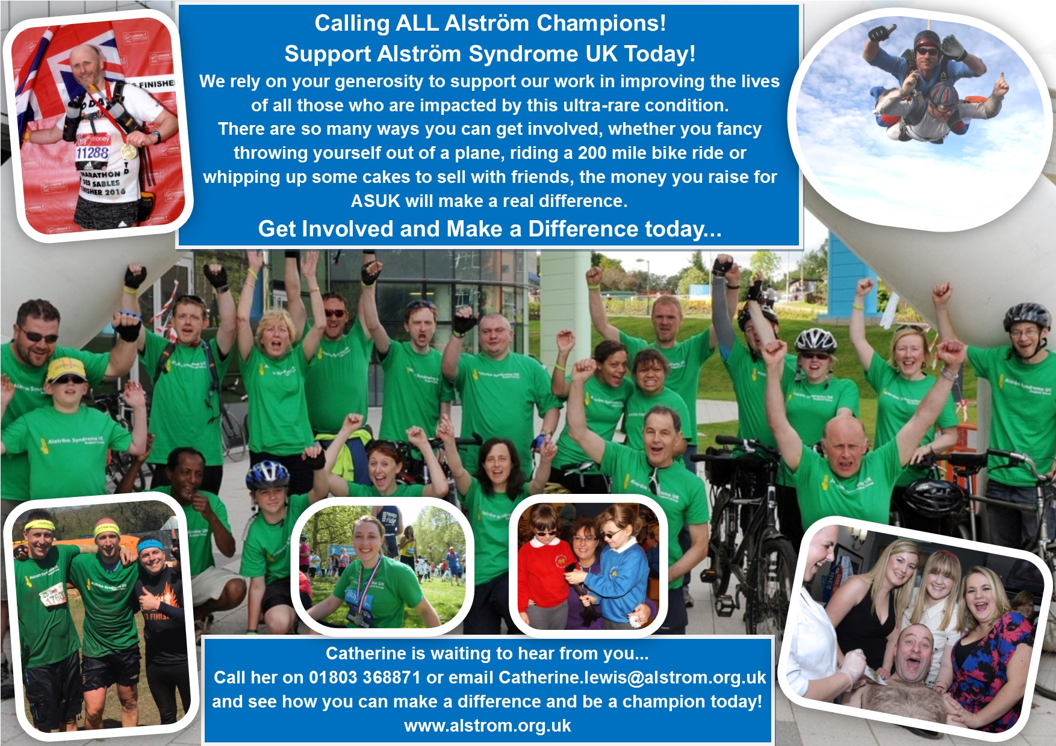

All of these ASUK supporters have made a HUGE difference to the lives of those affected by Alström Syndrome and on behalf of the AS community we are very grateful.

Fancy organising an event to match these and join in the fun, then why not get in touch and let's see your creative ideas flourish!

If you are ready and raring to go, head across to the ASUK JustGiving page where you can set-up your own fundraising page or if you would prefer to send a donation, this can be done quickly and securely through the ASUK JustGiving page too https://www.justgiving.com/alstromsyndromeuk

In case you missed our summer edition
Summer is quickly fading, but in case you missed the summer newsletter, take 5 minutes to catch up on our members’ latest adventures in Barbados and America!
Head across to the ASUK website to download your copy http://www.alstrom.org.uk/newsletters/

From us all at ASUK
Thank you for your continued support
https://www.justgiving.com/alstromsyndromeuk

