Alström Syndrome Telemedicine Clinics
Birmingham Women’s and Children’s Hospital
What is a Telemedicine Clinic?
A Telemedicine Clinic is a way of using technology to deliver healthcare at a distance to children, young people and their families.
How will I be invited to take part in a Telemedicine Clinic?
Birmingham Women’s and Children’s Hospital will send you a letter or text message confirming the date and time of your appointment. The letter or message will include a link to Zoom with an Identification number and a unique password.
What is Zoom?
Zoom allows people to meet virtually by using a computer or mobile device. Follow the link provided by the hospital to download the Zoom software if you do not already have this set up on your device. It is free and quick to install.
Who will be taking part in the Telemedicine Clinic?
Professor Tim Barrett or Dr Melanie Kershaw will lead the virtual clinic and they will be joined by other members of the Alström team. This may include Dr Ashish Chikermane or another cardiologist, Catarina Leal or another dietician, Marie McGee Transition Coordinator, Kirsty Mobberley our Diabetes Nurse Specialist if available. A member of the Alström Syndrome UK Family Support Service will also join.
How can I prepare for the Telemedicine Clinic?
There are a few things you can do to help you prepare for the clinic
- Download the Zoom software onto your device
- Make sure your device has a camera, microphone and speakers (mobile devices and laptops often have these built in)
- Weigh your child/young person at home if you can and make a note of their weight. Please measure their height too if possible.
- Put together a list of your child/young person’s medication
- Make a note of any new health professionals involved in your child/young person’s care
- Make a note of any questions or concerns you may have
- Complete the food diary if one has been sent to you by our Dietitian
- Decide if you would like anyone with you during the clinic. It may help to have someone with you to help keep your child/young person occupied. During this period of isolation, this will need to be someone within your household
- Some children/young people may like to ask their own questions. Please take time to discuss this with your child/young person and practice their questions with them beforehand, so they feel confident to speak up for themselves (Self Advocacy).
How will the Telemedicine Clinic work?
Follow the Zoom link and enter the identification number and password provided by the hospital.
This will take you to a virtual waiting area.
At your appointment time or soon after, you will then be taken to a new screen and the clinic team will all appear via video link in small boxes at the top of the screen.
Professor Barrett or Dr Kershaw will introduce everyone on the call and will then have a discussion with you about your child/young person.
You can ask questions at any time during the Telemedicine Clinic
If for any reason you are not able to connect to Zoom, Professor Barrett or Dr Kershaw will contact you by phone.
If you need to spend longer with an individual member of the team, then we have provided separate zoom meeting facilities. The health professional will give you details of the separate meeting identification number and password so that you can leave the main MDT meeting to join a one to one meeting.
What happens after the Telemedicine Clinic?
You will receive a clinic summary letter in the post and a copy will also be sent to your GP and other health professionals involved in your child’s care.
What if I have further questions after the Telemedicine Clinic?
You can contact any member of the Alström Syndrome team at Birmingham Children’s Hospital via the Clinic Coordinator, Lindsay Wilson on 0121 3339267
You can also contact your Family Support Worker at Alström Syndrome UK
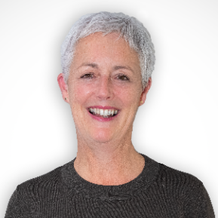
Jane Biglin
Senior Family Support Worker
(for patients living in the South of England)
Email: jane.biglin@alstrom.org.uk
Telephone: 07714 798413

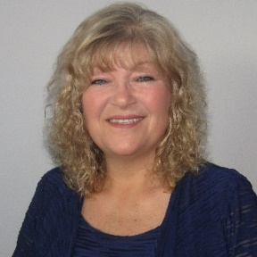
Carrol Birchall
Senior Family Support Worker
(for patients living in the Midlands & North of England)
Email: carrol.birchall@alstrom.org.uk
Telephone: 07847 760467

