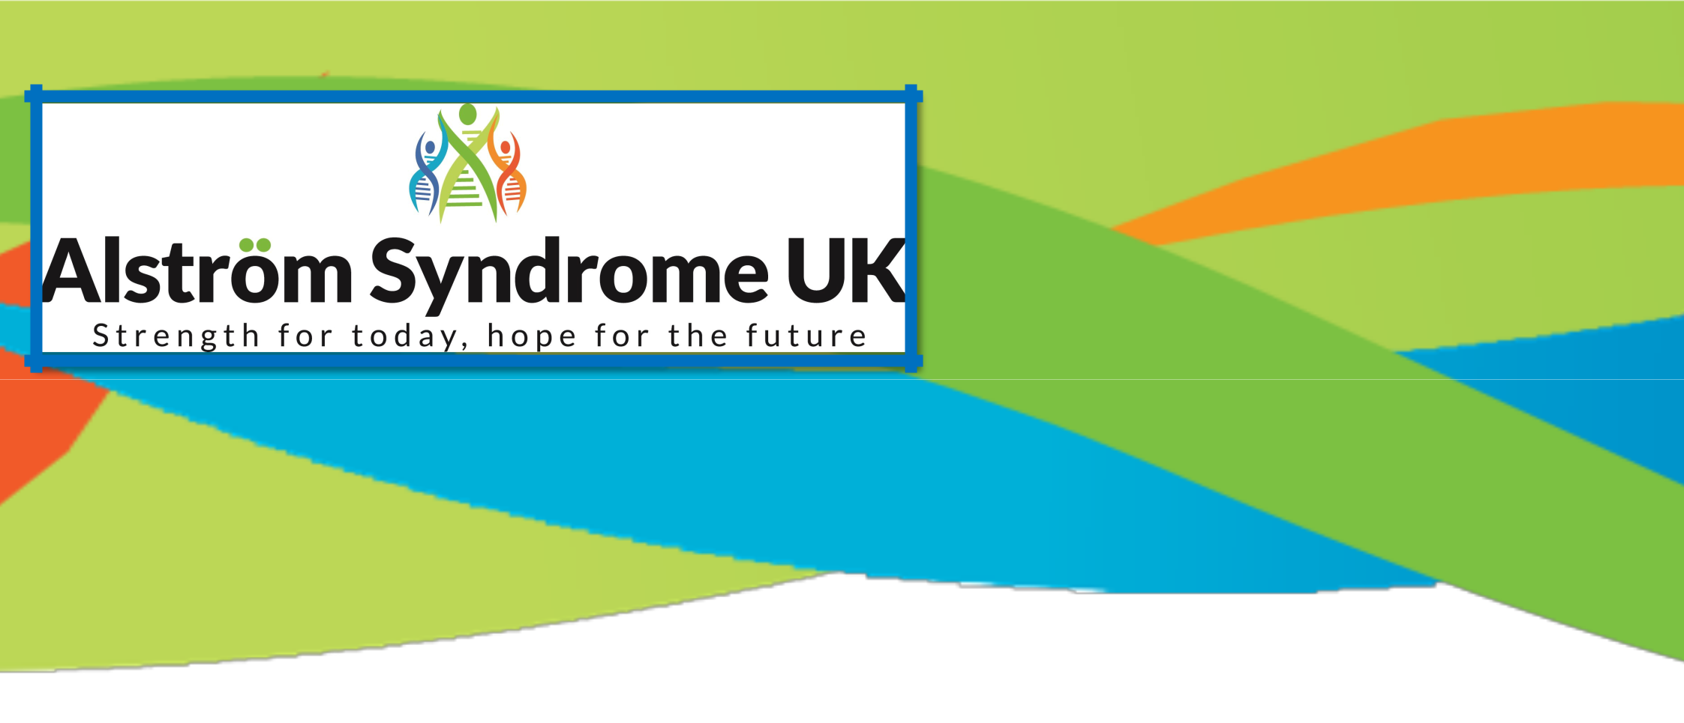
Alström Syndrome UK (ASUK) is a charity who provide information, support and advice for individuals affected, their families and carers and professionals. Alström Syndrome is a very rare genetic condition which can cause progressive blindness, loss of hearing and can lead to; heart and kidney failure, type 2 diabetes, liver dysfunction and associated problems. The symptoms arise at different stages making diagnosis very difficult. Our mission is to raise awareness, conduct pioneering research and enable better treatments and monitoring through the AS multi-disciplinary NHS clinics. Further information about our work can be found at

www.alstrom.org.uk

Welcome to the Summer 2020 ASUK Newsletter

Issue 24

An update from Ann Chivers, Chief Executive

Hello One and All,
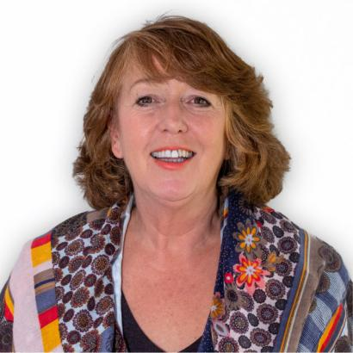

Who would have guessed after talking to you in our early Spring Newsletter that we would all find ourselves in the middle of this dreadful pandemic. It is now more important than ever, that we all stay connected and make sure we support one another during what are unprecedented times for us all.

It has at times appeared confusing to say the least, with what you can and can’t do but as things slowly return to some form of normality, I am sure we are all pleased to be able to go for a walk or meet others in our bubble. I think for many of us it has been a time of reflection and thinking about what is most important to us. Here at ASUK we have continued to offer support and find creative ways to ensure all our community stay supported and connected.

It is a challenge to find some positives during this awful time, but we have welcomed the chance to keep in touch and meet up with lots of you on webinars and at zoom meetings. For those of you with clinic appointments the team at BCH and the QE have worked wonders to make sure patients continue with their consultations. Adapting to tele-medicine
Ann Chivers
Chief Executive ASUK
clinics, which has been reassuring for many patients. I’m sure you’ll join me in giving huge thanks to Tarek, Tim and
the teams at both hospitals. Even throughout this pandemic and the furious busyness at both hospitals they have kept in
touch with families. We all appreciate their hard work and dedication so a big shout out to all the AS teams.

Lock-down has been tough going and I’m not sure many of us want to be out and about too much at the moment, so it’s been fab to see and hear what you have been up to at home on pages 4 and 5.

We will continue to bring you the latest ever-changing guidance and on pages 8 and 9 we have brought together some of the top tips and current guidance from the Governments website.

One subject we are always very passionate about is staying healthy and active and we have loved hearing about your lock-down activities. You can even pop along to our You Tube channel to view a short video of families staying in and working out.

New Vice-Chair
I am delighted to announce that Alex Griffiths-Rayson (pictured right) who has been a Trustee for several years, has become the new Vice-Chair. Lexi brings with her a wealth of experience, particularly championing the needs of young adults with AS.

Thank you
As always, a big thank you to all our families, friends and supporters for giving their time, contributing towards our fundraising campaigns and sharing their stories and experiences in our webinars.

Who knows what the future holds and how long coronavirus will shape our lives, but if we stay in touch, stay safe and look after yourself and your loved ones, we will support each other through these difficult times.

Please remember that you are not alone, we are here for you.

Wishing you and yours a lovely Summer, let’s hope the sun continues to shine. Stay safe and stay in touch.


Lexi Griffiths-Rayson, Vice-Chair
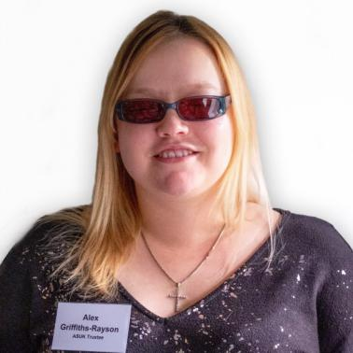

Best for now

Ann and the ASUK team

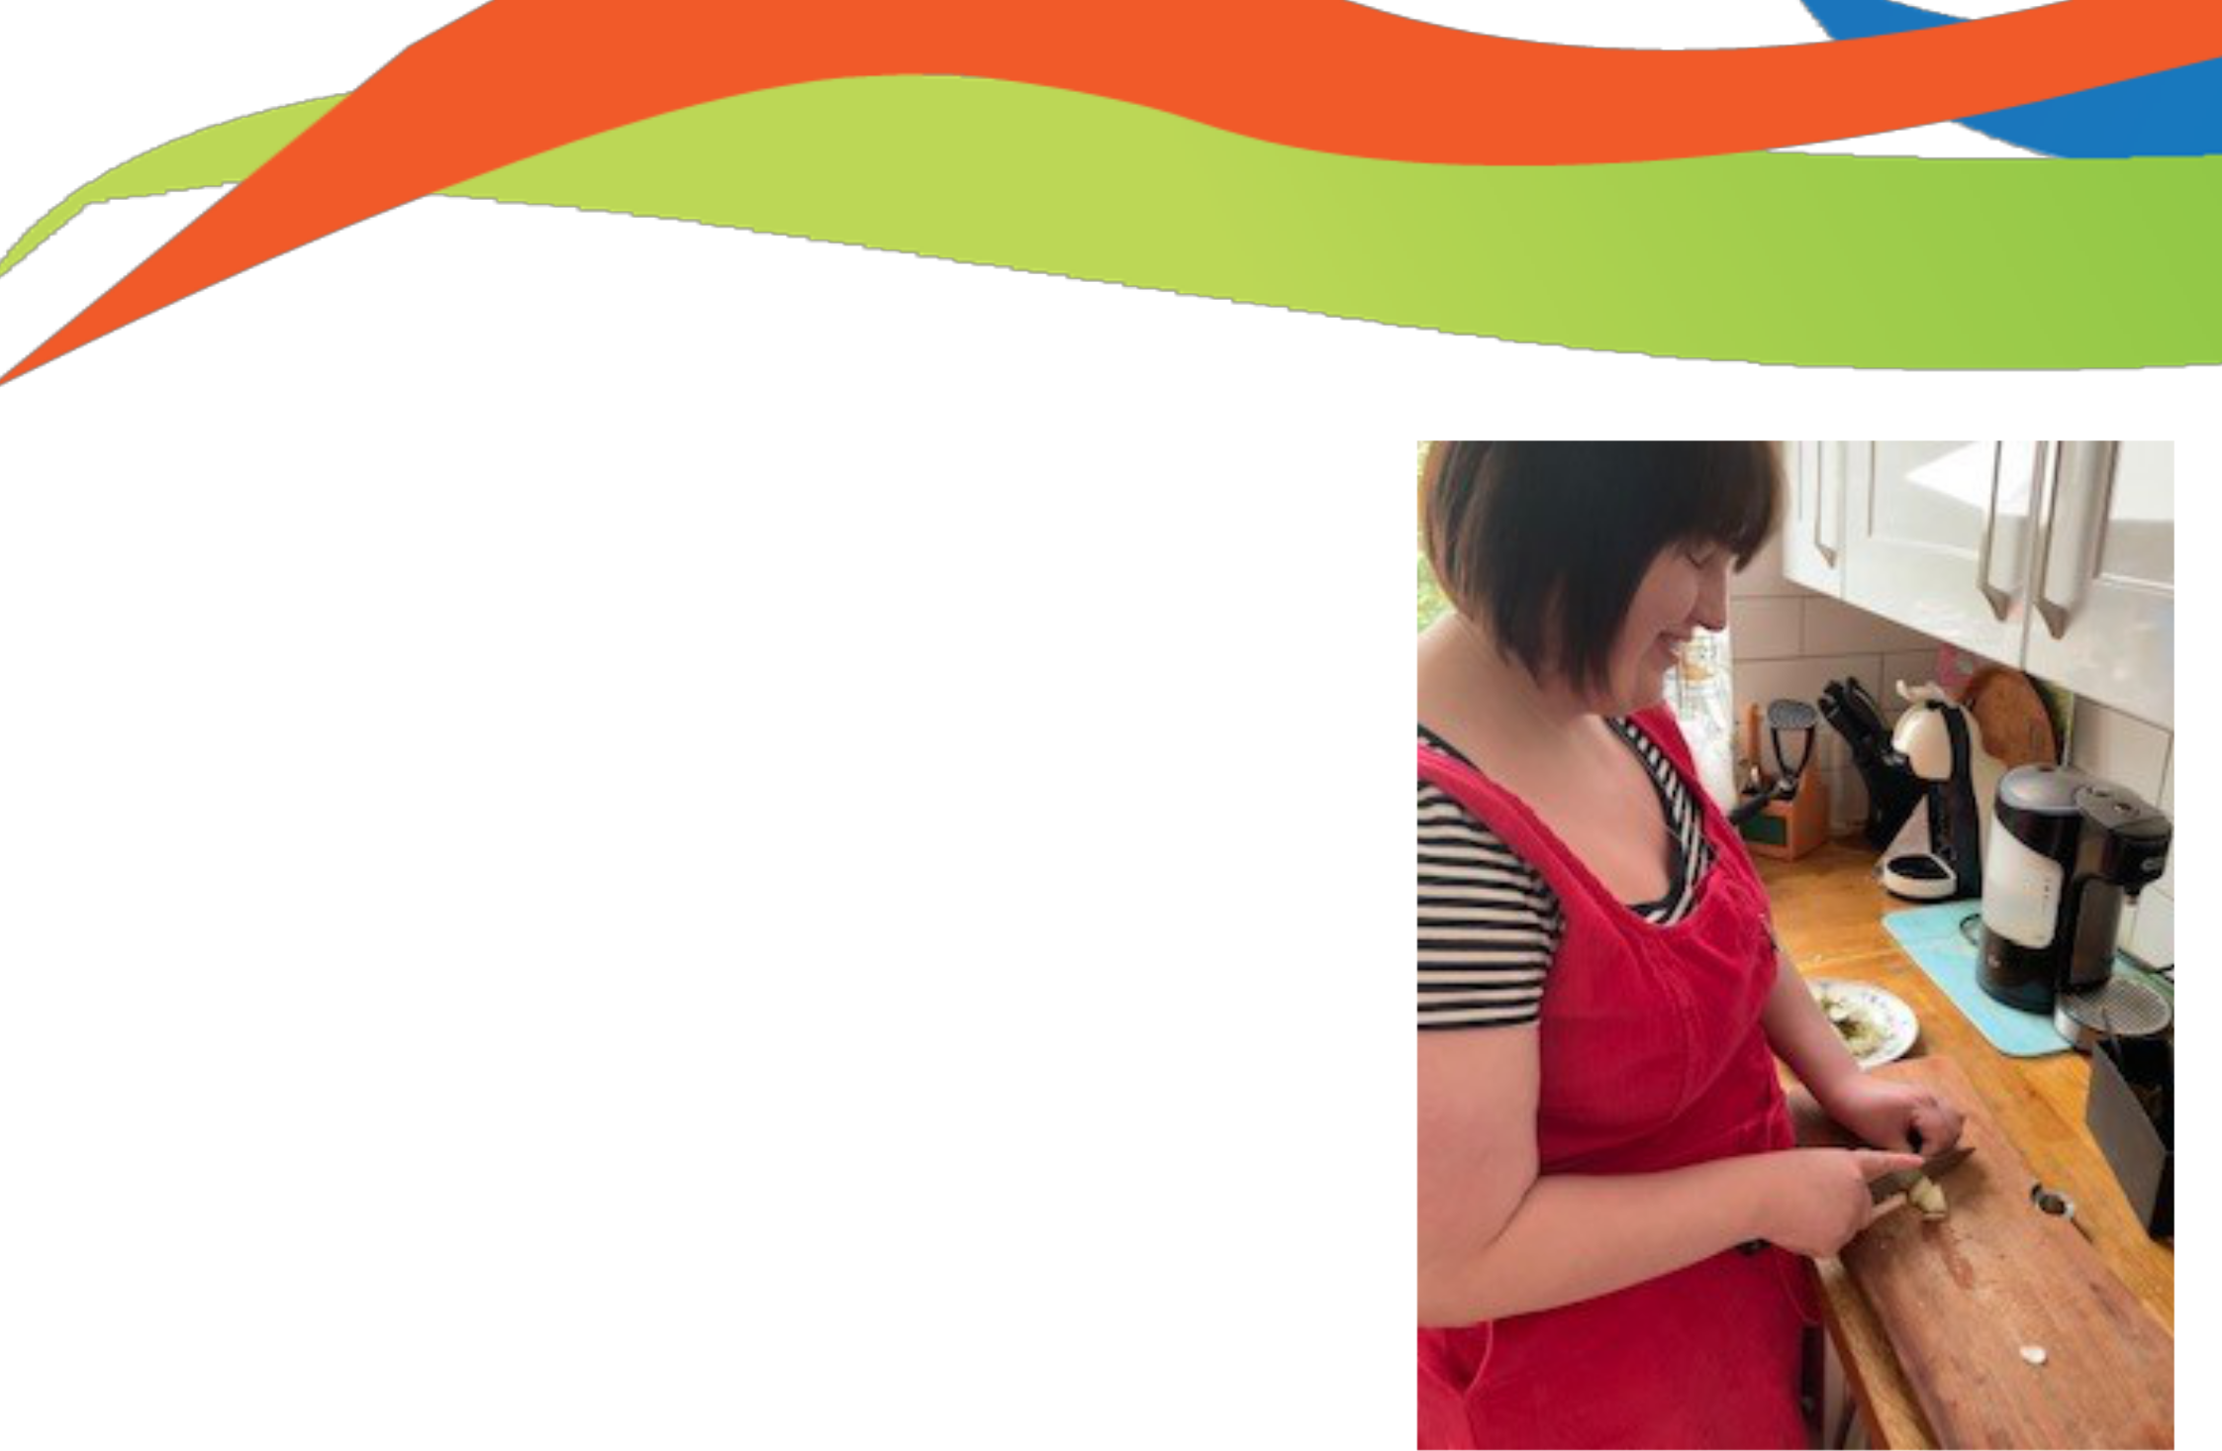

Cooking up a storm!

‘Stay Fit, Stay Healthy, Stay Happy’ cookbook being created and written by you!

Thank you for sending us your favourite family recipes, your top tips to stay active and the technology which helps you on a day to day basis stay independent. We have started bringing your recipes and top tips together on the website and plan to publish an actual book.

It can sometimes seem the hardest challenge to keep healthy when you have an ultra-rare condition like Alström Syndrome.

ASUK have brought together some top tips from families and professionals from the AS clinic on how they stay fit, healthy and happy.

Check out the information on our website, it contains some fabulous recipes such as Keema or spaghetti and meatballs from Melissa, top tips for equipment to keep you independent and ways our members are keeping active.

Please get in touch if you would like to share your top tips, recipes or equipment that you wouldn’t be without.

Lock down challenges

What have our members been up to during lock down?

Check out the website below to view how members have been keeping active throughout!

The best bit is you can also check out what our families have been up to during lockdown to stay active, in the ‘Staying In, Working Out’ video!

Head across to the ASUK website to discover more
http://www.alstrom.org.uk/stay-fit-stay-healthy-stay-happy/

Congratulations Hassan!
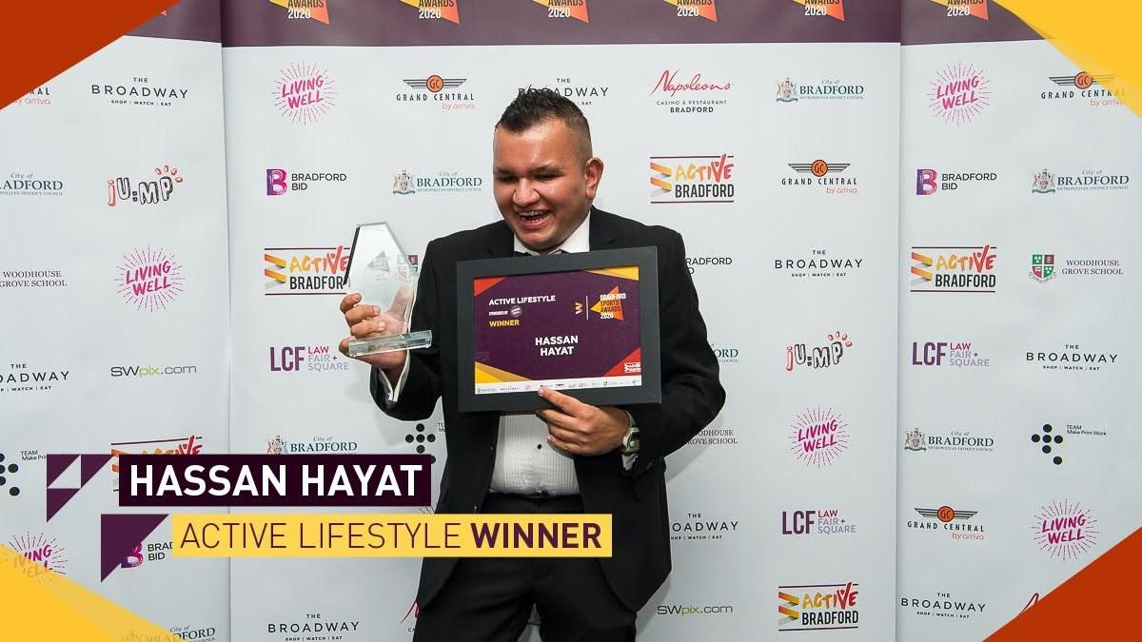

Active Bradford is a partnership of organisations committed to making Bradford a healthier and more prosperous place to live and work.

Each year Active Bradford host an awards ceremony where they recognise those people and organisations who go above and beyond in their local area to help other people get active or through their own personal sporting journey.

The awards welcome over 400 guests to the prestigious Utilita Energy Stadium. This year there was a record number of nominations, with 53 finalists across 18 awards, representing unbelievable sporting contributions and talent.

On the 12th March 2020, the awards ceremony took place and one of our members, Hassan who has took Bradford by storm with his tandem cycling has won the ‘Active Lifestyle’ award.

Hassan knows the importance of keeping fit and healthy and even though his has limited vision and hearing he has found a love for tandem cycling.

He doesn’t let anything stop him and he is a true inspiration to all.



Patient Registry—don’t delay, enrol today!

With the world suddenly finding themselves in lock-down, let's take this opportunity to break out of ground hog day and complete the ASUK Patient Registry.

This is your time to get all your medical information and medications all in one place.

Knowledge is power!

The ASUK Patient Registry enables you to provide your health information in an easy and straightforward format by completing questionnaires about your health in a safe and secure way.

This information will be available (anonymised) for researchers and clinicians worldwide to learn more about Alström Syndrome and develop further treatments into this rare condition. It is free to join for both you and professionals. This information will help build a worldwide picture of Alström Syndrome, improving knowledge and understanding of this rare and complex condition for everyone on the planet!

You have the potential to make a real difference to everyone living with Alström now and in the future.

How to join?

Find the CoRDS Connect website and complete the CoRDS activation form, it is quick, secure and easy to do, just go to the website below:

https://cordsconnect.sanfordresearch.org/BayaPES/sf/screeningForm?id=SFSFL

Don’t delay, enrol TODAY!

We are encouraging researchers and clinicians to study the anonymised data, so we are asking that you are enrolled, and questionnaires are completed by the 30th September 2020.

A big thank you to those who have already completed the registry. Why not volunteer to help others?

If you can offer any support to help others to complete the registry please get in touch with Catherine.

If you need any support to join the registry or if you would like any further information, please get in touch with ASUK Office Manager, Catherine Lewis on 07970 071675 or email catherine.lewis@alstrom.org.uk

Keeping you entertained!

Over the past few months in lockdown we have been updating the information on our website to include the latest guidance around coronavirus and ways you can stay entertained at home, as well as ensuring you have the support you need at a time that is right for you.

If you haven’t had a look yet, please check these resources out online, they cover everything from your rights and benefits to how you can discover a world online.

http://www.alstrom.org.uk/family-support/

Looking after yourself

There are lots of websites looking at how we can stay fit and healthy but what about our mental health and wellbeing? The websites below provide information about how to look after yourself and your loved ones during this difficult time.

The Mental Health Foundation

The Mental Health Foundation provides information about good mental health for all.

‘How to talk to your child about Coronavirus’ is a particularly interesting article for those with children.

https://www.mentalhealth.org.uk/coronavirus/talking-to-children

Find out more about the Mental Health Foundation on their website https://mentalhealth.org.uk/

Every Mind Matters

The NHS, Every Mind Matters project offers practical tips to help you look after your mental health and wellbeing, you can view their top tips on the NHS website https://www.nhs.uk/oneyou/every-mind-matters/

Young Minds

The charity Young Minds, offer a blog for young people which is full of personal accounts and information about how to keep yourself safe and healthy, take a look on their website https://youngminds.org.uk/blog/

The BBC

The BBC have brought together some useful resources in this article ‘Coronavirus: How to protect your mental health’
https://www.bbc.co.uk/news/health-51873799

Mindfulness

You may have heard people mention ‘Mindfulness’ and wondered what is it really all about.
There is a Every Mind Matters breathing exercise, on the You Tube site, it only takes a few minutes and may help you feel calm:

www.youtube.com/watch?v=wfDTp2GogaQ&app=desktop

What’s everyone been up to?
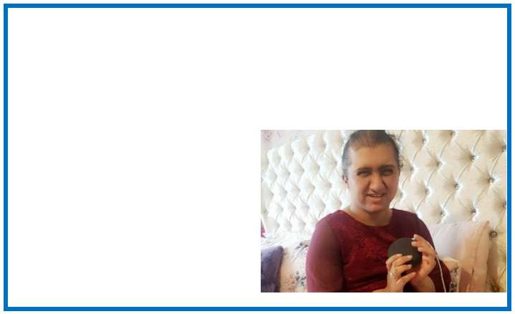

‘My Google Assistant is like a friend to me!’

Ruby and her older sister Khaynaat, share their thoughts about their new Google Assist, which ASUK was pleased to fund with a small grant.

My Google Assistant (GA) is my friend, I speak to it and it gives me lots of answers. I ask it questions like what is the weather like today or what has happened in the news, it always gives me the answers. I also ask GA to play music things like Little Mix songs which is one of my favourites. I had to teach it to find Bollywood music for me, now it can find radio stations and all sorts of different Bollywood style music. If you use your GA a lot, it starts to know what you like and it can find things easily for you.

I have lots of fun with my GA, I ask it to tell me jokes and I like to ask GA what type of music it likes! My GA makes me laugh because it sometimes gives funny answers! The GA keeps me entertained when I am doing things in my room. Google has helped me to find lots of things

- it has helped me to stop being bored and find things out for myself. Khaynaat, Ruby’s older Sister commented; ‘

My family and I have been really surprised how Ruby is using her GA. I thought she would never use it, as she found the voice over on the iPad so annoying and frustrating for her to use. Before Ruby had a GA she would listen to music on her radio, I would have to help her find radio stations. Now I’ve noticed that she is a lot more independent, searching on her GA for music or asking questions about things she wants to know. Using Ruby’s GA has improved her overall confidence to ask questions. I’ve heard her chat more to family members and she informs us as to what is happening in the local area as she listens to the news. Ruby also gives us her opinion as to what has happened, which is great as we end up chatting much more about things.’

Ruby sums up;

‘I would tell other people to use their Google Assistants, because it is fun to listen to music, find out what the date is or what the weather is going to be like. Using your GA will stop you from struggling to find out things. Instead of asking other people questions, now I can ask my GA questions, which makes me more independent and I can do it by myself!’

‘Just do it!’

Kion shares his experiences of using his cane to get out and about...

“I was about 5 years old when I started using a cane. I had a mobility teacher called Lisa, who I am still friends with to this day. She started to teach me how to use a cane. It takes time to learn what to do, but it’s worth it to learn the skills. I don’t go anywhere without my cane now – it’s part of me that I can’t do without.

I don’t like bumping into things or people, so my cane gives me independence. Because I started very young my cane has always been a part of my life.

My best advice to anyone who is trying to develop their independence, especially when you’re using your cane is; don’t be scared, JUST DO IT! What I mean by that is, when you’re out walking with your cane, it takes time to build up your confidence - take no notice of people around you, who don’t know you. You may think they are looking at you or they might say a stupid remark- just ignore them, don’t waste your time on them-don’t let their remarks bother you – be strong and block it out- don’t dwell on it.

Listen to the advice of your family, mobility teacher or carers as they know you best and will be doing the best for you. Take no notice of random

strangers-most of them don’t have a clue about VI!

It’s automatic to me now to use a cane its part of my life. I keep it by the front door. I go out independently, I know quite a few routes and get the bus around Rotherham. I make maps in my head, so I always know where I am. I have been assessed for a guide dog and I am on the waiting list now. Without building up confidence to use my cane or working on routes and travelling independently I would never have been assessed by Guide Dogs for the Blind. I passed the assessment and I am now on the waiting list for a dog. I have a busy life, on weekdays I help out at my local Sight and Sound Charity, on Saturdays I go out with my carer and on Sundays I spend time with my family. Living my life is important to me!

My best advice to you is: Don’t let people or their remarks get in your way - Just do it - get out there and live your life!”

Kion is 19, a season ticket holder for Rotherham United where he attends as many games as possible to support his favourite team. He also loves going to live music events and is a hardened rock music fan. He also has a keen interest in cars - the faster the better!

Kion also took part in our driving experience sessions, which was a dream come true!
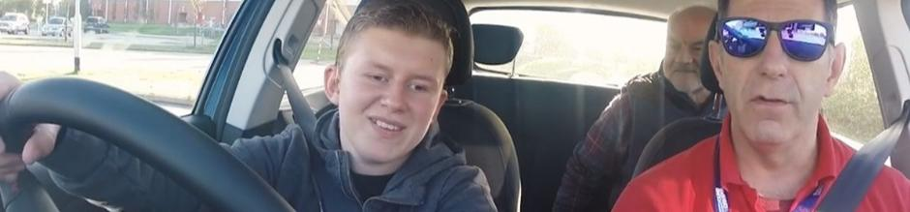


‘College, cooking and confidence’

Haris is 18 years old, he attends New College Worcester (NCW) Residential College as a full-time student. In his article he shares his experiences of preparing, moving and settling into NCW and his newfound confidence gave him the confidence to be ready for any challenges!

Why did you decide to go to Residential College? What was starting at NCW like?

I used to attend a secondary school with a specialist visually impaired unit. The staff there prepared me for changes that would affect my life as I grow up. My school was very good at supporting pupils to think about residential college as a place to continue their education and develop all round living skills.

When I was in Y8/Y9 I started to investigate colleges and what special needs support for pupils with visual impairment (VI) was all about. Some of the pupils from my school had moved onto the Royal National College (RNC) in Herefordshire. My dad and I went to RNC for the day, I followed this up with a residential weekend called ‘Have a Go’. I visited my local colleges too, but I did not think they could support my independence skills and how to become an independent traveller.

ASUK staff also recommended that I visit New College Worcester and Queen Alexander College in Birmingham. I put a case study together about each place I had visited – depending on what the colleges could offer me, what I would learn and how my independence skills could be developed. I showed all this to my family and together we decided. At the end of Y10, I took part in a three-day assessment at NCW – this is where I found out what it was like to be away from home, and how much more independent I needed to become. I knew NCW was the right decision for me!

How did your family feel about that?

I had a really good experience, although it was daunting it was exciting at the same time. I fitted in straight away, as people were like me. I knew another person there with Alström Syndrome, that helped me as I could talk to someone who understood all about AS. At the end of the first week I took part in a camp activity that was great fun! I like to be around people with VI, they understand me, and I feel like I fit in more.

How I’ve changed

My secondary school had given me hope, they taught me that I had nothing to fear… I was ready for challenges that came my way. By the time a VI person goes back home, they have changed into a completely new person and they can do more for themselves. I have changed, I can do so much more, and being a residential student has really built up my confidence. The first time I went on a train by myself, my Mobility Officer shadowed me as I used travel assist support.

Now I can book trains and taxis independently, when I travel, I use travel assist and feel secure in all my bookings and travel. Recently I took a friend from NCW to visit friends at RNC Hereford. I booked all the trains and taxis, got us both there and back safely, while managing to get refreshments along the way. I was really happy with this; it was a great achievement for me! Whilst at college I attend the local mosque, I used to be accompanied by a community service volunteer, now I travel there independently.

My Top Tips for parents/carers

A friend of mine who I knew at school, is a student at RNC, when I heard that he could make a Chicken Korma without any help I was very impressed. I wanted to be like that! My dad came with me to all the college visits, although he did not want me to leave home, he began to understand how much more VI people could do for themselves once they were away from home. My mum was upset about me leaving but she was happy for me to go, my siblings were happy for me to go too. I’m now working towards making a Chicken Korma without any help!

What parents/carers need to do is speak to more students who are already students in residential colleges so they can tell them what it’s like to be there. Their experience and their narration is much better than listening to the staff because it’s their experience and their lives!

Put a case study together of each college you have been to visit exploring how it will meet your son/daughters needs and why it will not meet them. This is important to put forward as evidence to get your funding from the local authority for your place.

How did you prepare for college?

To help me prepare for starting NCW my Mobility Officer started preparing me for local train journeys, this helped me to start planning longer train journeys. I was also taking BTEC cooking skills in school, which was improving my skills in the kitchen. I did feel a lot of pressure worrying about local authority funding for my college place. Once this was in place I could relax and started to plan what clothes, medication and technology I wanted to take with me.

My Top Tips for Young People (YP)

If other young people are thinking about residential college, go for lots of visits and ask lots of questions. Take part in any residential college weekend activities, so you get a feel for what it’s like to be away from home. You will become more confident and being away from home will develop your skills!

I am more confident than I ever thought I would be. Who would have thought that I could sit on a train on my own, the fact that I could grasp travelling independently is a wonderful gift to my confidence!

‘Tell everyone I can tell the time!’

Aisha is 12 years old, she loves singing and is part of a local choir. She likes Justin Bieber, Ed Sheeran, Stormzy and Burna Boy. She also likes reading her Braille books, at present she is reading about different types of transport. Aisha gives her thoughts on her new talking watch.

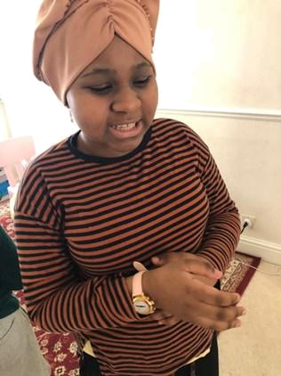

“After I attended my last Alström Clinic at Birmingham Women’s and Children’s Hospital, ASUK sent me a talking watch. I wear it on different wrists, I swop it around depending on which hand is free. My watch tells me the time, day and date. I press a button on the side of the watch, and it starts talking. I like to tell my mum the time in case she forgets. I have not had a chance to wear it in school because it is shut due to the Covid virus. I really want to show it off and tell everyone I can tell the time!

Before I had a watch, I used my phone, it’s much easier to have watch because it’s right there on my wrist and I can instantly find out if it’s time to do something. It also helps me to remember because now I know what the day and date is.

I really like my watch because I can use it by myself. I want to go to residential school in September 2020. It’s important for me to do things by myself because I’m growing up. I don’t want to forget how to do things, I want to learn how to do new things, so that when I’m older I will know what to do in my life.

Top Tips

- If someone wants a talking watch, they should order it straight away, because it will help you and you don’t have to ask other people what time is it?

- Although I’m excited to wear my watch don’t wear it in bed!”

Aisha’s mum gives her thoughts: ‘

My daughter is very happy with her watch; she was so excited to receive it. The watch has made such a difference to her, she can tell me

the time whenever she wants to. It is so nice to see her being independent. She feels the same as other people as she can tell them the time instead of asking them. It also makes my daughter have a sense of responsibility as she takes care of it and doesn’t want to lose it and depend on people to know the time and date.’

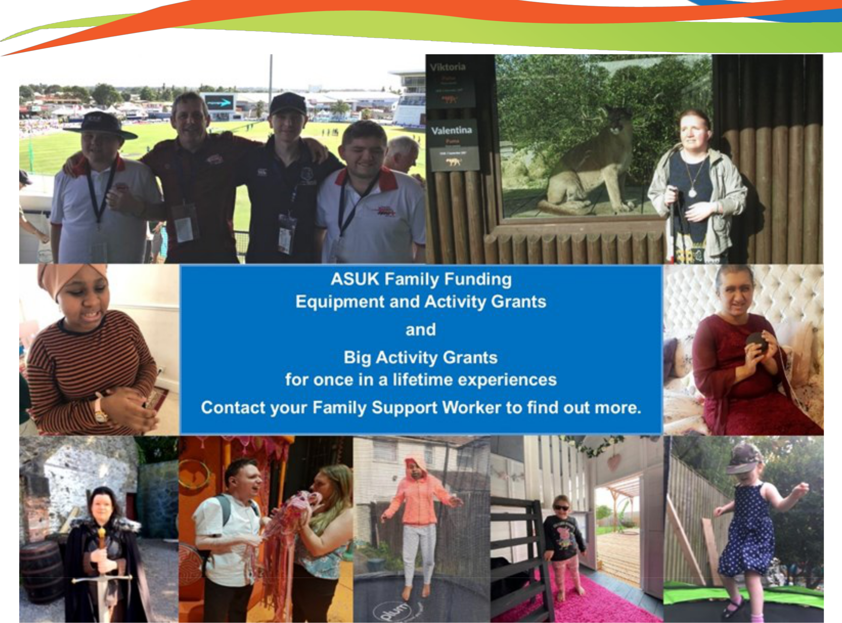

Thanks to funding from Sport England we can now offer families a contribution towards equipment that they may be unable to buy themselves, that will help them stay active. This might be an indoor piece of equipment such as an exercise bike or maybe something to use outdoors like a trampoline or maybe a tandem to cycle together!

Have a look at the photos of some of the fantastic activities, Big Activity Challenges and exercise equipment we have helped with.

If you would like to know more, ask your Family Support Worker, they can help you to complete an application.
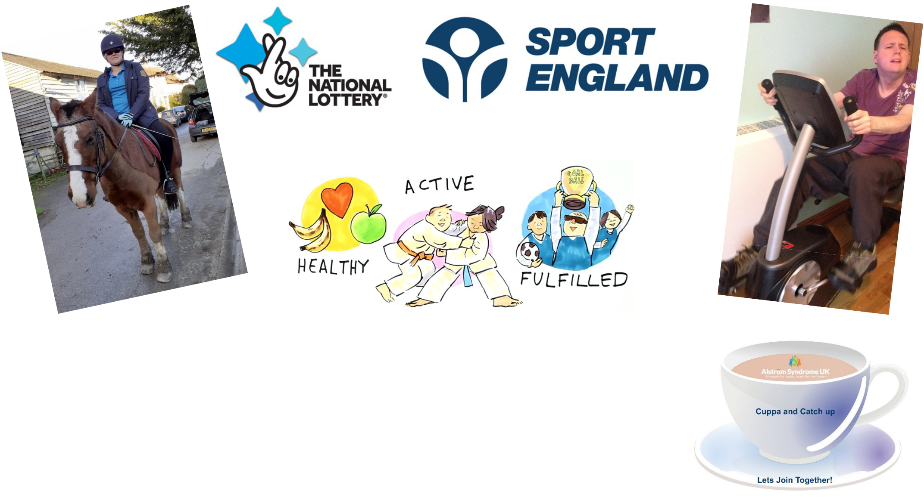

Fancy a catch up?

Alex and Melissa have been bringing together the Alström adult community, meeting regularly to chat about everything from how you are coping in lock-down and supporting each other to chatting about your favourite books and films and having a good catch up?

If you are interested in joining these monthly zoom sessions, please get in touch with Catherine on 07970 071675 or email Catherine.lewis@alstrom.org.uk

A big shout out to Sarah and Catrina, part of the BCH team

Meet Sarah Turner and Catarina Leal who work as part of the Alström team at Birmingham Women's and Children’s Hospital. They have been supporting some of our webinars, so we thought this would be a lovely opportunity to find out a bit more about them.
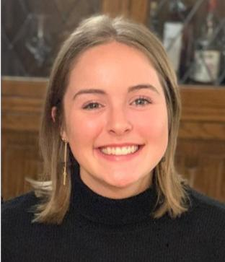

“I am Sarah and I work as an Assistant Psychologist within the Health in Mind team at Birmingham Women's and Children’s Hospital. Health in Mind provide psychological support to families facing the challenges of living with a health condition. That might include difficult thoughts or feelings or struggles with relationships, education or treatment. We support parents, young people and staff too, both on the wards and as outpatients. My links within the hospital include the Cleft, Craniofacial, Wolfram & Alström Syndrome and Cystic Fibrosis teams. I work with these teams to support the young people they look after, for example by meeting with families in clinic or providing support at tricky times.

Within Alström, I attend clinics and see all the young people for a brief psychology review for around 15 minutes. This is a chance for young people and families to chat about how they are coping with the condition, such as symptoms or treatment. It’s not easy having a health condition, so we discuss ways to help it feel more manageable and live a fulfilled life alongside having Alström Syndrome.

One example of a theme that comes up within Alström is difficulty with gaining independence, and I hear that this can be difficult for young people, particularly due to sight loss. Other examples of things we might support young people with, related to their Alström Syndrome, are anxiety around blood or eye tests, feeling limited by sight loss, and much more. In clinic, I also try to signpost young people to helpful social groups, for example cricket for the blind, to help them connect with people and feel understood.

If there is something that a young person is struggling with, our conversation might last a little longer and I can arrange to see them again to talk through further. Alternatively, we might arrange for more focused individual or group therapeutic support from our team. If a young person isn’t local to Birmingham, I will explore more local options for support with them. For more general mental health difficulties, such as depression or anxiety, I might also signpost into other services.

I have really been enjoying learning about Alström Syndrome, and I feel grateful to be able to support young people and families through the challenges it poses to live full and happy lives.”

“I am Catarina and I work as a Specialised Diabetes Dietitian, as part of the Diabetes Homecare at Birmingham Children’s Hospital. In my free time I love spending time with my little girl where we enjoy going for walks as a family, particularly to parks where she can see the ducks. We also enjoy exercising as a family, particularly during lockdown we have enjoyed doing this together where we exercise to the sound of music as long as we avoid lunges as that is something my 20-month-old refuses to do!


I work as a paediatric dietitian within the diabetes team at Birmingham Children’s hospital supporting patients with all types of diabetes. As a diabetes dietitian I support patients from diagnosis until they transition into adults. This is through educating them how to manage their diabetes on their day to day activities including diet, exercise and around new technology available to improve their quality of life. As part of my workload I also support patients with Bardet Biedl and Alström.

Within Alström, I attend clinics and see all the young people for a diet review. People with Alström have additional challenges with managing their weight such as a big appetite, challenges in getting physical activity and sometimes sleep difficulties. This is a chance for young people and families to chat about their daily challenges around diet and exercise as well as sleep routine. Before lockdown I used to support Marie in welcoming families the evening before clinic where we did a range of activities and I found this a great opportunity to get to know families outside clinic.

Raising our hands and awareness

Raising awareness of this ultra-rare and complex condition is vital to find undiagnosed patients and highlight the impact that rare conditions can have on a person's life. As these happy faces in the photo shows, the Alström Syndrome community in the UK came together once again to show their support for Rare Disease Day.
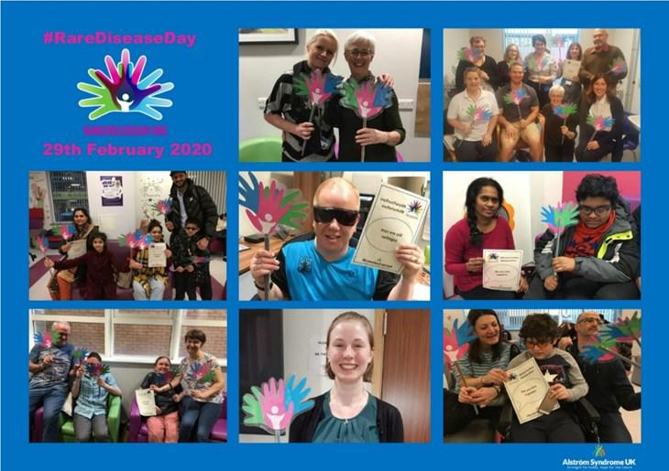

Rare Disease Day takes place on the last day of February each year. It brings the Rare Disease community together to raise awareness amongst the general public and decision-makers about rare diseases and their impact on patients' lives.

Rare Disease Day this year, fell on the 29th February and it

was the thirteenth international Rare Disease Day coordinated by EURORDIS. On and around this day hundreds of patient organisations from countries and regions all over the world held awareness-raising activities.

Building awareness of rare diseases is so important because 1 in 20 people will live with a rare disease at some point in their life. Despite this, there is no cure for the majority of rare diseases, and many go un-diagnosed. Rare Disease Day improves knowledge amongst the general public of rare diseases while encouraging researchers and decision makers to address the needs of those living with rare diseases.


Coronavirus guidance

It’s been great to see and meet families by webinar over the last few months. The key topic has been around Covid-19 guidance, although other topics and questions have been discussed.


We have brought together some of your questions, but please remember to always check the Government website for national and local advice and the most up to date guidance for you where you live. Especially now that there have been some local lock downs in areas.

Links to the latest information.

Here are some of the basics; everyone is being reminded to follow Public Health England advice to:

- Always carry tissues with you and use them to catch your cough or sneeze. Bin the tissue and wash your hands or use a sanitiser gel.

- Wash your hands often with soap and water, especially after using public transport.

- Use a sanitiser gel if soap and water are not available.

- Avoid touching your eyes, nose and mouth with unwashed hands. Avoid close contact with people who are unwell.

You can go to the Public Health England’s website for further advice around protecting those in vulnerable groups, such as children and adults with Alström Syndrome.

https://www.gov.uk/government/publications/guidance-on-shielding-and-protecting-extremely-vulnerable-persons-from-covid-19/ guidance-on-shielding-and-protecting-extremely-vulnerable-persons -from-covid-19

If you live in Wales, the government’s advice on shielding can be found
on this website:
https://gov.wales/guidance-shielding-and-protecting-people-defined-
medical-grounds-extremely-vulnerable-coronavirus-0

If you live in Scotland, the government’s advice on shielding can be found on the Governments website:
https://www.gov.scot/publications/covid-shielding/

You can find information and advice from Public Health England
at https://www.gov.uk/guidance/coronavirus-covid-19-information-for-the-public

NHS Guidance can be found by following the link to the NHS website https://www.nhs.uk/conditions/coronavirus-covid-19/

The guidance in summary

The guidance for those who are classed as clinically extremely vulnerable is that shielding has been paused. This means:

- you do not need to follow previous shielding advice

- you can go to work if the workplace is Covid-19 safe, but should carry on working from home wherever possible

- children classed as clinically extremely vulnerable should attend education settings in line with the wider guidance of schools re-opening

- you can go outside as much as you like but you should still try to keep your overall social interactions low

- you can visit businesses, such as supermarkets, pubs and shops, while keeping 2 metres away from others wherever possible or 1 metre, plus following other precautions

- you should continue to wash your hands carefully and more frequently than usual and that you maintain thorough cleaning of frequently touched areas in your home and/or workspace

- you will no longer receive free food parcels, medicine deliveries and basic care from the National Shielding Service

The guidance states that; it is your responsibility to adopt these principles wherever possible. None of these principles can completely remove the risk of catching coronavirus on their own. You should use them all wherever and whenever appropriate.

Here are some key points from the Governments website:

- Keep your distance from people outside your household or support bubble

Whilst recognising this will not always be possible, it is important to be aware that the risk of infection increases the physically closer you are to another person with the virus, and the amount of time you spend in close contact with them. You are unlikely to be infected if you walk past another person in the street, keeping to the 2-metre rule.

The government recommends that you keep 2 metres away from people as a precaution or 1 metre when you can mitigate the risk by taking other precautions in this list.

- Avoid being face-to-face with people if they are outside your household or support bubble

You are at higher risk of being directly exposed to respiratory droplets (released by talking or coughing) when you are within two metres of someone and have face-to-face contact with them. You can lower the risk of infection if you stay side-to-side rather than facing someone. The key thing is not to be too close to people outside your household or support bubble. If you must, keep it as brief as possible.

3. Keep your hands and face as clean as possible

Wash your hands often using soap and water and dry them thoroughly.

Where available, use sanitiser outside your home, especially as you enter a building and after you have had contact with surfaces. Avoid touching your face. Wash your hands as soon as you go home.

4. Keep indoor places well ventilated

Evidence suggests that the virus is less likely to be passed on outdoors and in well-ventilated buildings.

In good weather, try to leave windows and doors open in areas where people from different households come into contact, or, meet outside where you can.

Use external extractor fans to keep spaces well ventilated and make sure that ventilation systems are set to maximise the air flow rate.

Heating and cooling systems can be used at their normal temperature settings.

5. Avoid crowded spaces

You can lower the risks of transmission by reducing the number of people you come into close contact with. For example, avoid peak travel times on public transport, where possible and avoid densely crowded areas. Small groups in small spaces pose a risk as well as large, close crowds.

6. Work from home if you can

If you can do your job from home you should continue to do so, but you and your employer should discuss and agree working arrangements.

- If you must travel (for example, to work or school), think about how and when you travel

To reduce demand on the public transport network, you should walk or cycle wherever possible. If you must use public transport, you should try to avoid peak times.



8. Face coverings with people outside your household, wash your clothes regularly.

You must always wear a face covering on public transport or when attending a hospital as a visitor or outpatient. Hospitals will be able to provide a face covering in emergencies. If you can, you should also wear a face covering in other enclosed public spaces where social distancing isn’t possible and where you will come into contact with people that you do not normally meet. This is most relevant for short periods indoors in crowded areas.

You should be prepared to remove your face covering if asked to do so by police officers and staff for the purposes of identification.

Evidence suggests that wearing a face covering does not protect you. However, if you are infected but have not yet developed symptoms, it may provide some protection for others you come into close contact with.

Face coverings do not replace social distancing. If you have symptoms of Covid-19 (cough, and/or high temperature, and/or loss of, or change in, your normal sense of smell or taste - anosmia), you and your household must isolate at home: wearing a face covering does not change this. You should arrange to have a test to see if you have Covid-19.

A face covering is not the same as the surgical masks or respirators used by healthcare and other workers as part of personal protective equipment. These should continue to be reserved for those who need them to protect against risks in their workplace, such as health and care workers, and those in industrial settings, like those exposed to dust hazards.

Face coverings should not be used by children under the age of 3 or those who may find it difficult to manage them correctly.

It is important to use face coverings properly and wash your hands before putting them on and taking them off.

You can make face-coverings at home. The key thing is it should cover your mouth and nose.

Exemption Cards

Some people may feel more comfortable showing something that says they do not have to wear a face covering. This could be in the form of an exemption card, badge or even a home-made sign.

This is a personal choice and is not necessary in law.

Those who have an age, health or disability reason for not wearing a face covering should not be routinely asked to give any written evidence of this. Written evidence includes exemption cards.
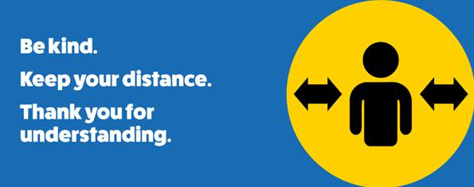

Templates can be found on the Gov.uk website

- Avoid shouting or singing close to people outside your household or support bubble

There is some evidence to suggest that shouting and singing increases the number of respiratory droplets people release. Therefore, the risk of transmission may be higher between people, if they are doing either, in close proximity to those outside their household. You should avoid doing either with people outside your household or social bubble.

- Reduce the number of people you spend time with within a work setting

You can lower the risks of transmission in the workplace by reducing the number of people you come into contact with regularly, where you can. Your employer can support with this (where practical) by:

- changing shift patterns and rotas to match you with the same team each time

- splitting people into smaller, contained teams

11. Wash your clothes regularly

There is some evidence that the virus can stay on fabrics for a few days, although usually it is shorter than a few days. Therefore, if you are working

Changing clothes in workplaces should only be considered where there is a high risk of infection or there are highly vulnerable people, such as in a care home. If you need to change your clothes, avoid crowding into a changing room.

- When at work or in business or public premises, follow the advice on site

Employers, business owners and organisations have a duty to assess and manage risks for your safety in the workplace and on their premises. The government has issued guidance for employers and businesses on coronavirus. This includes guidance on how to adjust to help you maintain social distancing.

It also includes guidance on hygiene, as evidence suggests that the virus can exist for up to 72 hours on surfaces. Therefore, frequent cleaning is particularly important for communal surfaces like:

- door handles

- lift buttons

- communal areas like bathrooms

- Kitchens

- tea points

(the guidance has been gathered from the Gov.uk website)

How do I know information is accurate and reliable?

There is a huge amount of information and mis-information swirling around about Coronavirus and what we should all be doing to stay healthy during this pandemic.

How do you know the information you are reading is reliable?

There are 4 sources of reliable information which we use to get the latest information and guidance.

These are:

The Government website https://www.gov.uk/coronavirus

The NHS website
https://www.nhs.uk/conditions/coronavirus-covid-19/

Public Health England website
https://www.gov.uk/government/organisations/public-health-england

You will find helpful summaries on the BBC News website
https://www.bbc.co.uk/

Distance Aware

A national initiative to enable individuals and organisations to politely prompt ongoing distancing and respect each other’s individual social space.

Maintaining social distancing is everyone’s responsibility going forward. While many people have made a very conscious effort to stick to the guidance, many haven’t, and some are getting tired and bored with sticking to the guidance. This, coupled with the increased anxiety of many around contracting the virus, is where the ability to offer polite prompts has been welcomed in many places.

Distance Aware aims to provide polite prompting to maintain distance (where possible) by the use of consistent and instantly recognisable symbols (these symbols are below).

You can find out more about these by going to the Bevan Commission website https://www.bevancommission.org/distance-aware
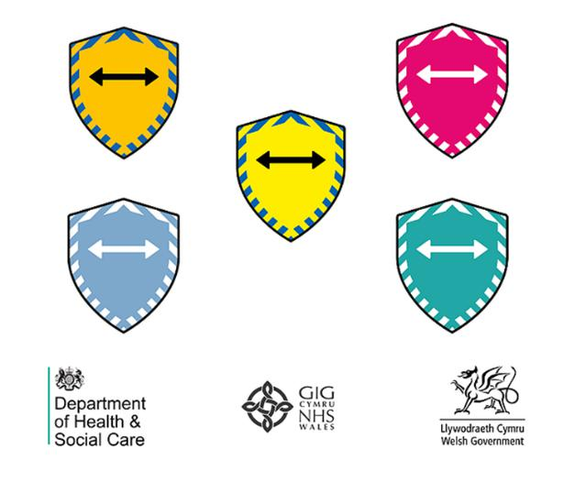

Breaking Down Barriers – The aim of the project

Breaking Down Barriers aims to:

- facilitate patient organisations and support groups to join together and share examples of good practice

- develop new guidelines to highlight effective ways to support families at increased chance of having a child with a genetic disorder

- address difficulties and inequalities experienced by families in accessing mainstream services

At Breaking Down Barriers, we believe that patient organisations and support groups have an important role to play in addressing the challenge of developing appropriate genetic services for the UK’s multi-ethnic population. The purpose of this project is to strengthen the ability of patient organisations and support groups to develop supportive and inclusive services for individuals and families affected by genetic disorders.

Why is this project necessary?
There are a small number of projects around the UK focusing on working with families from diverse backgrounds. Many of these are being driven by health professionals and while they may be benefiting small groups of people in specific locations, there is a clear need for a national project to benefit larger numbers of people and communities and to develop new policies and practices. Breaking Down Barriers can provide a model of good practice where by patient organisations and support groups can demonstrate a key role in providing effective support to families affected by genetic disorders.

Research on genetic service delivery and the patient and family experience shows that patients and families affected by genetic disorders continue to have problems accessing services. It is well documented that this is particularly so for those from minority ethnic groups and those with close cousin marriage. Providing accessible information about genetics to individuals and families is crucial in developing understanding about specific conditions and in ensuring people are aware of the reproductive choices available to enable them to make informed choices about future pregnancies.

Breaking Down Barriers has been discussed extensively with patients, patient organisations, support groups and health professionals and the project has received a very positive response. There is a shared understanding of the need to work in collaboration to help improve awareness of genetics and improve the accessibility to mainstream services. We are confident that the enthusiasm that has already been demonstrated towards this project will help us to achieve our aims and will provide crucial benefit to individuals and families living with genetic disorders.
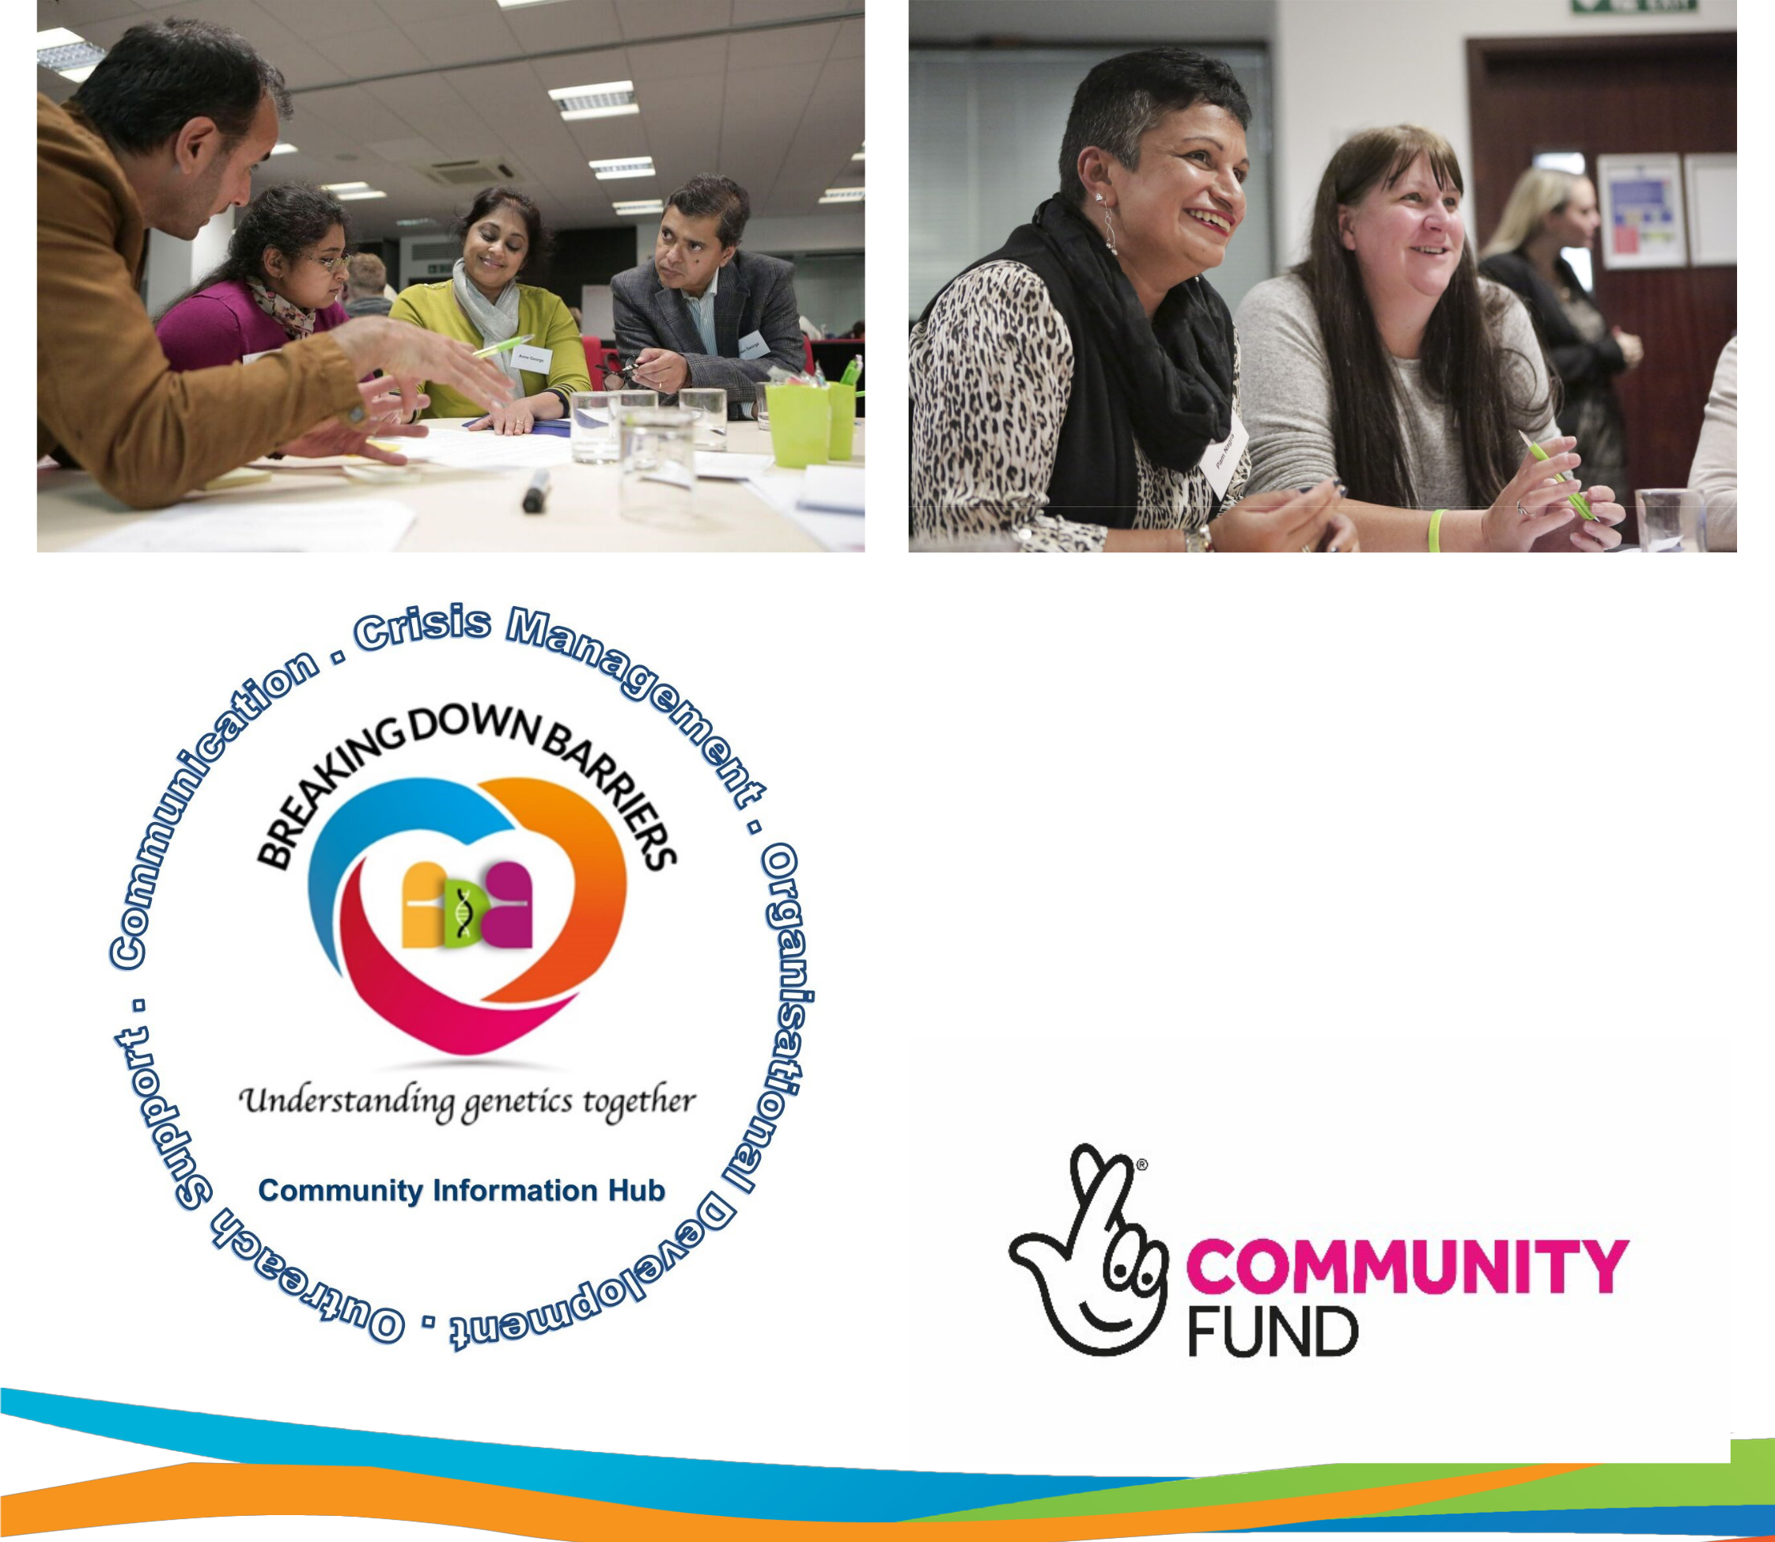

Breaking Down Barriers expands its work and support

Challenging health inequalities is at the centre of the work of Breaking Down Barriers. It is a network of 28 organisations working together to improve the lives of people from marginalised communities including those from BAME backgrounds. The focus is to address health inequalities: finding ways that health services can be shaped to be more inclusive and accessible, and working with families to encourage and support them to access those services. The Breaking Down Barriers network of organisations, is sharing good practice and exploring new ideas to help educate, empower, and provide an evidence base to promote equity of access to mainstream health services.

This will be in the form of a Community Information and Knowledge hub.

Thank you to the National Lottery for kindly funding this project.
Organisations Involved
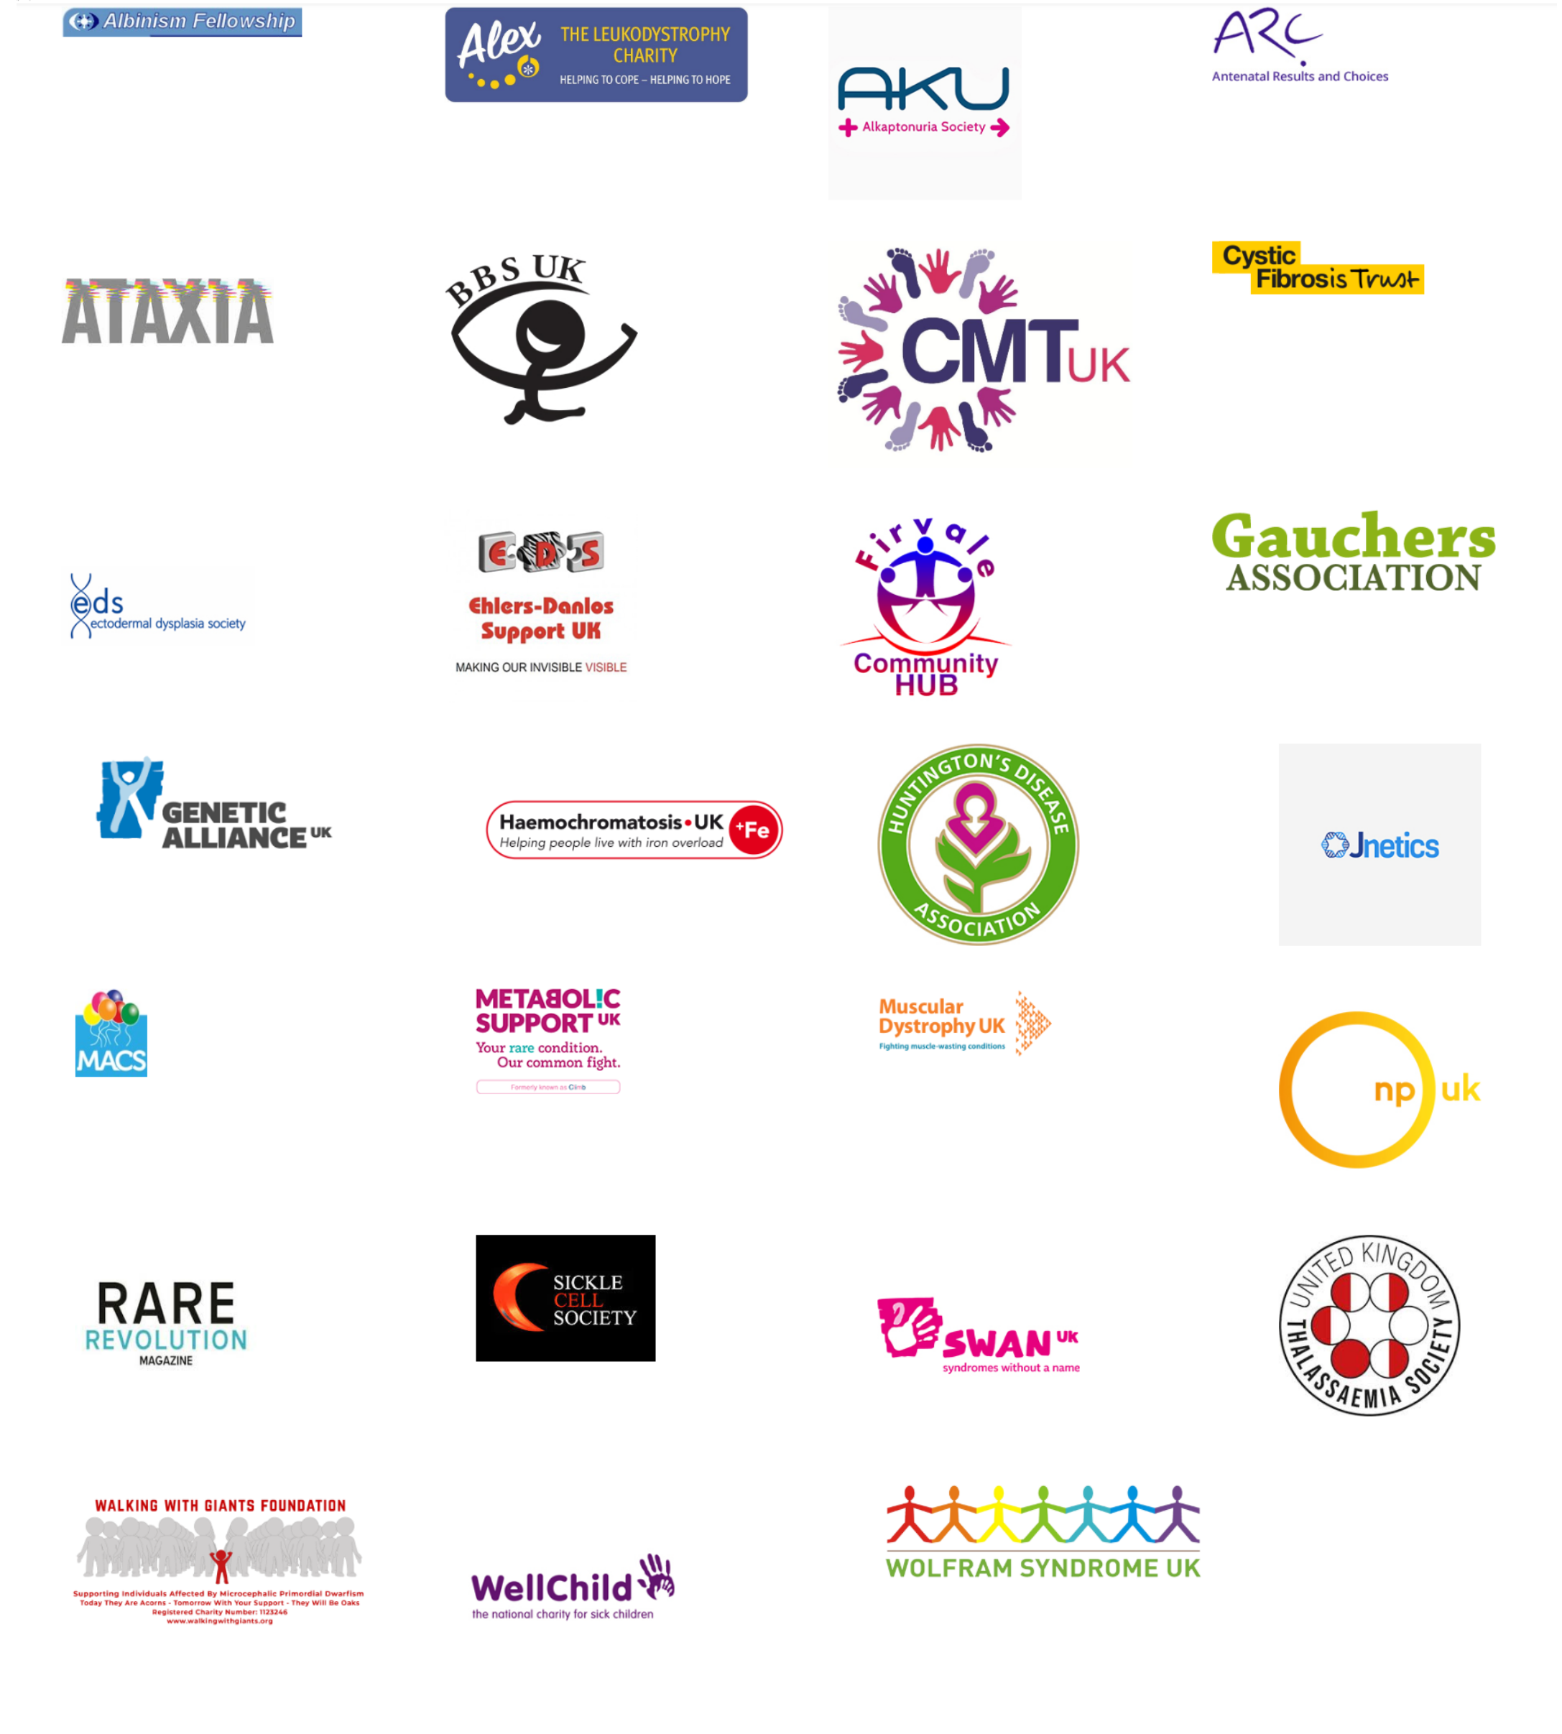

We’re pleased to be developing an information and resources hub and a training programme to support organisational development for BDB partners. Many organisations have experienced difficulties throughout the pandemic, and some were worried that without the necessary support and guidance they wouldn’t survive.

Please check out the Breaking Down Barriers website to find out more about this innovative project http://breaking-down-barriers.org.uk/




ASUK offer a help-line during office hours and an answer phone service at all other times where

calls are promptly returned by our experienced Family Support team; Please call 07970 071675 / 01709 210151

Meet the ASUK team | Please get in touch if you have any articles or suggestions for our next edition, Catherine is
Meet the ASUK team | looking forward to hearing from you! Her email address is Catherine.lewis@alstrom.org.uk,
 | please ensure all your ideas and suggestions are sent in by the end of October 2020.
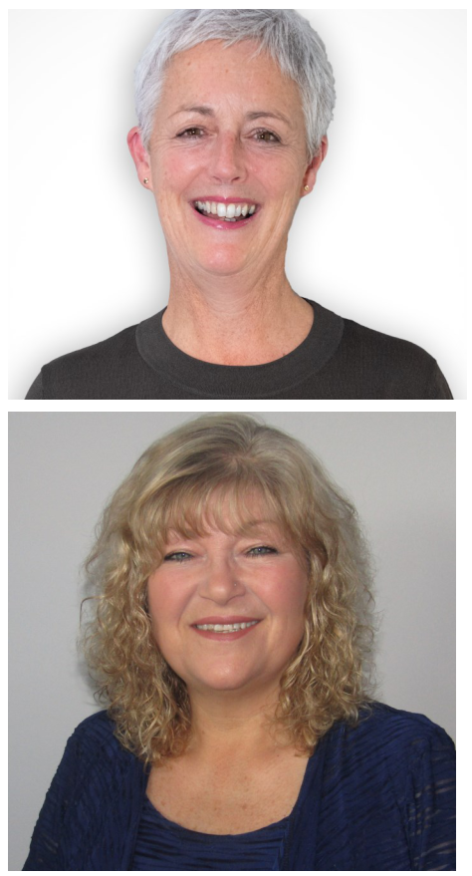
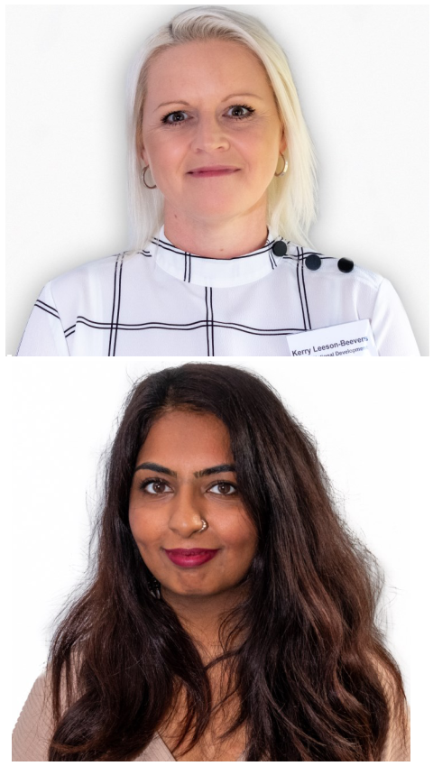

Kerry Leeson Beevers

National Development Manager Monday-Friday
Email: Kerry.leeson@alstrom.org.uk

Asya Choudry

Community Engagement Manager

Monday, Wednesday and Thursday

Email: asya.choudary@alstrom.org.uk
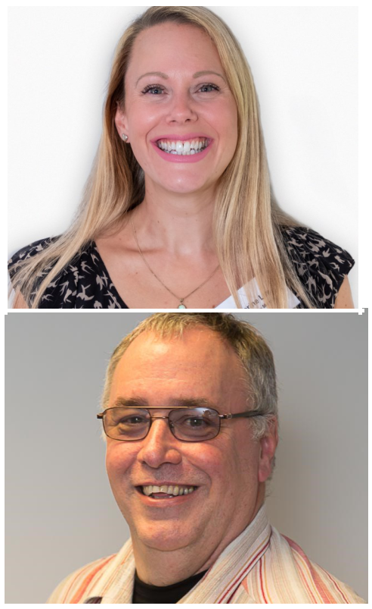
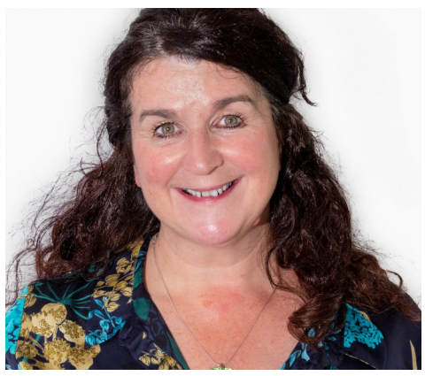

Marie McGee

National Transition Coordinator Part time

Email: marie.mcgee@alstrom.org.uk

Registered Office address: 4 St Kitts Close, Torquay, Devon TQ2 7GD

For all enquiries please get in touch on 07970 071675

Please visit our website www.alstrom.org.uk to keep up to date with our latest news.

ASUK has a dedicated You Tube page http://www.youtube.com/alstromsyndromeuk

Jane Biglin (South)

Senior Family Support worker Working days are Tuesdays and Wednesdays
Email: jane.biglin@alstrom.org.uk

Carrol Birchall (Midlands & North)

Senior Family Support worker

Monday-Thursday
Email: carrol.birchall@alstrom.org.uk

Catherine Lewis

Office Manager

Monday - Friday
Tel: 07970 071675

Email: Catherine.lewis@alstrom.org.uk

Steve Scoffield

Finance Manager

Works one day a week usually on a Wednesday
Email: steve.scoffield@alstrom.org.uk


Please keep up to date with Alström Syndrome UK via twitter @AS_UK and also via our dedicated Facebook page www.facebook.com/alstromsyndromeuk please click ‘like’ to show your support and spread the word!

You can donate securely online, visit our Just Giving page to make a difference today, https://www.justgiving.com/alstromsyndromeuk Registered Charity no 1071196 Registered Company Limited by Guarantee 3557191


