

Thank you to everyone who joined the Alström virtual get together, which was focused on youngsters on Friday 15th January 2021. I hope we answered some of your questions and concerns. Don’t worry if you missed this one, we have brought together the information for you.

As you know, the pandemic is changing daily and we all have more questions than answers, but we have brought together some top tips from the webinar which we hope will help.

Prof. Tim Barrett joined us for the webinar and started by explaining some initial information about Covid-19:

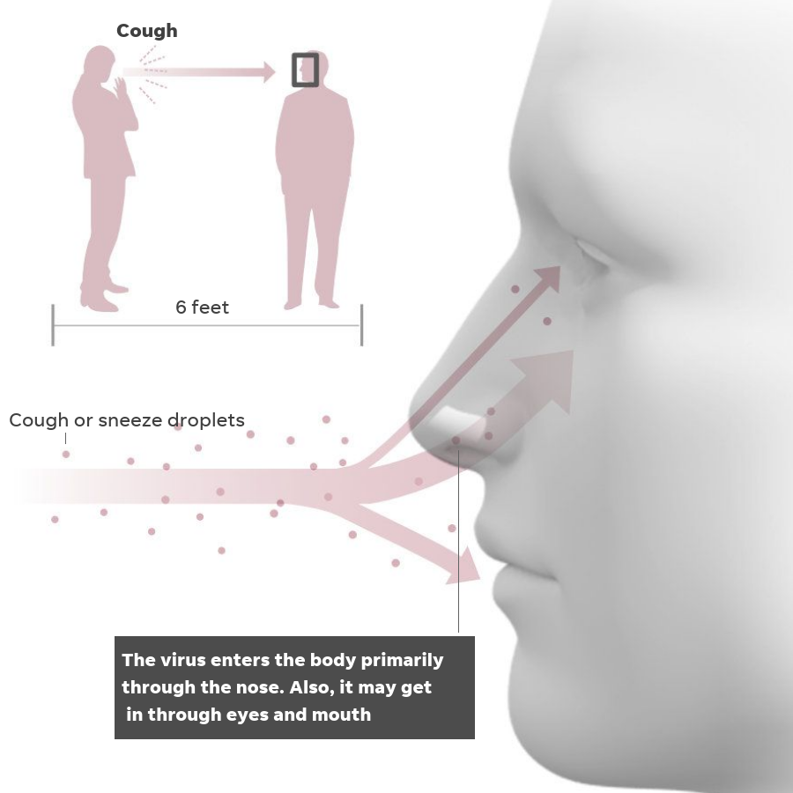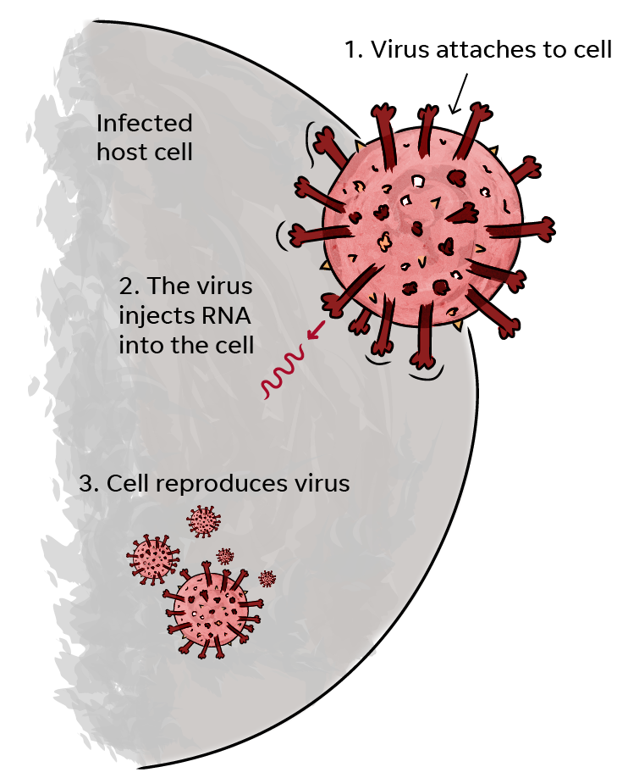

The vast majority of infections are transmitted via droplets (pictures above).  
The new variants make the virus particles better at attaching to cells.  
This is why staying 2 metres away from people, wearing a face mask, regular hand washing and only going out for essentials, is really vital to all stay safe and well.

**Brief background to vaccines**

There are now three vaccines, which are approved for use in the UK. One dose of the vaccine provides about 90% protection after 3 weeks. The initial findings for the, Pfizer and Astra Zeneca vaccines are that they are predicted to protect from the New Variant of Covid viruses from Kent and South Africa. But we are still learning all the time.

**Update on Covid-19 infections in children**The information and evidence below is a summary from the Royal College of Paediatrics and Child Health. More information can be found on their website [**www.rcpch.ac.uk**](http://www.rcpch.ac.uk/)

* There are far fewer children with Covid disease than adults (children make up about 20% of UK population but only 1-2% of people with Covid disease)
* Teenagers may be more susceptible to Covid disease than younger children
* Covid infection is milder in children than in adults. Most children develop mild or no symptoms. Less than 1 in every 100 children with Covid disease develop severe or life-threatening disease
* Children make a much better antibody response to the Coronavirus family of viruses (that includes the common cold and Covid-19) than adults
* Deaths in children due to Covid-19 have been extremely rare: mortality 0.01-0.1% (1 in every 10,000 children with Covid disease to 1 in 1,000 children with Covid disease). This compares to at least 6 in every 100 children who have a rare disease.

**New Public Health England study Jan 14th 2021 -   
relates to ADULTS who have had a Covid infection**

SIREN study, which regularly tests tens of thousands of health care workers since June 2020 for new Covid-19 infections, and for antibodies which suggest past infections.

Between 18th June and 24th November 2020, they identified 44 possible reinfections out of 6614 participants who had tested positive for antibodies. Those reinfections were less severe than first time around. This suggests people who have had Covid, have over 80% protection from reinfection. However, some people who have had Covid, continue to carry the virus and can transmit it to others. So if you have already had Covid, it is very unlikely you will have a severe infection if you get infected again; **BUT** you could still transmit it to others – so you must carry on with **HANDS – FACE – SPACE.**

There is still **NO** information yet on how long vaccine protection lasts.

**Statement from Professor Tim Barrett, Paediatric Clinical Lead for the Alström Syndrome specialised multi-disciplinary clinics, 5th January 2021**

‘On Monday 4th January 2021, the Government announced a national lockdown from 5th January. Primary schools, secondary schools and colleges will move to remote learning, except for the children of key workers and vulnerable children. Early years settings such as nurseries, alternative provision and special schools will remain open and vulnerable children and children of critical workers can continue to use childcare, childminders and other childcare activities. I understand the additional anxiety this will cause.

I would like to share the following in the hope that it may help.

1. The vast majority of children and young people are not being adversely affected by COVID-19, including those with underlying health conditions. Even those with significant underlying conditions are coping well with the virus. This is why young patients with Alström syndrome are not being asked to shield.

2. During the first wave, there was little knowledge about the virus and how it might affect someone with Alström, so much of our community were advised to shield as a precautionary measure.  Alström in itself in children is not now considered to be an additional risk factor, and so those children with the syndrome who are otherwise well, and who do not have any of the conditions listed in the clinically vulnerable group will not be asked to shield.

I am therefore fully supportive of children with Alström syndrome continuing to attend early years settings and schools if applicable.’

**Government General Guidance**

**You must stay at home.** The single most important action we can all take is to stay at home to protect the NHS and save lives.

**Leaving home**

You must not leave, or be outside of your home except where necessary. You may leave the home to:

* shop for basic necessities, for you or a vulnerable person
* go to work, or provide voluntary or charitable services, if you cannot reasonably do so from home
* exercise with your household (or support bubble) or one other person (in which case you should stay 2m apart). Exercise should be limited to once per day, and you should not travel outside your local area.
* meet your support bubble or childcare bubble where necessary, but only if you are legally permitted to form one
* seek medical assistance or avoid injury, illness or risk of harm (including domestic abuse)
* attend education or childcare - for those eligible

If you do leave home for a permitted reason, you should always stay local - unless it is necessary to go further, for example to go to work. Stay local means stay in the village, town, or part of the city where you live.

**EVERYONE - Remember Hand. Face. Space**



**Hands** – wash your hands regularly and for at least 20 seconds.

**Face** – wear a face covering in indoor settings where social distancing may be difficult, and where you will come into contact with people you do not normally meet.

**Space** – stay 2 metres apart from people you do not live with where possible, or 1 metre with extra precautions in place (such as wearing face coverings).

**We only have a very small number of youngsters who are shielding and remain clinically extremely vulnerable and should take precautions.**

These are:

* if they have received an organ transplant
* if they are on immunosuppressant medication
* if your child is undergoing cancer treatment
* those affected by severe asthma or chest infections
* those with severe disease such as severe kidney disease.

For children, in the UK the current information is more reassuring, even with underlying health conditions, children have recovered well from Covid.

**If your child is classed as extremely clinically vulnerable:**

They must not leave, or be outside of your home except where necessary.

**Shops and Pharmacies**Try to get someone to collect your shopping/medicines for you or use online services.  
The NHS Volunteer Service may be able to help with this <https://nhsvolunteerresponders.org.uk/>

**Exercise**Only with your household (or support bubble), this should be limited to once per day, and you should not travel outside your local area.

**Medical Assistance**It is important to seek medical assistance when needed to avoid injury, illness or risk of harm (including domestic abuse).

**Government Guidance**

Keep up to date with the latest guidance on the individual Government websites:

**England**

[**https://www.gov.uk/government/publications/guidance-on-shielding-and-protecting-extremely-vulnerable-persons-from-covid-19/guidance-on-shielding-and-protecting-extremely-vulnerable-persons-from-covid-19**](https://www.gov.uk/government/publications/guidance-on-shielding-and-protecting-extremely-vulnerable-persons-from-covid-19/guidance-on-shielding-and-protecting-extremely-vulnerable-persons-from-covid-19)

**Wales**[**https://gov.wales/guidance-shielding-and-protecting-people-defined-medical-grounds-extremely-vulnerable-coronavirus-0**](https://gov.wales/guidance-shielding-and-protecting-people-defined-medical-grounds-extremely-vulnerable-coronavirus-0)

**Scotland**[**https://www.gov.scot/publications/covid-shielding/**](https://www.gov.scot/publications/covid-shielding/)

**Northern Ireland**[**https://www.nidirect.gov.uk/articles/guidance-shielding-extremely-vulnerable-people**](https://www.nidirect.gov.uk/articles/guidance-shielding-extremely-vulnerable-people)

**Vitamin D**

FREE 4-month supply of vitamin D supplements for all adults who are clinically extremely vulnerable to support general health.

During autumn and winter, everyone is advised to take vitamin D to keep their bones and muscles healthy and to support their general health.

This is particularly important if you've been indoors over the spring and summer as you may not have been getting enough vitamin D from sunlight.

**Apply** [**https://www.nhs.uk/get-vitamin-d**](https://www.nhs.uk/get-vitamin-d)

**We hope this date will be extended as the recent shielding letters indicated, but currently you need to apply before Sunday 21st February 2021.**

Further guidance on how to safely take vitamin D supplements will be provided during the opt in process.

You can also find out more about vitamin D on the NHS website  
[**https://www.nhs.uk/news/food-and-diet/the-new-guidelines-on-vitamin-d-what-you-need-to-know/**](https://www.nhs.uk/news/food-and-diet/the-new-guidelines-on-vitamin-d-what-you-need-to-know/)

**Questions from families**

**Q1. Can we still gain additional services, such as priority shopping slots?**

If your child is classed in the small group of those who are extremely clinically vulnerable, then yes, you should receive these services if needed.

If you haven’t already registered for priority shopping and support services, then please follow the link to the Gov.uk website.

**You can add or update your details on the Gov.uk website** [**https://www.gov.uk/coronavirus-shielding-support**](https://www.gov.uk/coronavirus-shielding-support)

If you need help to collect shopping:

**The NHS Volunteer Service may be able to help with this** [**https://nhsvolunteerresponders.org.uk/**](https://nhsvolunteerresponders.org.uk/)

Unfortunately, for the majority of youngsters you will no longer be eligible for this service. If you were on the priority list before, this may still apply. Many supermarkets are also allowing you to ‘save’ your priority slot so you can keep this going forward.

**Q2. Can we form a support bubble with another household?**

The guidance states that those who are clinically extremely vulnerable can form a support bubble with another household or if you live on your own. It is still very important that you don’t mix with others outside your household and remain within this one support bubble if needed.

You can still receive care at home from social care and medical professionals. Any carers, PA’s or visitors who support you with your needs can continue to visit.

**Q3. What precautions can we take to stay safe?**

For the majority of children who now are no longer on the clinically extremely vulnerable list, it is still important to take precautions. Remember to only go out for essentials, if applicable you can attend school or nursery and exercise once per day. Remember, hand, space, face. This includes if you have carers coming into your home, to ensure they wear a face mask to keep you safe.

**Q4. Why are adults with AS on the clinically extremally vulnerable list but children are not?**

1. The vast majority of children and young people are not being adversely affected by COVID-19, including those with underlying health conditions. Even those with significant underlying conditions are coping well with the virus. This is why young patients with Alström syndrome are not being asked to shield.

2. During the first wave, there was little knowledge about the virus and how it might affect someone with Alström, so much of our community were advised to shield as a precautionary measure. Alström in itself in children is not now considered to be an additional risk factor, and so those children with the syndrome who are otherwise well, and who do not have any of the conditions listed in the clinically vulnerable group will not be asked to shield.

**Q5. Is it OK for my child to still go to school or nursery?**

Prof. Tim Barrett has reiterated that “I am therefore fully supportive of children with Alström syndrome continuing to attend early years settings and schools if applicable.”

**Q6. What are the early signs of Covid?**

* New and continuous cough
* High temperature
* Loss of taste and/or smell
* Some children experience a stomach upset, often with diarrhoea

**It is important to remember that often children experience no symptoms and if they do, they are often mild.**

**Q7. When should we seek further medical support?**

* If your child becomes breathless seek medical assistance
* If you are concerned about their health in any way dial 111 for guidance or in an emergency call 999
* Contact ASUK if you receive a positive Covid-19 test result, we can then inform the AS clinical team

**Remember:**

* **Call 111 if you have symptoms or are concerned**
* **Call 999 if shortness of breath occurs.**

**Q8. What do I do, if someone in my household gets Covid?**

* Book a Covid-19 test
* Self-isolate

**Self-isolation** is what you should be doing if you get coronavirus yourself. You need to remove yourself to a room, away from everyone else in the family and stay there for 7 days. If you are fortunate to have more than one bathroom then have one bathroom for yourself and one bathroom for everyone else. Whilst you are in the room, people should bring your food up on a tray and leave it outside your door.

**Q9. When are children with AS likely to receive the vaccine?**

The Government has advised that children under the age of 16 will not be able to receive the vaccine, in this round of vaccinations *(The Pfizer/Biotech and the Oxford/Aztrazeneca vaccine will be available for all those over 16 years old, the Moderna vaccine will be available for those 18 years and over).* The vaccines clinical trials did not include children and young people at first, although this is something that is now being looked at. Once people have had a chance to review the safety information from further trials including young people, this may mean that the vaccine will then be made available to people under the age of 16.

Prof. Tim Barrett will monitor this closely and see whether it is appropriate for young people with Alström Syndrome, to receive the vaccine when it becomes available.

**Q10. When are carers likely to receive the vaccine?**

Those who receive carers allowance or those who are the main carer of an elderly or disabled person, are included in priority group 6, it is hoped that they will receive the vaccine as soon as possible following the first 5 priority groups. The Government are aiming to have groups 1-4 vaccinated by mid-February.

**Q11. Is the vaccine something you would recommend for children with AS?**

Prof. Barrett explained that he would recommend the vaccine but that further safety information needs to be considered before it becomes available. Although the majority of children with AS are not in the clinically extremely vulnerable category, he understands that many families may still be anxious about their children getting Covid-19 and may want them to have the vaccine at the earliest opportunity.

**Important points to remember:**

* **Call 111 if you have symptoms and would like advice**
* **Call 999 if shortness of breath occurs**
* All those affected by **Alström Syndrome should stay at home**
* Provisions should be brought to you
* Remember hand, face, space

**Where to find further resources**

You can find a range of resources on our website; including the latest guidance about coronavirus, where to find support and how to stay connected and entertained whilst at home [**http://www.alstrom.org.uk/family-support/**](http://www.alstrom.org.uk/family-support/)**.**  
Please get in touch with Catherine Lewis, her email address is [Catherine.lewis@alstrom.org.uk](mailto:Catherine.lewis@alstrom.org.uk) if there are specific services which you think would be helpful for other families to know about and we can add these to our resource section.

**Keep in touch**

ASUK are here for you, we are open and feel free to contact your family support worker if you need any support. We can call you; you can call us.

**Jane Biglin**  
Senior Family Support Worker   
(for patients living in the South of England)  
Email: [jane.biglin@alstrom.org.uk](mailto:jane.biglin@alstrom.org.uk)  
Telephone: 07714 798413

**Carrol Birchall**  
Senior Family Support Worker   
(for patients living in the Midlands & North of England)  
Email: [carrol.birchall@alstrom.org.uk](mailto:carrol.birchall@alstrom.org.uk)  
Telephone: 07847 760467

Best wishes

  
Ann Chivers and the ASUK Team