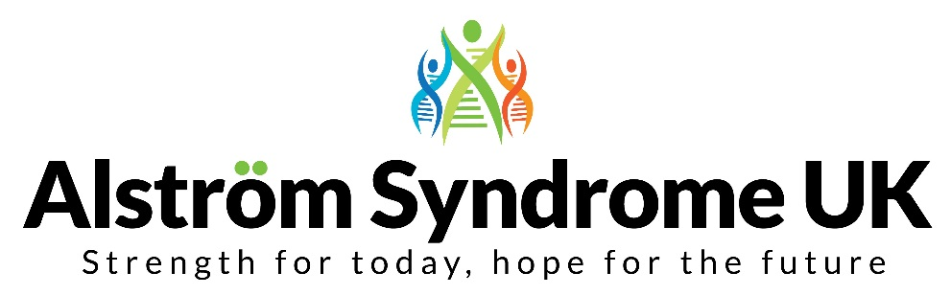
4 St Kitts Close, Torquay, TQ2 7GD
Tel: 07970 071675 / 077161 35940
Email: info@alstrom.org.uk
Website: www.alstrom.org.uk
Charity no: 1071196
Company no: 3557191

Dear Applicant,

Thank you for your interest in the Alström Syndrome Care Coordinator role with Alström Syndrome UK (ASUK). This important role reflects our ambition to continually improve the support that we offer to individuals with Alström Syndrome and those who love and care for them.

Alongside providing comprehensive support to individuals and families, your role will be responsible for supporting the coordination of the Alström Syndrome multi-disciplinary clinics in Birmingham and linking with local health, education and social care professionals. The role will also involve developing and continually updating person centred plans.

We recognise that people who are affected by Alström Syndrome and their families can be isolated and may not always receive the support and assistance they need. At ASUK we are working with people with lived experience, commissioners, clinicians, and other stakeholders to promote better understanding, healthcare management, and support.
Our aim is to improve lives and promote research into this ultra-rare condition.
We are looking for someone who wants to make a difference. Experience of delivering family support and an ability to work flexibly and travel, when necessary, will be essential. Knowledge and experience of dual sensory loss and working with people from diverse and marginalised communities will be an advantage, as will experience of working in a hospital or other healthcare setting.
Most importantly, if you are compassionate and determined and want to make a positive impact on people’s lives, I would encourage you to apply.
All applications must be submitted by 12pm on Friday 5th May 2023.
Interviews will take place on the 15th & 16th May 2023. It is hoped that interviews will be in person, however they may take place virtually.
Kindest Regards
Kerry Leeson-Beevers
Chief Executive

