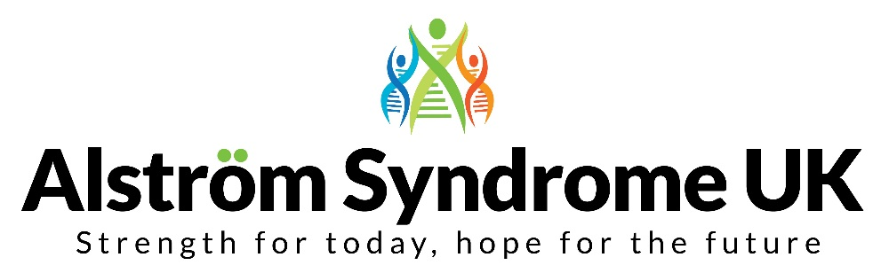
4 St Kitts Close, Torquay, TQ2 7GD
Tel: 07970 071675 / 077161 35940
Email: info@alstrom.org.uk
Website: www.alstrom.org.uk
Charity no: 1071196
Company no: 3557191

Dear Applicant,

Thank you for your interest in the Alström Syndrome Care Coordinator role with Alström Syndrome UK (ASUK). This important role at ASUK reflects our ambition to continually improve the support that we offer individuals with Alström Syndrome and those who love and care for them.

Alongside providing comprehensive support to families and individuals, your role will be responsible for supporting the coordination of the Alström multi-disciplinary clinics in Birmingham and linking with local healthcare professionals. The role will also involve developing and continually updating person centred plans.

We recognise that people who are affected by Alström Syndrome and their families can be isolated and may not always receive the support and assistance they need. At ASUK we are working with people with lived experience, commissioners, clinicians, and other stakeholders to promote better understanding, healthcare management, and support.
Our aim is to improve lives and promote research into this ultra-rare disease.
We are looking for someone who wants to make a difference. Experience of delivering family support and an ability to work flexibly and travel, when necessary, will be essential. Knowledge and experience of dual sensory loss and working with people from diverse and marginalised communities will be an advantage, as will experience of working in a hospital or other healthcare setting.
Most importantly, if you are compassionate and determined and want to make a positive impact on people’s lives, I would encourage you to apply.
All applications must be submitted by 9am on Monday 10th January 2022. Please note interviews will take place on the 18th/19th January 2022.
It is hoped that interviews will be face to face, however they may take place virtually.
Kindest Regards
Kerry Leeson-Beevers
Chief Executive

