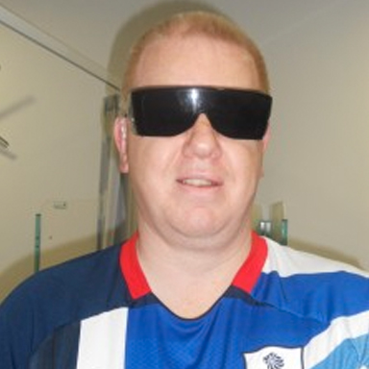
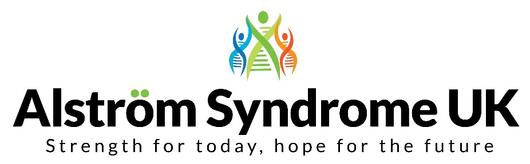
Searching for a ‘rare’ Trustee

Welcome to Alström Syndrome UK (ASUK), a small national charity who support families affected by this extremely rare condition, Alström Syndrome.
The ASUK team provide a world class service which includes supporting people affected and their families. I am most proud of the charities approaches in developing the world’s first; multi-disciplinary NHS clinics, clinical trials, research and the only medical handbook in the UK dedicated to the management of Alström Syndrome.
We have grand plans going forward and we would like further expertise on the Board of Trustees. If you have finance experience, or just understand budgets and figures, then we would like to hear from you. Get in touch and find out the ways you can help us to continue to drive the charity forward.
I am proud to be part of the charity’s innovative work in searching for answers into one of the rarest conditions and working hard to support individuals with Alström, their families and loved ones.
If you would like an informal discussion about the Trustee role please email Catherine on catherine.lewis@alstrom.org.uk or call her on 07970 071675 during office hours, in the first instance, and she will help to organise a call between us.
I look forward to speaking with you.
Kindest Regards
Trevor
Trevor Parkin, Chair of the Board at Alström Syndrome UK (ASUK)

