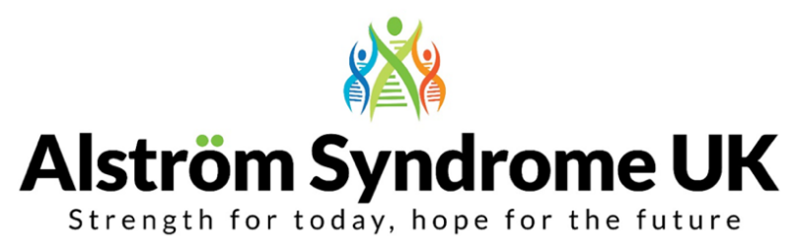

Alström Syndrome UK Conference; Together Again!
Saturday 12th October 2024
4* Mercure Birmingham West Hotel, Birmingham Road, West Bromwich B70 6RS

The theme of this year’s get together is Togetherness!

ASUK are super excited to bring the AS community together again, after such a long time since Covid brought the world to a standstill. We would like to invite you to come together, to share your experiences, unite with old friends and have fun making new ones. You will get to hear from AS Experts in the field of healthcare and research, take part in fun-filled demonstrations, and listen to informative workshops.

There will also be time to relax at the hotel with a full leisure suite provided; including a swimming pool, children’s pool, sauna, and steam room and if you are feeling energised, why not hit the fully equipped gym. There will be accessible games and activities as well as quiet spaces for those who want to sit and chat.

The ASUK team will be on hand throughout the event, to offer support and answer any questions, including any guidance on benefits, social care, or education concerns.

Booking Details

Name: Click or tap here to enter text.
Address: Click or tap here to enter text.
Telephone Number: Click or tap here to enter text. Mobile: Click or tap here to enter text.
Email address: Click or tap here to enter text.
Please list the names of everyone attending the conference and include the ages of any young people under the age of 18:
- Click or tap here to enter text.
- Click or tap here to enter text.
- Click or tap here to enter text.
- Click or tap here to enter text.
- Click or tap here to enter text.
- Click or tap here to enter text.
- Click or tap here to enter text.
Whilst families listen to presentations and connect during the day, children will be entertained with a day out at Drayton Manor Theme Park. Please list the names of any children wishing to attend and the name of the person supporting them on the day.
Name of Children attending and their ages Parent/ Guardian/ Volunteer
1. Click or tap here to enter text. 1. Click or tap here to enter text.
2. Click or tap here to enter text. 2. Click or tap here to enter text.
3. Click or tap here to enter text. 3. Click or tap here to enter text.
4. Click or tap here to enter text. 4. Click or tap here to enter text.
5. Click or tap here to enter text. 5. Click or tap here to enter text.

There will be a cold buffet provided for those arriving on Friday and lunch and dinner will be provided for everyone attending the conference on Saturday. Activities and hotel parking will be free of charge throughout the weekend.
Please let us know of any dietary requirements or allergies below:

How will you be travelling to the conference? Click or tap here to enter text.
Information Packs will be distributed at the event. Please indicate how you would like to receive your pack by ticking your preferred option:
Standard Print Copy ☐ Large Print Copy (font size 16) ☐ Braille Copy ☐
Which day(s) will you be attending | Number of adults attending | Number of children attending
Friday 11th October 2024 – Informal get together as families arrive, alongside activity demonstrations.  Cold buffet will be provided from 6:00 pm  (please tick the box if you will be requiring this) | Click or tap here to enter text.  ☐ | Click or tap here to enter text.  ☐
Saturday 12th October 2024 - Conference 9:30 am – 17:30 pm | ☐ | ☐
Saturday evening – Dinner and entertainment 18:30 pm until late | ☐ | ☐

Early bird rate until 31st May 2024: If you need accommodation the Mercure hotel have offered an early bird rate of £109.00 per room, per night on a B&B basis, (sleeps 2 adults and 1 child) and if you need a second hotel room, this will be charged at the lower rate of £70. ASUK will book your room and then you can pay the hotel directly. There are only a limited number of interconnecting rooms, so please let us know asap if you need one of these.

Please tick when you will you need accommodation Friday night ☐ Saturday night ☐
No accommodation is needed ☐

Please add your accommodation requirements below:

I can confirm that ASUK can pass my families contact information onto the Mercure Hotel, so they are able to book my accommodation and the hotel will be in touch to finalise payment. Please tick to confirm ☐

We know how difficult times are for people financially at the moment, and we don’t want this to be a barrier and stop people from attending the event. If you need financial support to attend, then we may be able to offer a grant to contribute to your hotel and travel costs.

Please tick the box if you would like to be contacted about this grant, by one of our family support team ☐

We are currently finalising the agenda for the conference, which as always will be full of interesting topics such as research developments, clinical updates, and personal experiences from the AS community. This year we are also excited to announce the ‘quiz the researchers and clinicians’ sessions, where young people, parents and carers will take to the stage and ask the important questions. This is your day, so please let us know if there are any topics you are eager to hear about, or if you would like to be involved, please add your comments in the box below:

We would like as many people as possible to have the opportunity to come together at this event. If there are any concerns or barriers to you attending, please do get in touch, so that we can help find a way to support you.

We continue to provide family events and activities free of charge to ensure as many families as possible can attend. Donations are always greatly received so we can continue delivering these vital services. Donations can be made easily and securely via our JustGiving page https://www.justgiving.com/alstromsyndromeuk

Please email the completed booking form to Catherine Lewis at Catherine.lewis@alstrom.org.uk
You can also book over the phone with Catherine on 07970 071675
Alternatively, please post to: Alström Syndrome UK, 4 St Kitts Close, Torquay, Devon TQ2 7GD
Please ensure booking forms are returned promptly to secure your place.
We can’t wait to see you all there!

